CAREER NEWS Friday 8 February

 Faculty of Engineering Co-Operative Program
The Monash Engineering Co-operative Education Program (Co-op) is designed to equip students with up-to-date, relevant industry experience and prepare them to become engineers of the future. The program offers the flexibility for students to engage for a three or six-month term and undertake meaningful work-based learning; explore different industry sectors, understand what it is to be a working engineer, and connect their experience to their studies in a more practical way. Students will also gain valuable professional development, culture sharing and personal growth from participating in the experience.
Students are encouraged to browse how it works to learn more about the benefits of participating in this program, one of which being that it is a paid industry experience.
This program is available to students who are already at university, but VCE students are encouraged to give this program serious consideration when planning tertiary study.
Browse Monash Engineering Co-operative Education Program (Co-op)
 Course Seeker
Course Seeker is an Australian Government initiative that has been funded by the Australian Government Department of Education and Training (the Department).

This interactive, searchable website displays course information, entry requirements, admission processes and student satisfaction and graduate survey results at the study area and institutional level.

The aim of this website is to help students make informed decisions about their future study by allowing them to access clear, meaningful and transparent information on ATARs/OPs, prerequisites and enrolment policies.

There are currently over 70 institutions listed on this website with many more to be added soon.

*Note that the ATARs currently reflected are for the 2018 offer period and the website will soon reflect the 2019 ATARs.
Students are encouraged to spend some time browsing and familiarising themselves with Course Seeker

Have You Considered a Career in…
- Audiology

Audiology is a health care profession involved in assessing, managing and rehabilitating hearing loss and balance disorders. According to the Good Universities Guide - Audiologists test hearing and assess the nature of hearing disorders. They are responsible for the non-medical management and rehabilitation of hearing loss and associated disorders of communication.

Audiology is a rapidly growing profession and qualified audiologists are in high demand both locally and internationally. To become an audiologist, students usually have to complete a bachelor degree in linguistics, physics, psychology, special education, speech pathology, science, or a related discipline, followed by a graduate diploma and a Master’s degree in audiology. In Victoria, the Masters of Audiology is offered by La Trobe University, and the University of Melbourne.

- Orthoptics

Orthoptists are eye care professionals. They specialise in detecting, diagnosing and treating vision and eye disorders. To become an orthoptist, a student usually has to study orthoptic or ophthalmic science at university. The only university in Victoria offering studies in orthoptics, is La Trobe University.

- Speech Pathology
The Good Universities Guide indicates that speech pathologists diagnose, treat and provide management services to people with communication disorders, including speech, language, voice, fluency and literacy difficulties, or people who have physical problems with eating or swallowing.
Speech pathologists may perform the following tasks:
- treat children who are unable to communicate effectively due to conditions such as cleft palate, hearing loss, delayed speech or language development, cerebral palsy or emotional disturbances
- treat adults whose language, speech or voice has been affected by surgery, disease or disorders of the nervous system, brain damage or hearing loss
- help children and adults overcome stuttering
- assess and treat children and adults who have difficulty chewing and swallowing

In Victoria, Speech Pathology is taught at undergraduate level at ACU, Charles Sturt University, and La Trobe University

- Health Information Management (HIM)
According to the Good Universities Guide, Health Information Managers combine knowledge of healthcare processes, health records and administration, information management and human resource management to provide services that meet the medical, legal, ethical and administrative requirements of the healthcare system. In other words, Health Information Managers work in the ‘business’ side of healthcare. They work in e-health at the forefront of Health Information Management technology. Victoria (and Australia) is facing a critical shortage of Health Information Managers, so doing a course in HIM will lead to great employment opportunities. Health Information management is taught by a number of universities in Victoria including:

- ACU – Applied Public Health
- Federation University – eHealth & Informatics
- La Trobe University - Health Sciences (Medical Classification)/Health Information Management
- Monash University – Health Sciences
- RMIT University - Associate Degree in Health Sciences
- University of Melbourne - Graduate Certificate in Health Informatics and Digital Health

- Prosthetics and Orthotics
La Trobe University is one of only a very few universities in the world offering a qualification in Prosthetics and Orthotics – the Bachelor of Applied Science and Master of Clinical Prosthetics and Orthotics.
Prosthetics and orthotics are clinical disciplines that deal with artificial limbs (prostheses) for people with amputations and supportive devices (orthoses) for people with musculoskeletal weakness or neurological disorders. Few things are as rewarding as giving someone the ability to walk, stand or even just pick up a cup. Studying clinical prosthetics and orthotics gives you the ability to do just that. You'll learn about artificial limbs (prostheses) for people with amputations, and supportive devices (orthoses) for people with musculoskeletal weakness. This course offers practical experience and is the only course of its kind in the Asia-Pacific region.

Students study anatomy, physiology, biomechanics, prosthetic and orthotic prescription, and design and fabrication. They also develop strong practical skills in research methodology, clinical assessment, and the application of prosthetic and orthotic techniques.

Medical Career Planning
NSW Health has compiled an extensive list of extremely useful fact sheets to assist students in making more informed career choices about the many careers in the health industry, and to ensure their career plans not only fulfil their personal aspirations but also align with the needs of the industry. Students keen on finding out more about what the job is about, whether or not there is a shortage, etc. are encouraged to browse the following link on NSW Health - Medical Career Planning
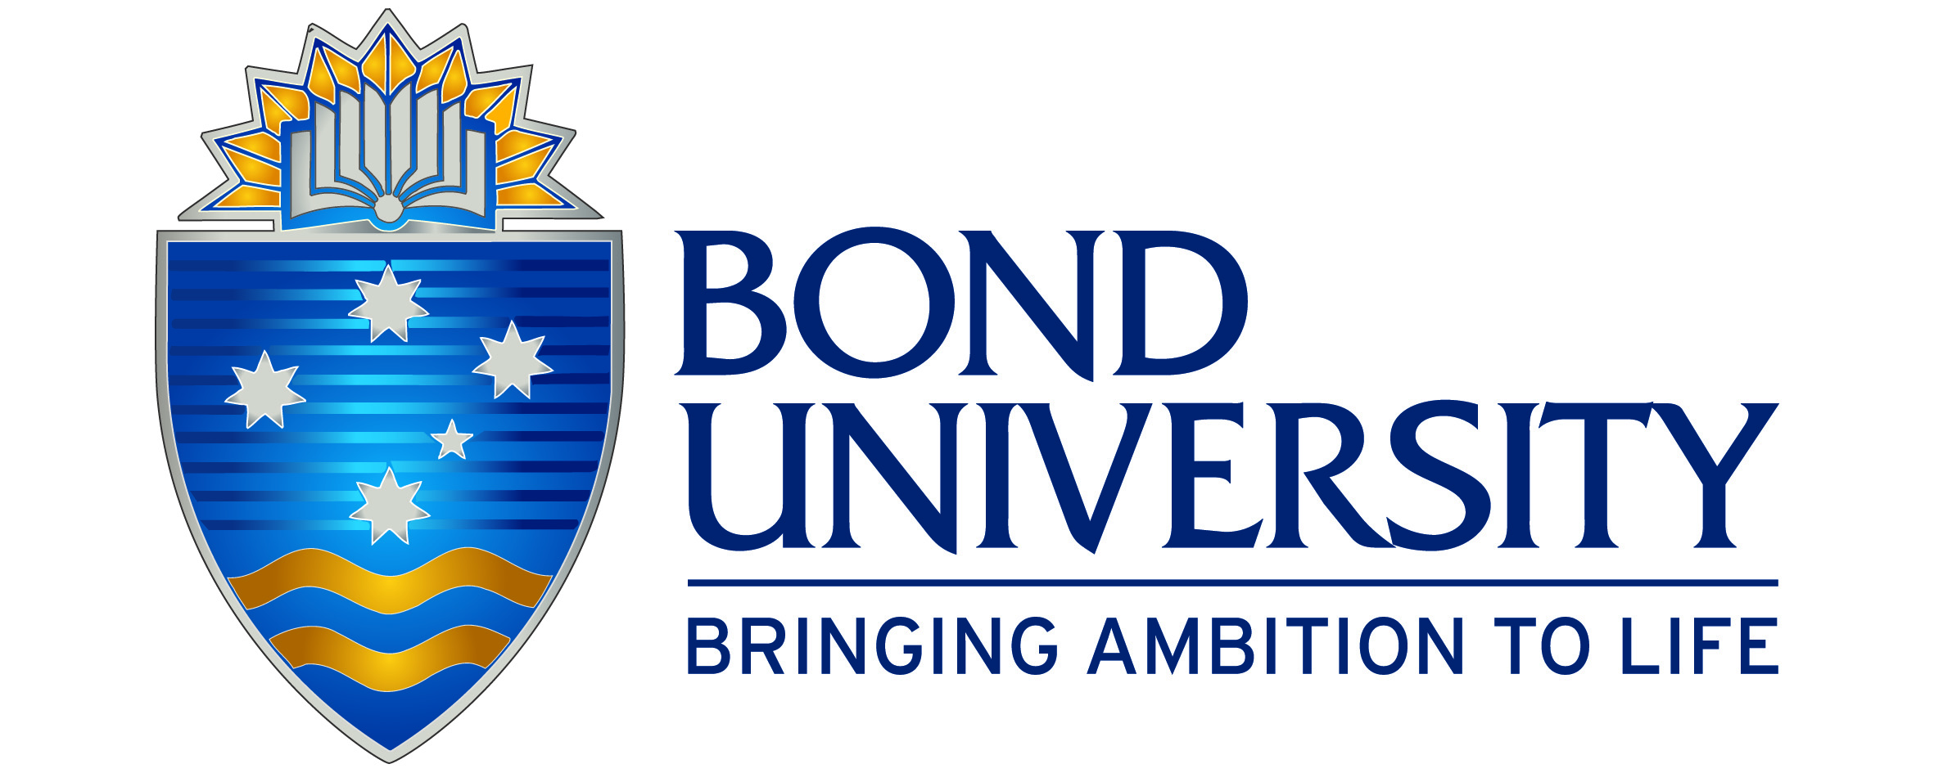 Snapshot of Bond University in 2019
- Australia's Highest Rating University*
In the 2019 Good Universities Guide, Bond University was awarded more 5-star ratings in the Educational Experience category with 5 stars being the maximum rating awarded by the Good Universities Guide.
Bond rates five stars across a range of key performance indicators including:
Student Support Teaching Quality
Overall Quality of Education Learner Engagement
Learning Resources Skills Development
Student Retention Student Teacher Ratio
Bond also ranked in top 20 of world's best small universities - Times Higher Education

2. Accelerated Degrees
Graduate up to 12 months ahead of the rest by studying three semesters per year.

3. Five-Star Teaching Quality
Learn from world-renowned, highly qualified academics and high-level corporate and government consultants who take a hands-on role in guiding students’ career paths.

4. Leadership Development
Part of Bond University’s unique approach is to help students develop a strong foundation of key leadership attributes that will prepare them for career success, regardless of which field of study they choose.
5. World-class Facilities
Not only does Bond offer state-of-the-art facilities, it also offers unprecedented access to them. This means students can apply their profession as they learn it, in an environment far more akin to the real thing.

6. Practical Experience
Bond is committed to producing graduates who are “ready to hit the ground running” thanks to the practical case studies and internships with its network of blue chip employers such as KPMG, IBM and the Marriott International to name a few.
7. Globally Focused Courses
Australian in character yet international in perspective, Bond offers globally focused course content and a world of cultural enrichment.

8. Beyond Bond
A practical, activity-based program that extends across the duration of all undergraduate degrees, as a mandatory degree requirement, ensuring all Bond students engage in various extra-curricular activities that complement their academic studies.

9. Great Social Life on Campus
With so many students on campus, Bond has a real community feel and a vibrant student social life. Students have over 70 sporting and social clubs, one of Queensland’s leading fitness centres, cafes, restaurants, and support services on offer, all available on campus.

10. Global Bondy Alumni Network
Bond has a global network of 26,000 alumni, which is active in over 120 countries around the world, so students can be connected practically anywhere their ambition may take them.
* 2019 Good Universities Guide - Good Universities Guide
Why Bond University
 Courses in Global and International Studies
Many universities in Victoria offer courses that include major studies in international studies, global studies, international relations, policy studies, politics, etc. that students keen on a career as a diplomat, or working in government or NGO’s, might be keen on studying. Students should note that the prerequisite VCE subject for most of the degrees listed below is only an English or EAL. For a comprehensive list of all relevant courses (including the many other double-degree options) on offer at universities, visit VTAC

UNIVERSITY | COURSE | MAJOR STUDIES IN 2019
ACU | International Development Studies | International Development Studies.
ACU | Arts/Global Studies | Business Studies, Drama, Economics, Global Studies, History, Literature, Mathematics, Media, Music, Philosophy, Politics and International Relations, Psychology, Sociology, Study of Religions/Theological Studies, Visual Arts.
Deakin | International Studies | Anthropology, Arabic, Chinese (Burwood, Waurn Ponds), Indonesian, International Politics, International Relations, Language and Culture Studies, Middle East Studies, Politics and Policy Studies, Spanish.
Deakin | International Studies/Commerce | Accounting, Anthropology, Arabic, Chinese, Economics, Finance, Financial Planning, Human Resource Management, Indonesian, International Politics, International Relations, Language and Culture Studies, Management, Management Information Systems, Marketing, Middle East Studies, Politics and Policy Studies, Spanish.
Deakin | Laws/International Studies | Anthropology, Arabic, Chinese, Commercial law, Indonesian, International relations, Language and culture studies, Middle East studies, Politics and policy studies, Spanish
La Trobe | International Relations | International Relations.
La Trobe | Laws/International Relations | Law, International Relations.
La Trobe | Politics, Philosophy and Economics (PPE) | Economics, Philosophy, Politics.
Monash | Global Studies | Cultural competence, Global studies, Human rights, International relations, International studies, Languages.
Monash | Laws/Global Studies | Constitutional law, Corporations law, Criminal law & procedure, International relations, International studies, Administrative law, Contract, Cultural competence, Equity, Evidence, Global studies, Human rights, Intellectual property, Languages, Law, Lawyers' ethics in practice, Litigation and dispute resolution, Professional practice, Property, Taxation, Torts, Trusts.
RMIT | Arts (International Studies) | Cross cultural studies, Cultural diversity, Globalisation, History, Human rights, International development, International economics, International law, International relations, International studies, Language and culture studies, Language and literacy, Politics and policy studies, Social research methods.
RMIT | Legal and Dispute Studies | Dispute resolution and mediation, Human rights, Justice, Law, Law (Family), Law (civil), Law (criminal), Law (evidence), Law (information), Law (labour relations), Legal practice, Legal studies, Organisational processes, Social sciences, Sociology.
Swinburne | Laws/Arts | Administrative law, Advertising, Australian law and statutory interpretation, Chinese, Cinema and screen studies, Civil procedure and alternative dispute resolution, Commercial law, Company law, Competition law and policy, Contract law, Copyright, Creative writing and literature, Criminal law and procedure, Criminology, Digital advertising technology, Environmental sustainability, Equity and trusts, Federal and state constitutional law, Global studies, History, Indigenous studies, Intellectual property law, Japanese, Journalism, Legal practice and professional conduct, Media industries, Misleading conduct, Patents and designs, Philosophy, Politics and international relations, Professional writing and editing, Property law, Social media, Sociology, Taxation law, Trademarks and related rights.
Uni Melbourne | Arts | Ancient world studies, Anthropology, Arabic studies, Art history, Asian studies, Australian Indigenous studies, Chinese societies (minor), Chinese studies, Classics, Creative writing, Criminology, Development studies (minor), Economics, English and theatre studies, English language studies (minor), Environmental studies (minor), European studies (minor), French studies, Gender studies, Geography, German studies, Hebrew and Jewish studies, History, History and philosophy of science, Indonesian studies, Islamic studies, Italian studies, Japanese studies, Knowledge and learning (minor), Law and justice (minor), Linguistics and applied linguistics, Media and communications, Philosophy, Politics and international studies, Psychology, Russian studies, Screen and cultural studies, Sociology, Spanish and Latin American studies.
VU | Community Development | Community development.

