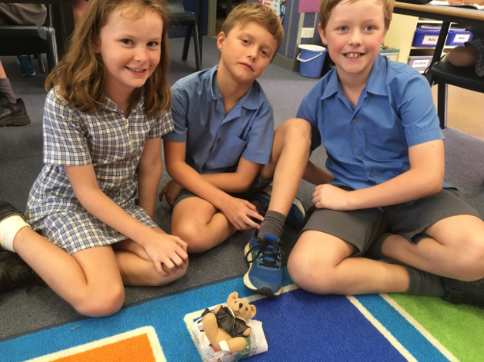 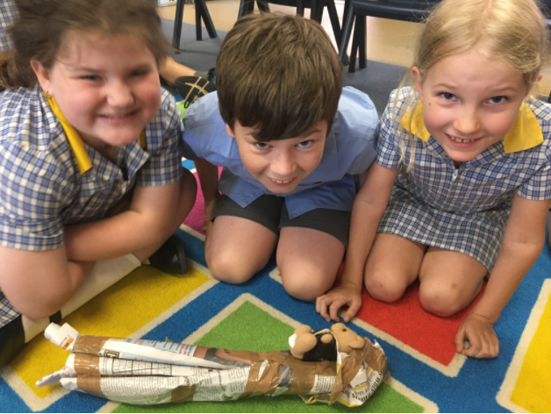

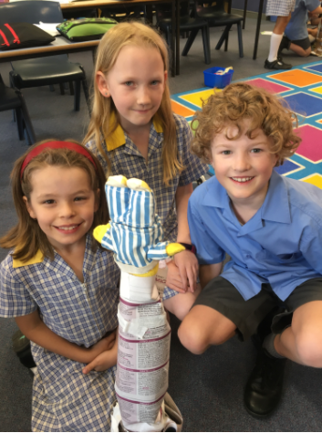 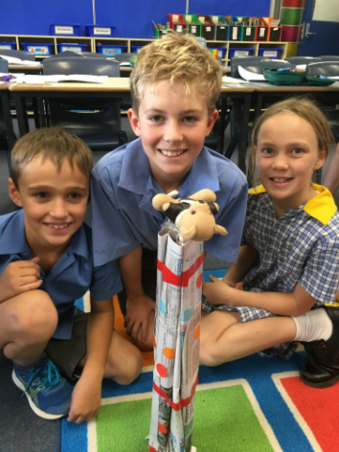

**3/4 Aqua are developing their skills to Try, Try and Try Again as part of their PDHealth and Bounce Back programs by building the highest tower with newspaper that could also hold the weight of a small toy. This task was a fun challenge with many ideas being shared.**