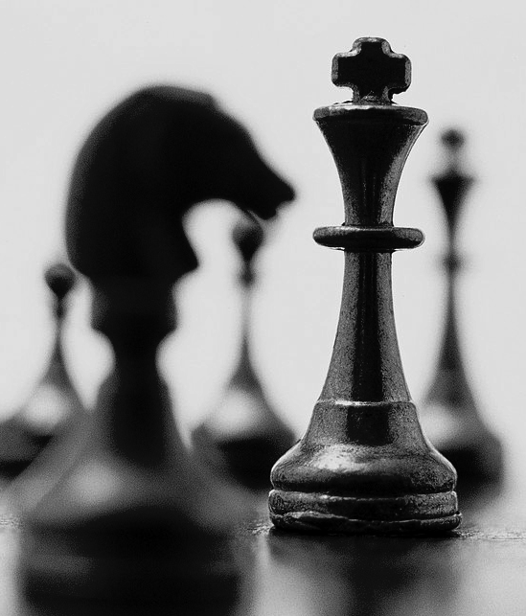
Chess Ideas

Ph: 9532 8370

Fax: 9532 8360
Mobile:0476024493

P.O. Box 3158
Ripponlea 3185

admin@chessideas.com.au

- Established in 1994

- Teaching in over 100 schools in Melbourne and Ballarat.

- Coaches to the top junior students in Victoria.

St Mary’s P.S.
Term 1, 2023
Thursday Lunch time
Classes start 2nd February

.

Date: 2/2 – 6/4 (no 13/3): 9 weeks
Time: Thursday Lunch Time 11.00 – 11.40
Cost: $16.00 per lesson $144.00 for the term.

Students will not receive a refund for classes missed for absentees. School camps or swimming classes can be deducted from Payment. If you are starting later than the start date you deduct the weeks, you have missed.

PAYMENTS MUST BE MADE ONLINE AT: www.chessideas.com.au -
Go to Pay Fees – Click on Term Fees
Enter the amount from your registration form 144.00 - no $ sign
Add to cart
Next pages enter all details for your child as asked:
Chess username or ID please put N/A Click to pay:
You go to PayPal where you can pay with a PayPal account or click credit card payment at the bottom of page, no American Express or Diners card

All Payments need to be made by the second week of Chess

If your child has a medical condition we should know about please ring our office with details.

Play Chess at home against the computer.
Go to www.chessideas.com.au home page.
Click on “play chess”. It’s fun!

CHESS REGISTRATION TERM 1, 2023
St Mary’s P.S If you cannot pay online this form can be completed and handed to our Chess Tutor at the first lesson

NAME OF CHILD: __________________________________________________ GRADE: ______________

CONTACT PARENT/GUARDIAN: _____________________________________ Ph. #: ________________

SIGNATURE OF PARENT/GUARDIAN: _______________________________________________________

Credit Card Details:

NAME ON CARD: ________________________________________________Amount : _____________

CARD NUMBER: ________________________________________________ EXPIRY DATE: __________

EMAIL: __________________________________________________________________________________

