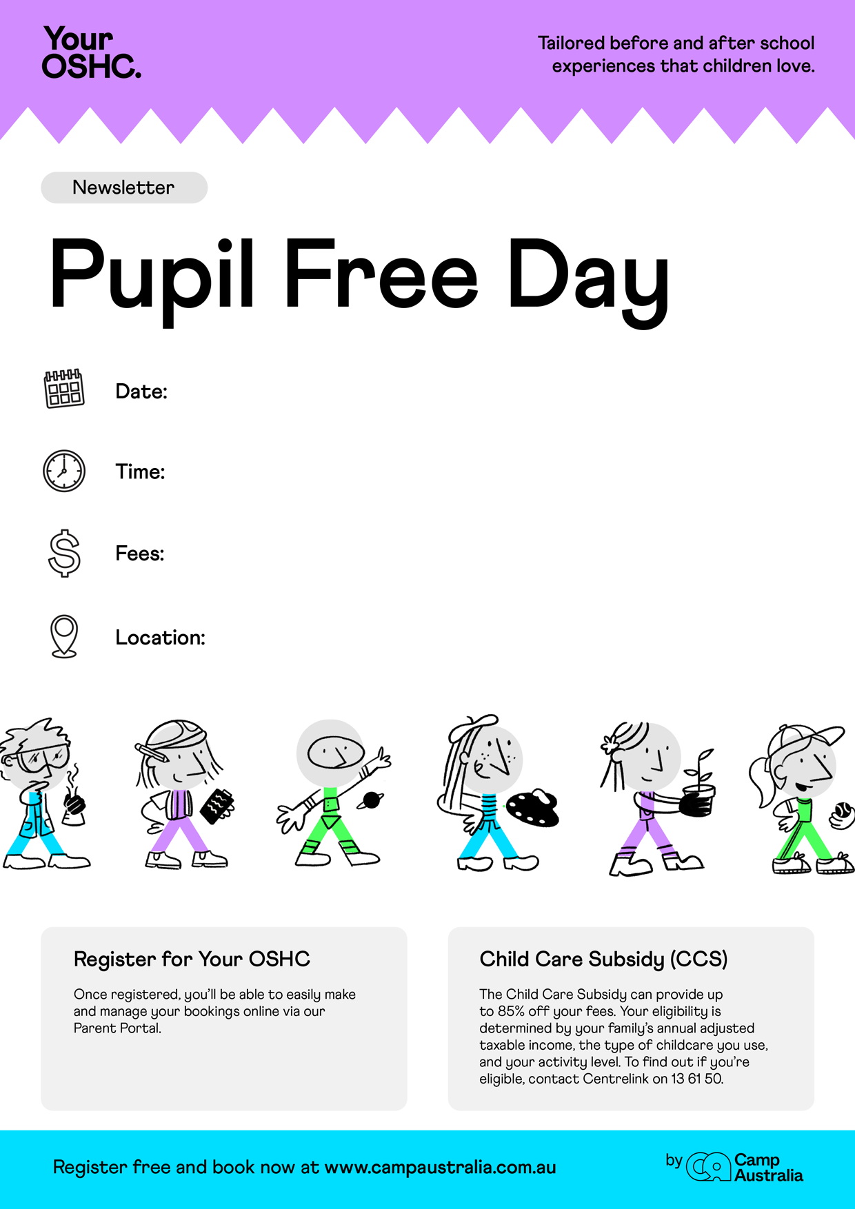[](https://pp.campaustralia.com.au/)[](https://www.campaustralia.com.au/)

6-45am to 6-30pm

1st June 2023 THURSDAY

6-45am to 6-30pm

$69-95

Camp Australia- Oatlands Primary School