Section 1 for Students and Families

Career News

Big changes are happening

UWA
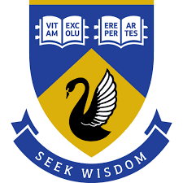
The University of WA has made a significant pivot and it now takes mature students based on their life experience, and it has introduced micro-credentials as a component of its entry pathways. The micro-credentials can be used to gain credits at UWA.
UWA’s client satisfaction survey results are improving and there seems to be a significant shift underway to a more diverse and supportive culture.

ECU
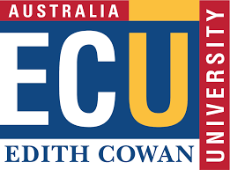
ECU is working up to its 2026 move to its city campus near Perth railway station.
WAAPA courses will move in there along with some business courses that WAAPA students can take to learn how to manage their own careers and creative enterprises.
- Teaching courses are going from Mt Lawley to Joondalup.
- Business and Law is now the biggest school at ECU, and it is getting international recognition.
- Medical and Health Sciences undertakes more high-level research than other school.

Curtin
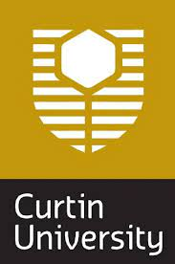
Curtin is planning to pivot its culture to build on the ethical leadership and heroic achievements of their namesake, Prime Minister John Curtin.
Curtin University already has a reputation for academic excellence. Embracing the values of John Curtin will add a new and excellent dimension to the culture of the university.

Partnerships
All universities are reaching out to schools as they compete with each other for future students. This is great for schools and for individual students who can take advantage of the opportunities that are emerging at a rapid pace.

ATAR students continue to succeed at uni
Uni students who have gained entry through ATAR continue to experience the most success, even doing two or three ATAR courses increases a student’s chance of success.
All universities are creating alternative pathways into degrees, and they are developing more support for students who are struggling.

Two Way TAFE Pathways
- More vocational courses now deliver credits into university courses:
  - VET enrolled nursing qualification leads into registered nursing,
  - Many IT courses lead from VET diplomas into degrees.
- As universities recognise experience, workers will be able to build their careers by undertaking higher qualifications throughout their careers.
- With so many VET courses currently being free, there is more transition from uni courses into VET ones where uni graduates seek technical skills to advance their careers.

Universities Accord
Bigger changes have been heralded by the launch of the remarkable Universities Accord which impacts all post school education, not just universities.
Our universities in WA seem to have anticipated many of the initiatives that are identified in the Accord and they have started to move in the recommended directions.
You can download a copy of the Accord HERE.

Labour Market Update from Jobs and Skills Australia
February data reflect a continued softening in labour market conditions, with key indicators from the survey remaining fairly flat over the month.
Recruitment Activity Up
Recruitment activity increased only slightly by 1 percentage point in February 2024, while recruitment difficulty fell by 1 percentage.
These findings are consistent with an easing in other indicators of labour demand, including a decrease in online vacancies over the year, a slowing in the pace of employment growth, and an uptick in the unemployment rate in recent months. That said, employers were optimistic about the future, with 26% of employers surveyed last month expecting to increase their staffing levels in the next three months.
Read the full Recruitment Insights Report now.

Women are paid about $18,000 less than men
The Workplace Gender Equality Agency has published its first report which shows that men get paid 19% more than women.
Men’s median annual base salary in 2022-23 of $79,613 compares to $68,071 for women.
When bonuses and overtime are added — common for high-paying jobs mostly held by men — the gap in total remuneration widens to $18,461.
While the Construction Industry has 31.8% gender pay gap, Finance and Professional industries also demonstrated significant pay gaps.
See a snapshot of the pay gaps HERE.

7 April WA Manufactured Trains Hit the Tracks
The first WA-made trains in more than 30 years will come into service on 7 April. (You can go in the draw for a free ticket for the inaugural trip HERE.)
There is a new METRONET Trades Training Centre in Midland. Because of the sheer size and scope of the industry, there is an abundance of opportunities available for people at every stage of their career across a variety of different organisational bodies.
Go to these pages for information on careers in
- Rail Construction
- Engineering trades
- Construction trades

4 – 12 April is Kickstart Festival Time
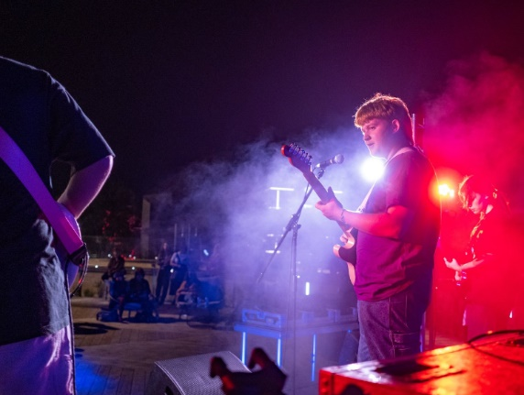
Young creatives will be performing at the Kickstart Festival during the school holidays.
The Albany Winter Wonderland Social brings high school aged students together on Friday 5 April to celebrate the talents of their fellow peers.

Paint My Precinct – Vic Park
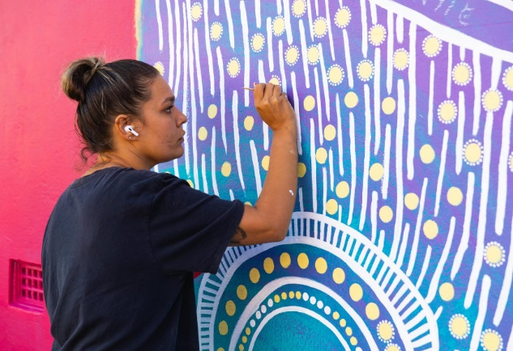
Young creatives are invited to grab their spray cans and stencils and learn the tricks of the trade from local mural hero FRANK the Artist.
This is part 1 of a 3 workshop series, run in partnership with the Town of Victoria Park.
Check out the full program HERE.

Workshop participants may also get to help shape design of a new mural artwork at Aqualife during May. This isn't just about learning cool spray techniques – it's about expressing yourself, collaborating with your community, and making a real difference.
8 April.
Get crafty with us at the first workshop session on Monday 8 April, 4:00 – 5:30 pm at Victoria Park Community Centre, East Victoria Park.

16 – 19 May Careers Expo
This careers event attracts:
- local and national universities,
- vocational and professional training providers,
- Jobs & Skills Centres
- industry associations and
- employers.
Careers Expo 2024 will be at the Perth Convention and Exhibition Centre .
Check details HERE.

Filmbites Screen Academy for 7 – 18 year olds

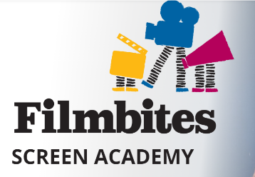
Filmbites teaches:
- Acting
- Film-making
- Animation
- Game Design
To West Australians aged 7 – 19. There are beginners’ classes and advanced classes which run after school, on weekends and on school holidays.
They are booking now for Term 2. Check it out HERE.

WAAPA EXPLORE Music Short Courses 2024
Whether you’re a singer or instrumentalist, a classical musician or contemporary musician, WAAPA’s acclaimed staff present a range of free workshops to help you prepare for your WACE exams, WAAPA audition, master your instrument, or just have fun. Places are limited so book now!
Available Courses:
- Classical FastTrack 1.0 – Sun 21 April
- Sax Festival / Massed Sax Day 1 – Sat 25 May
- Sax Festival / Massed Sax Day 2 – Sun 26 May
- Percussion Pandemonium – Sun 9 June
- Jazz Workshop 2024 – Sat 13 July
- Classical FastTRACK 2.0 – Sun 21 July & Sat 10 August
- Amy Beach’s Gaelic Symphony Revealed – Sat 17 August

University Events

University Open Day Calendar 2024
23 March |  | Murdoch University
24 March |  | Curtin Open Day
14 April Joondalup  21 April South West  28 April Mt Lawley | 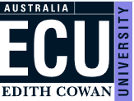  Edith Cowan
4 May |  | Notre Dame

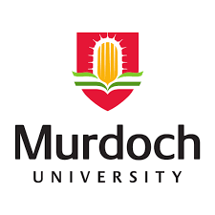
23 March Murdoch Open Day
Open Day is the perfect opportunity to explore your future and find out more about all that we offer here at Murdoch University. You can explore our campus, chat with academics and graduates, meet our student ambassadors and find the course you’re passionate about.

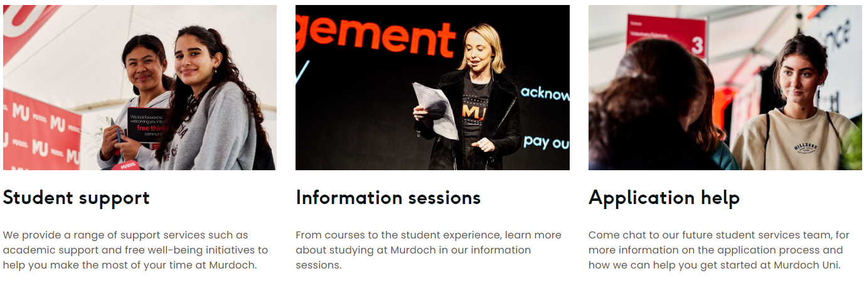Find details HERE.
24 March Curtin Open Day
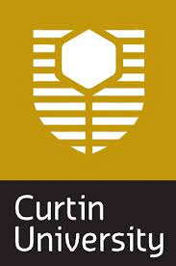
There is so much on at the Curtin Open Day that their new day planner is practical and helpful.
Middle School Highlights
- Find your perfect job at the career wheel.
- Go to the Year 9 and 10 student and parent info session

Senior School Highlights
- If you are in Year 12, go to the Financial Planning Booth
- Check your Global study passport competition.
- Book into Year 11 and 12 Student and Parent info sessions.
- Book into presentations and join some of the hands-on activities.

Find details HERE.

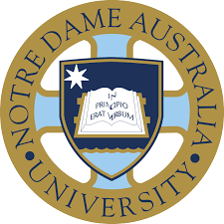
3 April Notre Dame Bachelor of Biomedical Science and Doctor of Medicine – Assured Pathway
Do you aspire to be a doctor? Join our School of Medicine to learn everything you need to know about our Assured Pathway to Medicine. The session is designed for year 11 and year 12 students from all around the world.
Date: Wednesday 3 April 2024
Time:12 noon: Webinar via Zoom
For more information, please email the International Office at international@nd.edu.au.

3 April Murdoch Year 11 & 12 Exploration Day
This FREE event will allow you to explore all Murdoch has to offer.
Immerse yourself on our campus and meet our friendly staff and current students, while taking part in interactive workshops specific to your area of interest and explore our unique facilities!
Registrations are essential. You can register HERE.

5 May Notre Dame Open Day
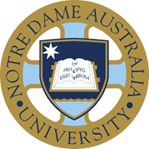
Notre Dame allows you to identify what information you are looking for and I guess they will customise your Open Day experience for you.
You can find details HERE.

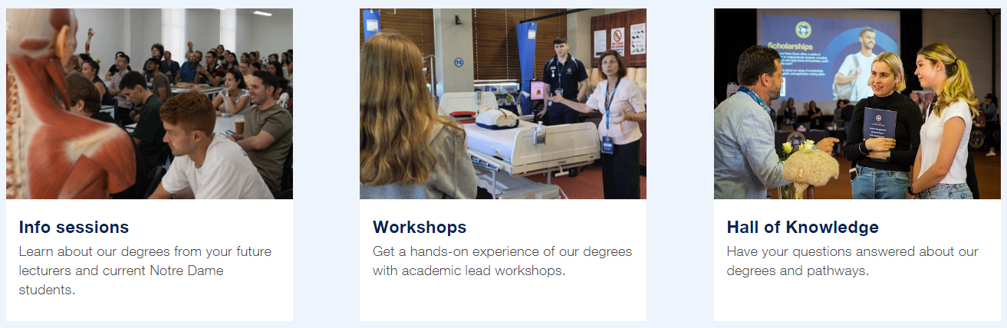

ECU Open Days
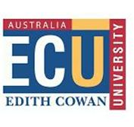
ECU has three open days.
The Mt Lawley one includes information about WAAPA
- 14 April Joondalup
- 21 April Bunbury
- 24 April Mt Lawley
.
Find more HERE.

24 April ECU Year 11 and 12 Engineering Showcase
We are pleased to invite you to attend our upcoming School of Engineering courses and careers information session so you can discover why engineering is such a great profession and how ECU can provide you with an excellent start to a highly rewarding career.
5pm – 7pm Joondalup Campus
Register HERE.

5 May WAAPA Production Tour
ECU's Western Australian Academy of Performing Arts (WAAPA) is one of the world's leading performing arts academies and we're giving you the opportunity to explore our state-of-the-art production and design facilities.
6 – 7.30pm Mt Lawley Campus
Register HERE.

9 May Notre Dame Doctor of Medicine information Session Online
Join us for an online information session designed to provide you with crucial insights into Notre Dame's Doctor of Medicine program. This webinar offers a unique opportunity to delve into the program's structure, entry pathways, and exciting new developments.
Date: Thursday, May 9, 2024
Time: 4:00PM - 5:00PM (AWST)
Register HERE.

9 May ECU Year 11 and 12 Parent Information Session
For parents of students in year 11 and 12, navigating the conversations about life after high school can be daunting. ECU's online information session is designed to alleviate your concerns and provide all the information you need to guide them through Year 11 and 12 and beyond. Register HERE.

University News

Early Offers not made until 2 September
All WA universities will be open applications for 2025 on 1 May.
The first offers will not be made until 2 September. This is a significant change which brings our procedures into line with a consistent cross jurisdictional approach.
More information can be found HERE.

UWA News from Career Advisors’ Event

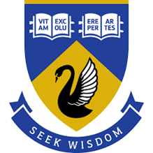
UWA is changing
In 2023 UWA piloted the UWA + Starter Program in which students can complete micro-credentials while still at school. By completing 3 micro-credentials, students can get credit towards a degree.
Find details HERE.
- UWA+ Starter
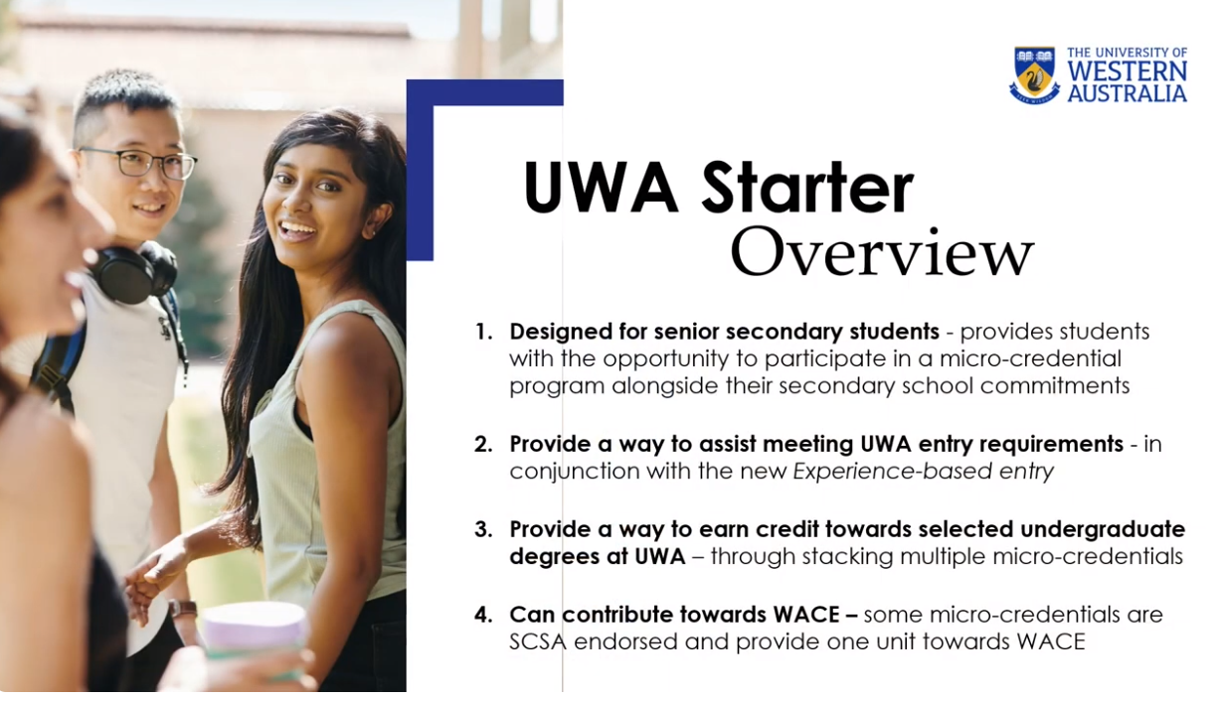
Term 2: 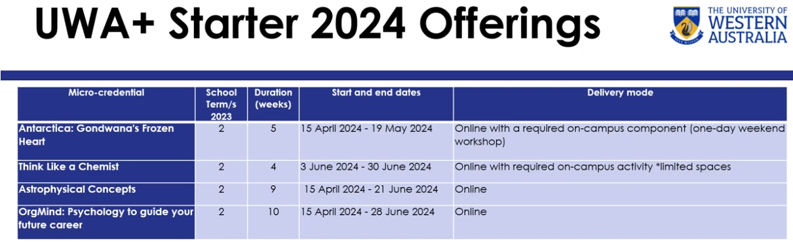

Term 3 Enrolments Open 15 April
  - Microcredentials available in term 3 will be available on 15 April. Enrolments are due by 14 June.
  - Term 4 microcredentials will be available on 15 July. Enrolments are due 6 September.
In the future they are going to start allowing students to enrol directly, rather than through the school. Visit www.uwa.edu.au/study.UWA-Strarter for details.
UWA provided these videos outlining changes and opportunities that are now available. Admissions
Number of students coming through Experienced Based Entry has virtually doubled in 2024.
70% of those are school leavers
- Courses and Pathways
- Internships/ McCusker Centre for Citizenship Internship
- Wellbeing and Engagement

Unis are working harder to ensure engagement and wellbeing of students given the changing cohort that they are working to attract.

Information from ECU Career Advisors Day

ECU Outstanding student satisfaction
We are used to ECU achieving outstanding graduate outcomes results from QILT and from the Good Universities Guide. This year ECU told us about their outstanding longitudinal results which measure outcomes 3 years after graduation.
- 93% were in full time employment, which is higher than all other WA universities.
- They earn more with a median full-time salary of $86,900.
- 71.8% are in professional or managerial positions
- The highest paying jobs were in computing and information systems, engineering, health services, teacher education and nursing.

The 2023 Good Universities Guide gave ECU five stars in overall Experience, Student Support, Skills Development, Learning Resources and Teaching Quality.

The School of Business and Law is now the biggest school at ECU and they proudly talked of their international and national status and achievements, including its ranking in the top 6% of the prestigious AACSB rankings.
Their efforts must be a significant contributor to the outstanding ECU student satisfaction results.

New ECU Courses

Education
They have the “new” one year Graduate Diploma in Teaching for both Primary and Secondary teachers. It leads to the second year in the Master of Teaching:
- Master of Teaching (Early Childhood)
- Master of Teaching (Primary)
- Master of Teaching (Secondary)

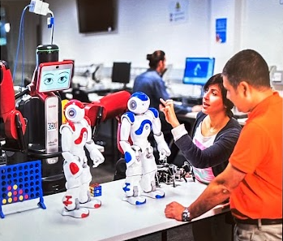
Engineering
- Bachelor of Engineering (Energy) Honours.
- Bachelor of Engineering (Robotics and Autonomous Systems) Honours

Students who achiever 94 or above in their ATAR can be awarded a $20,000 Engineering scholarship. There are 5 available per high school in WA.
Also check the Sir Frank Ledger Scholarship
Medical
This is the strongest research school at ECU.
- Bachelor of Preclinical Foundations of Imaging Science (3 years)
- Graduate Diploma of Medical Sonography. (1 year)

Arts & Humanities – new in 2025
- Bachelor of Communication
- Bachelor of Creative Writing
- Bachelor of Design
- Bachelor of Journalism and Broadcast Media
- Bachelor of Screen Production
- Bachelor of Visual Arts

Paid Professional Social Work Placements
Course practicum requirements are frequently a barrier to students who must stop their work to attend non paid on site learning experiences. ECU has arranged for field placement students to be paid.
Make enquiries HERE.

Medical and Health Science Career Categories
The Medical and Health Science School has identified these five personas that match people to medical careers.
To do the Career Finder Quiz go HERE and identify Health as your preferred industry

Most popular university courses in WA 2024
TISC has collated application statistics which analyze the final applications, offers and enrolment data for 2023 Admission
The most popular courses in WA
The Tertiary Institutions Service Centre (TISC) processed over 28,000 applications to WA’s five universities this year. Here were the 10 courses that received the most applications for 2024:
University | Course | Applications
UWA | Doctor of Dental Medicine via Bachelor of Biomedicine (Specialised) | 2,284
Curtin | Bachelor of Medicine, Bachelor of Surgery | 1,667
Curtin | Bachelor of Commerce | 1,118
Curtin | Bachelor of Engineering (Honours) | 1,102
UWA | Bachelor of Commerce | 1,063
UWA | Bachelor of Engineering (Honours) | 1,043
UWA | Bachelor of Science | 1,025
UWA | Bachelor of Biomedical Science | 922
Curtin | Bachelor of Science (Nursing) | 890
Curtin | Bachelor of Biomedical Sciences | 852

You can discover information about how many students applied for all university courses in 2024 HERE.

Training News

Applications for 2024 Training Awards opened on 1 March.
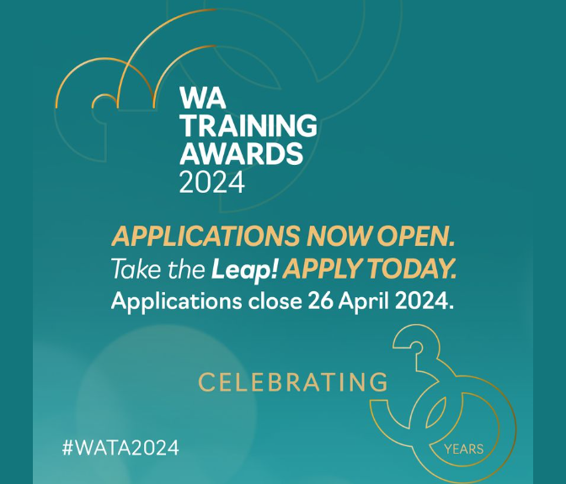
With the boom in vocational training in Western Australia over the past few years, there will be stiff competition this year.
School students are traditionally interested in the School-based Apprentice of the Year.
This award is for students undertaking a Certificate II or above through a school based apprenticeship or traineeship.
There are seven individual categories.
- WA Apprentice of the Year
- WA School-based Apprentice of the Year
- WA Trainee of the Year
- WA Vocational Student of the Year
- WA Aboriginal and Torres Strait Islander Student of the Year
- WA Cultural Diversity Training Award
- WA International Student of the Year.
You can check them out HERE.
Check out What to expect on Judging Day.

WorldSkills WA Competitors
Congratulations to these West Australians who have won positions in the Australian WorldSkills Team that is competing in the French city of Lyon in September.
The 47th International Competition is set to be the biggest skills competition ever, with over 1,500 Competitors from 75 countries set to compete in 59 skills. More than 250,000 visitors are also expected to attend the event, which will run from September 10th to 15th.
Skill | Competitor
Wall and Floor Tiling | Jacob Dixon
Painting and Decorating | Antoinette Jackson
Cabinet Making | Lewis Italiano
Jewellery | Mitchell Rigney
Cyber Security Team | Kai Baharthah- King  Lachlan Gelavis

Good luck to all competitors and our special good wishes go to the West Australian representatives.

Australian Apprenticeships and Traineeships Information Service
The Australian Apprenticeships and Traineeships Information Service (AATIS) offers pathways information to students, job hunters, career advisers and employers. Our website, app and resources are used by schools, parents, friends and supporters providing career planning and direction.
Find them HERE.

Senior School Opportunities

28 March Registrations Close Years 9 – 12 ECU Engineering Experiences

April 3,4 & 5 program
The Creating Real Engineering and Technology Experiences (CREATE) program is designed by ECU Engineering staff for Years 9 – 12 students.
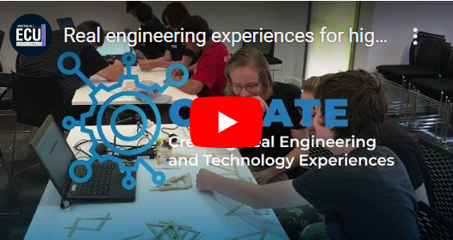
Activities span key engineering disciplines including Mechanical, Electrical, Civil, Chemical, Electronics, Mechatronics, Automation and Control, Instrumentation, Robotics and Data Processing. Mathematics, of course, underpins study within all engineering disciplines and is a key focus for the program.
Find details and register HERE.

31 March 2024: Applications Close for Rotary Youth Exchange 2025
Rotary Youth Exchange students spend 12 months in a foreign country with board and accommodation provided by host families.
Students:
- make lifelong friends,
- expand their world views and
- have a brilliant time.
Students must be between the ages of 15 and 18 on the 1 January of the year of their exchange.
Contact Rotary Youth Exchange Western Australia for details on how to apply.

3, 4 and 5 April ECU STEM One Day Workshop
Year 9, 10, 11 & 12 students are invited to a One Day STEM Workshop where students can explore activities focused on Science, Technology, Engineering & Mathematics! Register here: trybooking.com/CPLKN

Defence Force Work Experience
Defence Work Experience Program provides young Australians interested in Defence as a future career, the opportunity to sample life in Defence and learn more about the Australian Defence Force (ADF) and the Australian Public Service (APS).
The Defence Work Experience Program is pleased to advise that Defence is offering opportunities for work experience activities. We encourage you to check our website regularly.
Day in the life of a Soldier: Irwin Barracks - May Job Ref - WEP/00474/24
- Army
- Irwin Barracks
- 16 May 2024
Closing Date: 31-Mar-2024
An Aerial View: Air Force Careers Day RAAF Base Pearce - May Job Ref - WEP/00726/24
- Air Force
- RAAF Base Pearce
- 21 May 2024
Closing Date: 14-Apr-2024

Apply now for Curtin Focus on Mining 2024 for July
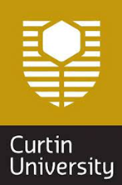
The Focus on Mining Camps are five-day residential camps for high school students to experience what it’s like to study and work in the mining industry in WA. Students will get to tour mine sites, participate in hands-on workshops and meet industry leaders. The program targets students in Year 11 or 12 who have an interest in science or engineering and who would like an introduction to the mining and resources sector.
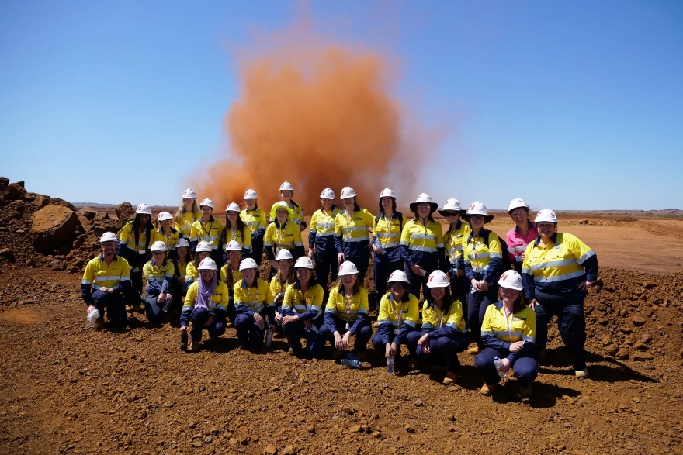
The camp is free with all travel, meals and accommodation provided.
Five-day residential camp – July
Dates: 1-5 July 2024
Duration: Five-day residential camp
Who: Year 11 & 12 STEM students
Location: Perth – Kalgoorlie – Perth
Cost: Free
Apply for July here

Projects Abroad
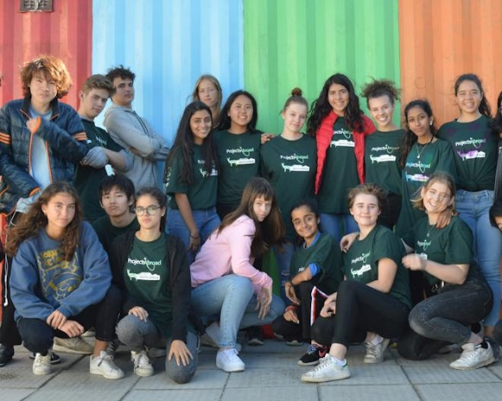
If you are aged 15 to 18 and looking for an unforgettable overseas experience, explore Projects Abroad High School Specials: tailor-made volunteer programmes.
As a teen volunteer abroad, you'll have the opportunity to travel, make a difference, and connect with peers from around the world.
Join other teen volunteers as you embark on a structured itinerary filled with meaningful projects, cultural activities, and excursions.
Find more details HERE.

Year 12 Opportunities

University Clinical Aptitude Test 2024 Registrations are open
There are now three pathways into medicine in WA that require you to do the UCAT test.
- medicine at Curtin
- UWA Assured Pathway to Medicine and Dentistry
- Notre Dame Assured Pathway
To be offered a place in any of these three pathways you need:
- amazing ATAR scores,
- a great UCAT score and
- have an interview or do the CASPER test.
The UCAT testing begins on 1 July and runs through to 9 August.
You can register here,
UCAT BOOKING OPENED via ucat.edu.au | 5-Mar-2024
Concession application deadline | 10-May-2024
Access Arrangements application deadline | 17-May-2024
BOOKING DEADLINE | 17-May-2024
Late UCAT booking deadline | 31-May-2024
Late Access Arrangements application deadline | 31-May-2024
FINAL late booking deadline | 5-Jun-2024
Cancellation deadline | 10-Jun-2024
Testing begins | 1-Jul-2024
Last testing date | 9-Aug-2024
Results delivered to universities | By early September 2024
You can see key dates HERE.
Practice Tests
There are many hints and practice tests on the UCAT page.
Check AI for tips
I asked ChatGPT “what could I do to improve my UCAT score” and it gave 6 good suggestions which I think would improve my result.
Paying for UCAT preparation courses
I get bombarded with ads from companies that want me to promote their UCAT preparation courses. I have been to information sessions at UWA and at Churchlands High School where we were advised that the tests on the UCAT site are more than adequate and not to bother with the paid preparation courses.
Regional candidates for medicine
Curtin University provides significant support to RRR students who want to apply for medicine. If you live in a regional area check So you want to be in a doctor, but you live in the bush.

UWA Fogarty Scholarship applications closing soon

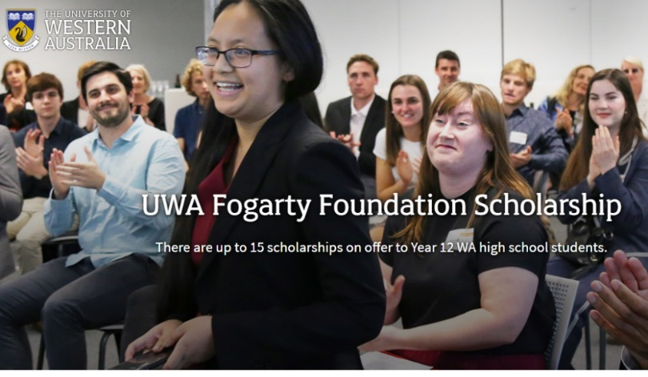
The UWA Fogarty Foundation Scholarship Program is one of Australia’s premier scholarship programs. It is a joint venture between the Fogarty Foundation and the University of Western Australia, investing in the future leaders of Western Australia.
There are up to 15 scholarships on offer for Year 12 high school students from WA.
Each scholarship is valued at $10,000 per annum.
Applications close on 30 May 2023

Thinking of Studying Overseas?
There is a group called Crimson Education that many students use to support their applications to overseas universities.

They have extensive networks in the USA, UK and European countries, and support students to apply for mainstream courses and for specialist courses.
I haven’t used them so have no idea how good they are, I just know that lots of West Australian students use them.
Find more information HERE.

Have Defence Pay For Your Degree
The ADF can pay students a salary and benefits while they study at university.
- Aviation.
- Engineering.
- Software engineering.
- Systems engineering.
- Information technology.
- Cybersecurity.
- Space studies.
- Data science.
Find details HERE.

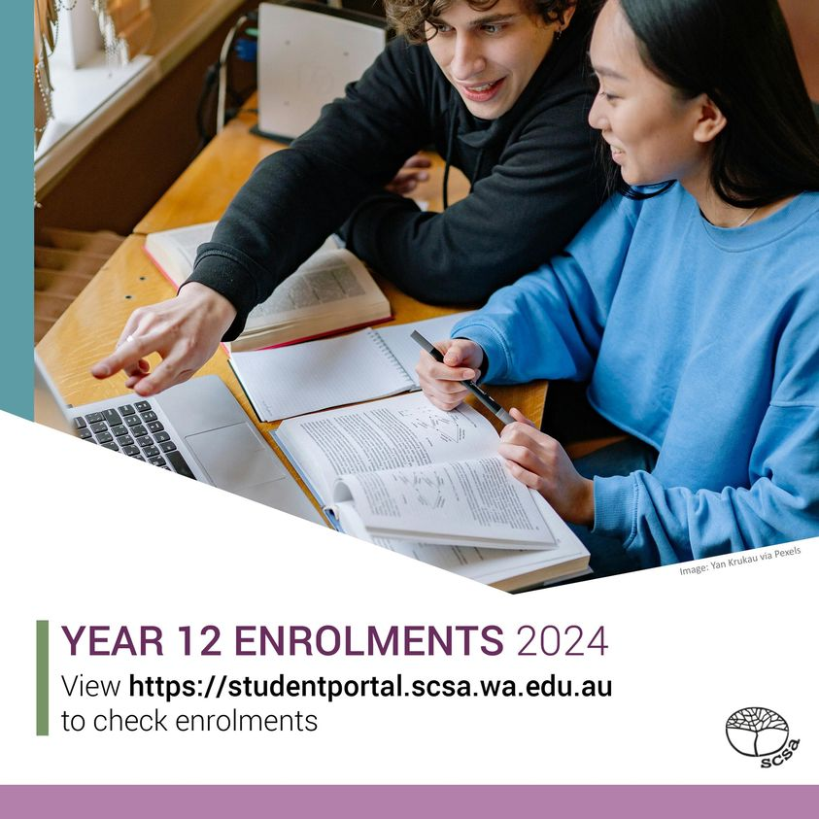
Are you enrolled properly?
The Year 12 Enrolments 2024 blog on the School Curriculum and Standards Authority website at www.scsa.wa.edu.au gives detailed information on how to check your enrolments and ensure that you have provided all the information needed for your ATAR, General, Foundation, Preliminary and VET courses.
. Check HERE.

Download the WACE Manual 2024

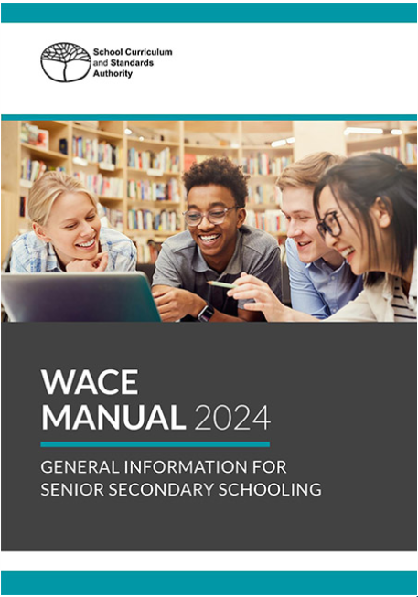
The WACE Manual 2024 is for students in Years 11 and 12 in 2024.
It describes what you need to do to achieve your WACE in 2024.
Go through it with your form/home room teacher or career advisor to make sure you are meeting all requirements to get your WACE.
Download it HERE.

Year 11 Opportunities

Register now for Curtin Girls + Engineering Tomorrow
Runs Terms 2 & 3.
Register now for Girls Engineering Tomorrow
The program will offer an opportunity to:
- Receive study support.
- Meet inspiring women in engineering.
- Connect with our university GET Student Mentors
- Participate in a range of engineering-themed activities and workshops.
- Learn about engineering courses and careers.
Register HERE

Year 10 Opportunities

Year 10 Subject Selections for University 2027
If you're in Year 10, the TISC University Admission 2027 will be available in Term 2 to help you to choose senior secondary courses that meet university recommended and required entry requirements.
TISC collates information across all West Australian universities. You can find the latest information now by checking the universities of your choice.

Keep Your Options Open by selecting maths
If you think you might like to go to uni, make sure you take Mathematics: Methods ATAR, Mathematics Specialist ATAR or Mathematics Applications ATAR.
Check the Curtin Course Guide for current information but you will get into most uni courses with one of these.

Curtin Year 10 Course Guide
Each university puts out course guides.
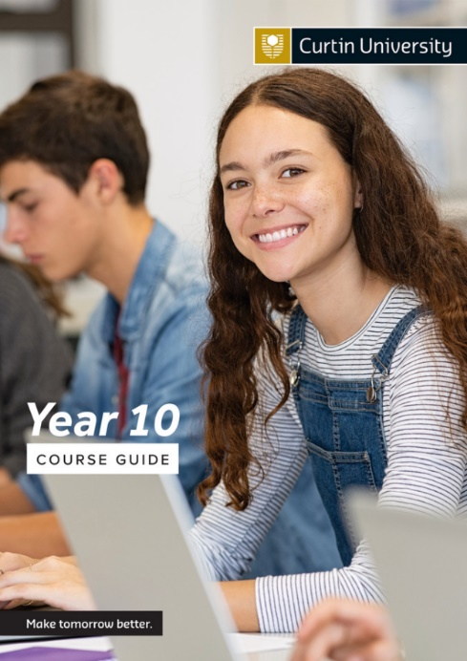
The Curtin University Year 10 Course Guide includes:
- Tips on how to choose your study pathway.
- Information about uni life.
- Details about ATAR, Portfolio and other pathways to Curtin.
- Scholarship information
- Information about double degrees
You can download a copy HERE.

You can check out the video at Choosing subjects for year 11 and 12.
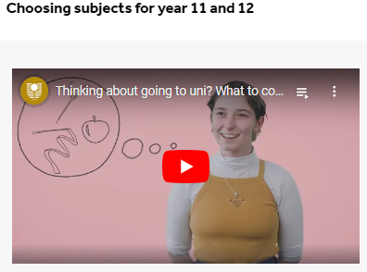
Curtin also provides these links to jump to the section you’re looking for.
- Choosing your course
- Exam tips and tools
- How to apply
- Scholarships and finance
- Common questions
- Before you start uni

Engineering at Curtin
Curtin has a lot of prerequisites for Engineering (Honours).
- Mathematics Methods ATAR and at least one of the following: Physics ATAR, Chemistry ATAR, Engineering Studies ATAR.
- Desirable WACE subjects: Mathematics Specialist ATAR.

Chemistry is a prerequisite for Medicine at Curtin
If you think you might like a career in medicine and want to try for a place at Curtin Medical School, you will need to have Chemistry ATAR and Mathematics: Methods ATAR, Mathematics Specialist ATAR or Mathematics Applications ATAR.
UWA also recommends that you take Chemistry and Maths Applications, but they are not essential prerequisites.

STAT – Your alternative route to tertiary courses – Applications open 7 May
The Skills for Tertiary Admission Test is available as an alternative entry pathway to university for students who are at least 20 years of age before 1 March in the year of entry to university.(That is, you are currently 19 or over.)
Registrations for STAT for entry to Australian universities open 7 May and close 14 May.
You can find details and practice tests HERE.

Middle School Opportunities

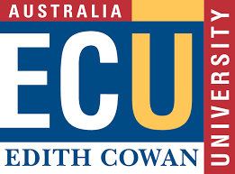
3 April Experience ECU for Years 9 & 10
Experience ECU is a one day program of hands-on discovery workshops and activities across the ECU schools of: Engineering, Science, Medical & Health Sciences and Business & Law.
Discover what it’s like to study at Edith Cowan University. You’ll also be able to explore our campus, meet staff, ask questions of our current students and find out about our courses.
There will be 3 more programs offered in July.
Find details HERE.

Girls + Engineering Tomorrow Forum @ Curtin Years 9 & 10
A forum for Year 9 and 10 girls and their teachers to explore engineering through hands-on workshops, information on engineering pathways, and a Q&A with engineering role models.
Register now for this one-day forum in Term 4 for Year 9 and 10 girls and their teachers to explore the world of engineering. Find information HERE.

Girls in 7 – 9 Curtin STEM Workshops – Register Interest Now
Inspire STEM is a program combining engaging hands-on workshops and mentoring to introduce students to the world of STEM. Students will explore a range of STEM areas, hear from experts and learn about STEM study and career pathways.
This program is free, and sessions are held after school in Terms 2 & 3 at Curtin University, Bentley.
You can register your interest HERE.

WA Academy of Performing Arts – Junior Academy for Secondary Students
The WAAPA Junior Academy is designed specifically for young people who have a passion for performing.

Junior Academy courses
- Acting and Performance Making - School Years 7 to 12
- Music Theatre - School Years 7 to 12
- Tell Your Story - (For CALD Students)

For Term 2 courses check HERE.

Primary School

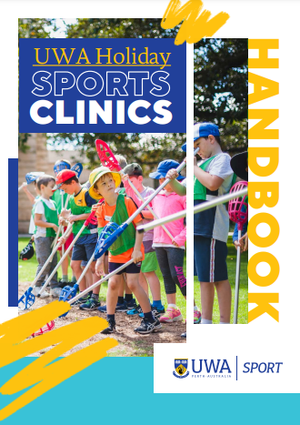
2 April – 12 April Explore new sports at UWA
This is promoted as being for people ages 6 – 17 but the photos are all of primary school aged kids.
These are half day sessions, in either the morning (8.45am-12noon) or the afternoon (12.45 – 4pm). They help participants to develop skills across a range of sports. One photo in the Handbook shows a student doing fencing.
These sessions are not free and are NOT eligible for Child Care or KidSport subsidies.
Get details HERE.

Little Ripples
This resource provides parents with activities and games that they can do at home with their children. Activities are designed to broaden the child’s awareness of career opportunities that are available.
You can find Little Ripples HERE.

Regional Opportunities

Renewable Energy Battery for Collie
Collie is to get a massive new battery that will take advantage of the existing electricity grid that was initially built as part of the coal generation industry.
It is anticipated that the new facility will provide long term jobs in renewable energy for people in the South West.

Aboriginal and Torres Strait Islander Opportunities

Apply now for Indigenous Australian Engineering School 2024

The Indigenous Australian Engineering School (IAES) is a week-long residential camp introducing students to engineering studies and careers. Students will do site visits, meet industry representatives and participate in educational activities. The program targets Indigenous students in Year 9, 10, 11 and 12 with an interest and aptitude towards engineering, science and mathematics.
For more information go HERE.
Dates: 30 June – 6 July 2024
Duration: six-day residential camp
Who: Indigenous students in Years 9 – 12
Location: Perth
Cost: Free
Find details HERE.

Broome, Kalgoorlie and Moora Drive to the Future
The PCYC Drive to the Future Program ensures that more young drivers are safe and qualified to drive.
In addition, by providing quality instruction and guidance to novice drivers, the program aims to improve overall community safety.
Find details HERE.

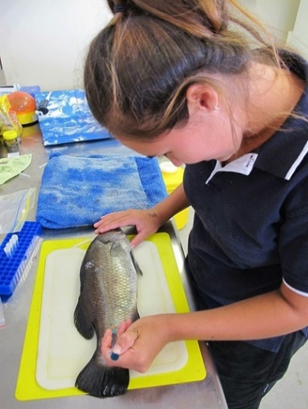
CSIRO Traineeships
CSIRO's Indigenous Engagement Strategy seeks to increase the employment of Australian Aboriginal and Torres Strait Islander peoples within our organisation.

Students with Disability Opportunities

27 March Accessibility in Office 365
Wed 27 Mar 2024 1:00 pm – 2:30 pm AEDT
Andrew Balzer from Microsoft shows how to make your Office 365 more inclusive and accessible in this 1.5-hour webinar.
You will see a live demo of the easy-to-use tools that are built into the Microsoft Office suite, such as the Accessibility Checker and Learning Tools. You will also discover how to create and access content for people with different abilities and preferences, using features like Be my eyes, Office Lens, and Ease of Access settings.
Further information and registration details for the ADCET Webinar: Accessibility in Office 365 - Inclusive isn’t elusive

Disability and Indigenous Peoples' Education Fund
The Australian Disability and Indigenous Peoples’ Education Fund is open for applications. This education fund is about helping people complete or undertake courses and programs through six monthly grants of up to $2,500.
Australians with disabilities of any age may apply for any assistance to help with their education.
Deadline for applications: March 31st Find details HERE.

Curtin AccessAbility Newsletter
The newsletter includes information about:
- Scholarships and grants
- What’s happening on campus?
- Research projects and studies.
- Reminder of the deadline for equity exams
- Seminars and workshops.
To register for the newsletter, go HERE.

Individual Access Plans at Curtin
Curtin’s Assess Plan outlies the reasonable adjustments recommended for students with a disability/medical condition. Potential students who have a disability should contact Curtin early so that there is plenty of time to design the perfect plan for entry to a uni course. Find out more HERE.

Support for Young Carers
There are over 40,000 young people in WA who have a sibling, parent or family member with disability, physical or mental health challenges – they are called ‘young carers’. It is important to recognise that young carers take on extra practical and emotional responsibilities that other young people don’t have to.
The support that young carers provide does not go unnoticed. There is free support and a team dedicated to helping young carers thrive and reach their individual goals.
Find out more HERE.

International Student Opportunities

3 April Bachelor of Biomedical Science and Doctor of Medicine – Assured Pathway
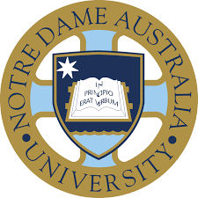
Do you aspire to be a doctor? Join our School of Medicine to learn everything you need to know about our Assured Pathway to Medicine. The session is designed for year 11 and year 12 students from all around the world.
Date: Wednesday 3 April 2024
Time: 3:00 PM - 3:45 PM (UTC+08:00) Perth time [Change Time Zone]
Venue: Webinar via Zoom
For more information, please email the International Office at international@nd.edu.au.
Register HERE.

17 April Discover Physiotherapy at Notre Dame
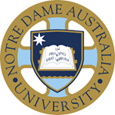
Webinar for future international students
Do you wish to practice as a physiotherapist? You’ll learn about the different undergraduate and postgraduate physiotherapy programs offered in Notre Dame Australia, internships, support offered, study load, and scholarships from staff and students in the School of Health Science and have your questions about the University of Notre Dame answered.
Date: Wednesday 17 April 2024
Time: 12 noon
Venue: Webinar - Zoom link will be provided upon registration
For more information, please email the International Office at international@nd.edu.au.

18 April International Student Expo 2024
What can you find at the Study Expo?
- Universities, TAFEs and Private Colleges
- Free and Personalised Visa/PR Advice**
- Explore Great Tips to Land a Job
- Application Fee Waived*
- Up to 50% Scholarship Available*
12 noon to 6pm Tree by Hilton, Northbridge
Get tickets HERE.

30 April Nursing at Notre Dame Australia
Webinar for future international students
Are you seeking a rewarding career in nursing? The University of Notre Dame Australia’s Bachelor of Nursing degree is highly regarded and is the foundation of a career in nursing. You’ll learn about the program, internships, support offered, study load, and scholarships from the staff and students in the School of Nursing and have your questions about the University of Notre Dame answered.
Date: Tuesday 30 April 2024
Time: 12 Noon
For more information, please email the International Office at international@nd.edu.au.
Register HERE.

Study Perth Student Hub
There is a dedicated space for international students in the heart of Perth.
It is open seven days a week and offers free amenities, study spaces, technology resources, and recreational activities.
Perth’s international students can meet with other students at the StudyPerth Student Hub.at 555 Wellington St Perth. Find out more HERE.

