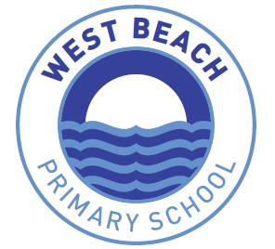 Parent/Teacher Interviews
Parent / Teacher interviews are scheduled to be held in weeks 9 and 10 of this term. This is a key component of our reporting process and a valuable opportunity for parents to meet with teachers and discuss their child’s progress. This partnership between school and home is crucial and we encourage ALL parents to participate in this important meeting. If for any reason you are unable to attend a meeting during the times which are available you are asked to contact your child’s teacher who will be keen to arrange an alternative time to meet.
Once again this year, West Beach Primary School is using an online parent interview booking system which will enable parents to book interview times and receive instant email confirmation of their booking. To book a parent/teacher interview simply follow the steps listed below:
- visit https://www.schoolinterviews.com.au/code?z=HuK0r6
- login using the code:
274aj
3. Follow the on screen instructions
The online portal is now open. If you do not have internet access or you would like assistance in making a booking please call the front desk, who will make an online booking on your behalf.

Matthew Mulree
Deputy Principal

