Allied Health News
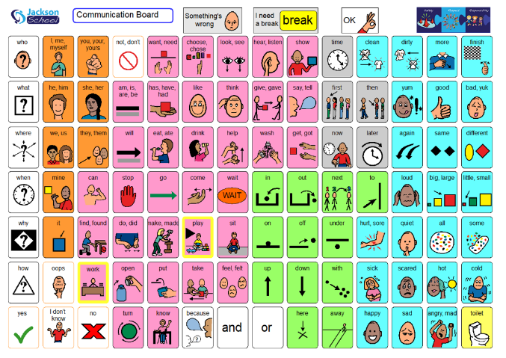
Words of the Week
Words of the Week are: work and play.

You can find the Communication Board here

Holiday Craft
Making cards and decorations provides lots of opportunities to develop fine motor skills such as cutting, pasting and drawing. Here are some of our favourite activities to celebrate the holidays and build skills whilst having fun.

Fingerprint Activities support finger isolation and motor planning.
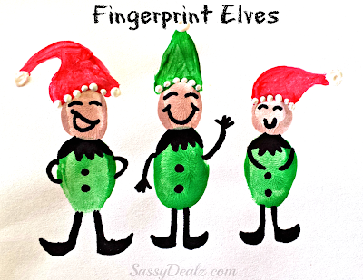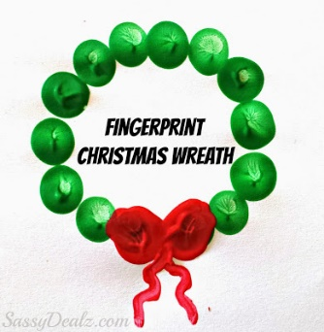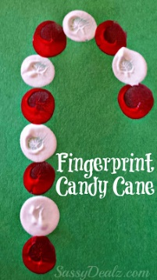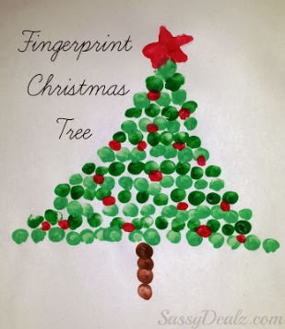

Drawing around hands and cutting them out builds bilateral coordination, hand dominance and scissor skills!
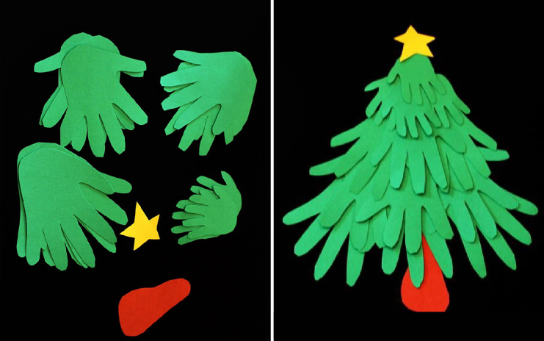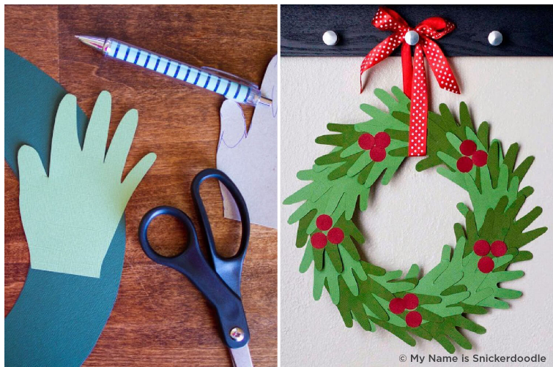

Holiday baking supports planning skills, following instructions, hand strength and most of all is delicious!
