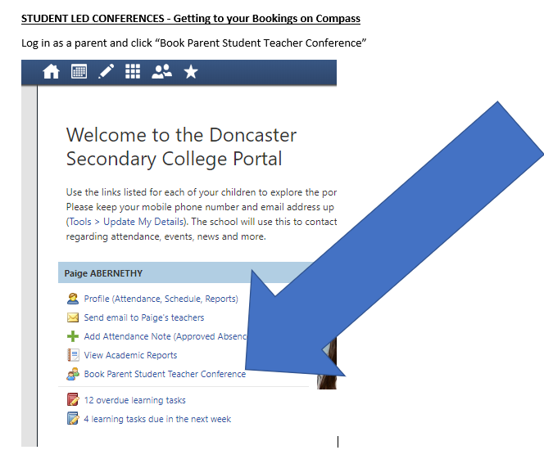

Once you are in you can click on a teacher on the right and you will see a screen like the one below. The white sections show when the teacher is free. If it is all greyed out then the teacher is booked out for the day.

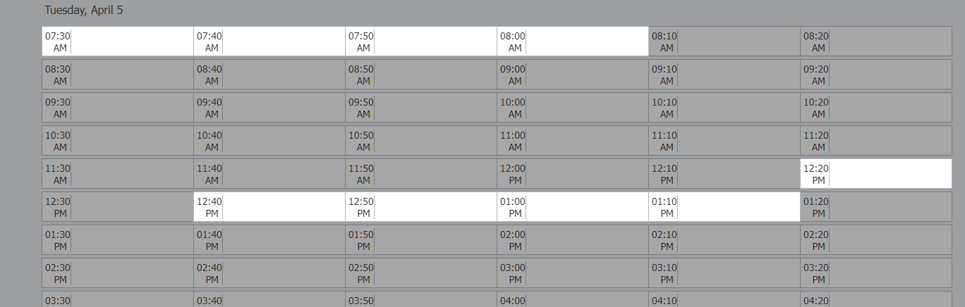

**Do you need an interpreter?**

You can book Chinese and Persian interpreters when you make teacher bookings on Compass. If other interpreters are required, please contact the college. Please make booking as early as possible to allow us time to organise interpreter.

**On the day:**

The SLCs are taking place on March 26th between 7:30am-8pm. It is happening OFF-SITE via MS Teams. Refer to the MS Teams MEET links. This will be shared with families soon.

**Teacher all booked?**

Sometimes this happens, apologies. Teachers cannot make a time to meet with you on an alternative day. However, we encourage you to look over Learning Tasks on Compass, the Progress Reports and the Semester Report to support your understanding of how your child is progressing in their subjects. If you reach out to teachers via email, they will be able to respond to queries about your child’s learning, as soon as they are able.