THE MARKET

As I strolled through the market I heard parent’s chit chatting and kids yelling at their parents for stuff. As I strolled into an aisle I smell hot jam doughnuts and fruits. I see people selling toys books fidgets keychains and clothes but the seller said not touch so I move on I buy roast potato chips and a wrap

The market is fantastic

CAMPING

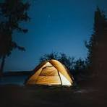I can hear possums rattling hard wood trees. I can see flames coming out of the fire. and smoke went into the sky and see a snake hissing at me and sand crushing with fishing rod bells going off at Night And tents everywhere and thousand stars and dogs barking and music playing sausages Sizzling marshmallows roasting and making s’mores And finding wood to put in the fire and saying jokes around the fire and dancing around the fire