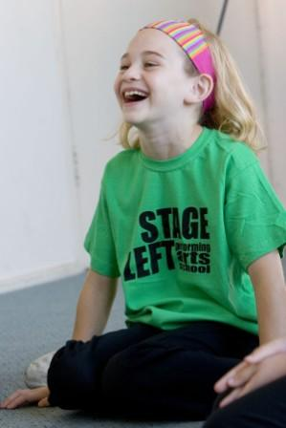
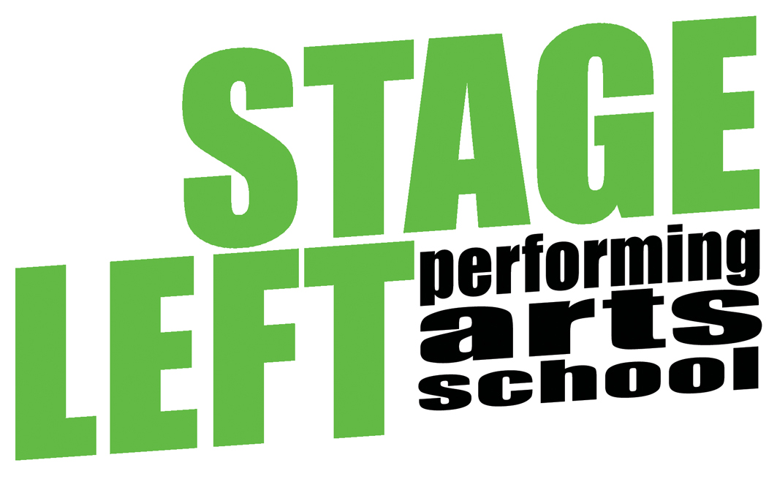

JOIN US for TERM 3 2025
Performing Arts Classes at St Cecilia’s PS!

If you are keen to act, sing and dance then get your application form in now and join us for some Term 3 fun! Our classes run every Wednesday after school at St Cecilia’s PS - for St Cecilia PS kids only.

Our classes are for Grades 1-6. All students explore acting, singing and dancing in a fun and creative environment.

FREE TRIAL CLASS – St Cecilia students are welcome to book in for a free trial class

Term 3 Dates: Wednesday 23rd July – Wednesday 17th September

Times: 3.30-5pm (all students will have a short snack/toilet break after school before classes commence)

Structure: Students will be divided into two groups–Grades 1-3 and Grades 4-6 and take part in two classes each week that run for approximately 40 minutes each.

Class sizes are strictly limited so make sure you get your enrolment to us as soon as possible

Please click below for:
Application Form for Term 3 2025
Information Form
(hard copies of forms are also available at the school office)
For further information regarding Stage Left please visit our website www.stageleft.com.au

