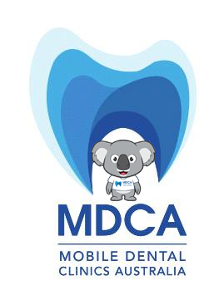

OUR MOBILE DENTAL CLINIC WILL BE VISITING
Dromana Secondary College
Week commencing: Monday 30th May 2022

On consent we provide comprehensive Dental Services including:
- Dental Health Education
- Comprehensive Oral Examination
- Clean, Scale and Fluoride application
And if required:
- Fissure seals, fillings, extractions and X-rays

Children from Families receiving FAMILY TAX BENEFIT A, may be eligible for up
to
$1013 of FREE dental over 2 years.

*If not eligible, our experienced team can provide the same treatment for only $99
https://www.cognitoforms.com/MDCA2/ChildConsentForm

www.mobiledentist.com.au 1300 765 640

