CAREER NEWS Friday 6 March

 Dates to Diarise in Term 1
- Victorian Careers and Employment Expo – 19 to 21 March 2026

News from Holmesglen Institute
- Thursday Open Days
Holmesglen’s Open Day is happening on Thursday 12 March, offering a chance to explore courses, meet expert teachers, and tour our facilities.
Open Day is the perfect way to see what studying at Holmesglen is like. Enjoy campus tours, course information sessions, and a free BBQ with drinks.
Browse the Open Day sessions by study area:

- Arts and Design
- Building and Construction
- Business and Finance
- Computing and IT
- English, Education and Teacher Training
- Hospitality, Tourism and Events
- Horticulture and Environment
- Nursing, Community and Health Services
- Sport, Fitness and Wellbeing

Find out more at Holmesglen Institute.

- St. Kilda Career Pathways
St. Kilda Football Club and Holmesglen Institute are excited to announce an industry-first expansion of their education partnership for aspiring sports professionals.

Commencing this year, Holmesglen’s Bachelor of Sport Business and Bachelor of Sports Media students will have the chance to undertake practical, real-world training at the St. Kilda Football Club. Students will gain access to unparalleled experiences in one of Australia’s most dynamic and sought after sectors. They will have the chance to work directly alongside industry leaders in an elite sporting environment, unlocking a wealth of experiences within the broader AFL ecosystem.
Students will also engage directly with St. Kilda’s senior coaching staff and executives, gaining unique exposure to the inner workings of an elite AFL environment across various administration and football operations departments.
Each year, at least four Bachelor degree students will be selected for St Kilda internships with contact hours shared between the club’s spiritual home at RSEA Park in Moorabbin and Holmesglen’s Chadstone campus.
Watch this YouTube clip to learn more.

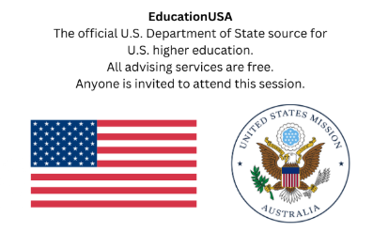 Learn the Steps to Study in the U.S. as a Student-Athlete
Dreaming of competing in the US?
EducationUSA, the U.S. Department of State’s official source of information on U.S. higher education, provides free, accurate, and comprehensive advising to students considering study in the United States.
The U.S. Consulate General Melbourne is pleased to deliver its first free in-person public information session for 2026, designed for students, parents, school staff, and coaches.
Whether students are actively being recruited, supporting a student-athlete, or just beginning to explore the possibility, this session will help them better understand their options and next steps.
Following the admissions overview, the session will transition to a moderated conversation with Australian Olympian Stephanie Ratcliffe and her father, as they share their firsthand experience navigating the U.S. recruitment and admissions journey.
Date: Thursday 5 March 2026
Time: 6.00pm – 7.30pm
Location: Scotch College, 1 Morrison Street, Hawthorn VIC 3122
Venue: Geoffrey McComas Theatre - James Forbes Academy
Registration is required for all attendees. Places are limited, and registration will close once capacity is reached.
Register at Learn the Steps to Study in the U.S. as a Student-Athlete.

 Discover Monash Events
Monash University will be hosting several Discover Monash events or activities over the coming weeks. Unless specified online**, these will be face-to-face events.
Participating in one or more of these events will assist students in making informed choices about their study options after Year 12.
The following events will take place from March until May and students are encouraged to register early. For a complete list, and to register, visit Events Calendar - Discover Monash.
Information Evening** | Tuesday 3 March, 6.30pm - 8.00pm
Discover Bachelor of Information Technology** | Monday 16 March, 6.00pm - 6.50pm
Discover the Bachelor of Computer Science** | Wednesday 18 March, 6.00pm- 6.50pm
Discover Criminology and Criminology/Policing | Wednesday 18 March, 6.30pm- 8.00pm
Discover the Bachelor of Arts | Thursday 19 March, 6.30pm - 8.00pm
Discover Pharmacy and Pharmaceutical Science** | Thursday 26 March, 6.00pm - 7.00pm
Clayton Campus Tour | Thursday 9 April, 10.00am - 11.30am
Discover Business study options & employability | Thursday 9 April, 11.15am - 11.45am
Peninsula Campus Tour | Thursday 9 April, 2.00pm - 3.15pm
Caulfield Campus Tour | Friday 10 April, 10.00am - 11.15am
Discover Business study options & employability | Friday 10 April, 11.30am - 12.00pm
Clayton Campus Tour | Friday 10 April, 2.00pm - 3.30pm
Discover Medicine** | Tuesday 14 April, 5.30pm – 6.30pm
Discover the Bachelor of Digital Business** | Tuesday 21 April, 6.00pm - 6.45pm
Discover Biomedical Science and Nutrition Science** | Tuesday 5 May, 5.30pm - 6.30pm
Discover Nursing and Midwifery** | Wednesday 6 May, 5.30pm - 6.30pm
Discover Science: The Monash Science Experience | Wednesday 7 May, 6.00pm - 8.00pm
Discover Fine Art, Curating, Design & Architecture** | Tuesday 12 May, 7.00pm - 7.45pm
Discover the Bachelor of Media Communication | Wednesday 13 May, 6.30pm - 8.00pm
Discover Health Sciences, Public Health and Psychology** | Wednesday 13 May, 5.30pm - 6.30pm
Discover Engineering: Engineer your future | Monday 18 May, 6.30pm - 7.30pm
Discover Occupational Therapy, Physiotherapy, and Paramedicine** | Wednesday 20 May, 5.30pm - 6.45pm
Discover Radiography and Medical Imaging** | Thursday 21 May, 5.30pm - 6.00pm
Discover Teaching and Learning Design - Peninsula | Thursday 21 May, 6.30pm - 7.30pm
Discover Speech Pathology** | Tuesday 26 May, 5.30pm - 6.00pm
Discover the Bachelor of Learning Design and Technology** | Tuesday 26 May, 6.30pm - 7.30pm
Discover Degrees in Global Relations, Politics & Economics | Thursday 28 May, 6.30pm - 8.00pm
Discover Teaching and Learning Design - Clayton | Thursday 28 May, 6.30pm- 7.30pm

 News from ANU in 2026
- Applications for 2027 Entry
Current domestic Year 12 students who intend applying directly to ANU for an Early Offer for undergraduate study in 2027 are advised that direct applications open on Wednesday 11 March 2026, and close on Friday 8 May 2026.
Early offers are released in September each year.
Students can start their applications at any time and log back in, as needed, to complete the process. They will
The Early Offer application to ANU will prompt applicants to provide specific documentation, and students are encouraged to be prepared and gather the following documentation:
- Year 11 result and Year 12 subject enrolment.
- Documents supporting their eligibility for adjustment factors
- Additional documentation may be required depending on their circumstance, and students will be notified if anything else is required during your application.

Students are advised to read through the Application Information before applying at Applying to ANU.

- Reminder: ANU Open Day 2026
Get ready to explore a world of possibilities. ANU Open Day is your chance to discover new passions and world-class teaching and research. Immerse yourself in our supportive community and learn how we'll prepare you for exciting careers.

Date: Saturday 28 March 2026
Time: 9.00am – 3.00pm

Exciting opportunity: Register to attend ANU Open Day on Saturday 28 March 2026 and go into the draw to win a trip for two to Canberra, including flights/transport, two nights' accommodation and a free campus lunch.
Register and find out more here.

 Projects Abroad
Join Projects Abroad for a meaningful, practical, and purposeful adventure overseas.
Projects Abroad has been running volunteering programs for over 20 years.
Some of these include –
- Community Work and Early Years Development
- Conservation Work
- Human Rights and Social Justice
The programs run in the mid-year break as well as summer in destinations such as Fiji, Cambodia, Sri Lanka, Tanzania and Peru.
Projects Abroad will be running a free webinar for students who may wish to find out more.
Date: Monday 16 March 2026
Time: 6.30pm (AEST)
Register at this link.
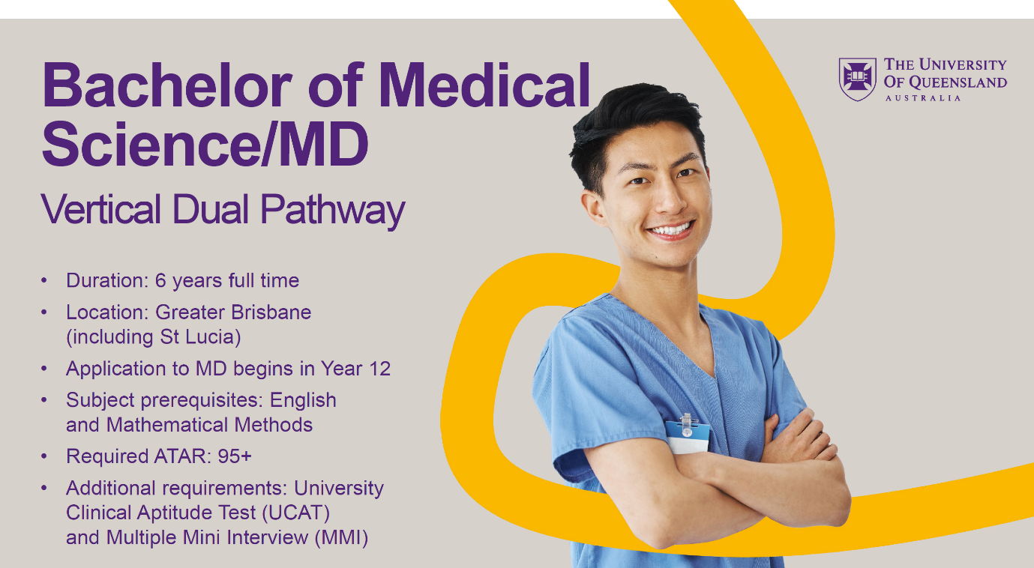
New Pathway to Medicine
From 2027, the UQ Medical School will be offering a new 6-year pathway to becoming a doctor. The Bachelor of Medical Science / Doctor of Medicine program will allow students to enter the medical workforce as doctors at least 1 year earlier than other study pathways at UQ.
This vertical dual program is ideal for high school students who want to progress quickly into the UQ Doctor of Medicine. It offers excellent preparation for the UQ Doctor of Medicine, helping students develop the knowledge, skills and values expected of modern healthcare professionals.
The entry requirements are:
- an adjusted ATAR 95.00 (or equivalent) or higher
- Year 12 English (or equivalent)
- Mathematical Methods (Units 3 & 4, C) (or equivalent)
- UCAT
- MMI
The UCAT ANZ must be completed the same year students apply and will be used to rank applicants for invitations to a Multiple Mini Interview (MMI).
Entry is competitive and will be based on ATAR, UCAT ANZ and MMI scores.
To progress to the MD component, students will need to complete the pre-medicine component within 2 years, achieving a pass in all courses.
To learn more about UQ's 6-year pathway to medicine, please join UQ at the upcoming Medicine Information Evening on 18 March 2026 commencing at 6.00pm (AEST).
Register here for UQ's Medicine Info Evening.
 Data Science and Information Systems Degrees in Victoria in 2026
Data science combines multiple fields, including statistics, scientific methods, artificial intelligence (AI), and data analysis, to extract value from data. Note: Data Science is often offered as a major in Science or Computer Science degrees. This is the case for the University of Melbourne - Bachelor of Science.
Information Systems, an integrated set of components for collecting, storing, and processing data and for providing information and digital products. Note: Information Systems is also often offered as a major in Science or Computer Science degrees, as well as some Business degrees.
Visit VTAC for a comprehensive list including all double degrees on offer.
INSTITUTION | COURSE NAME | VCE PREREQs | MAJOR STUDIES IN 2026
Deakin University | Bachelor of Data Science  Note: the Bachelor of Data Science (Honours) is also offered | Units 3 and 4: a study score of at least 25 in English (EAL) or at least 20 in English other than EAL. | Cloud technologies (minor only), Cyber security (minor only), Data science (AI, Data mining, Machine learning, Data management, Discrete mathematics, Programming, Data analytics, Natural language processing), Education (minor only), Embedded systems (minor only), Finance (minor only), Full stack development (minor only), Health analytics (minor only), Human resource management (minor only), Marketing (minor only), Psychology (minor only), Retail management (minor only), Security management (minor only), Sports analytics (minor only), Sustainability and environmental science (minor only), Virtual and augmented reality (minor only).
Federation University | Bachelor of Information Technology (AI and Data Science) | Units 3 and 4: a study score of at least 20 in any English. | Artificial Intelligence and Data Science.
Monash University | Bachelor of Applied Data Science  Note: the Bachelor of Applied Data Science Advanced (Honours) is also offered | Units 3 and 4: a study score of at least 25 in English as an Additional Language (EAL) or at least 25 in English other than EAL; Units 3 and 4: a study score of at least 25 in one of Maths: Mathematical Methods or Maths: Specialist Mathematics. | Anatomy and developmental biology, Applied and statistical mathematics, Astronomy, Biochemical science, Biological science and genetics, Biomedical science, Business analytics, Business information systems, Chemical sciences, Computer Science, Computer systems engineering, Crime and society, Cybersecurity, Data challenges, Data science, Digital media, Discrete mathematics, Drugs and society, Earth and atmospheric sciences, Economics, Geography and the environment, Language and society, Marketing science, Mathematics, Microbiology, Mobile apps development, Modelling with differential equations, Molecular and cell biology, Pharmacology, Physics, Physiology, Social research, Software development, Statistical modelling.
RMIT University | Bachelor of Data Science  Note: the Bachelor of Data Science (Professional) is also offered | Units 3 and 4: a study score of at least 25 in English other than EAL or at least 27 in EAL; Units 3 and 4: a study score of at least 20 in one of Maths: General Mathematics, Maths: Mathematical Methods or Maths: Specialist Mathematics. | Advanced data science, Analytics, Artificial intelligence and machine learning, Big Data, Cyber Security, Data analysis, Data mining, Data science, Data warehousing, Data wrangling, Database, Enterprise systems development, Ethics, Forecasting, Information retrieval, Legal issues, Machine learning, Privacy, Programming, Statistical computing, Statistics.
Swinburne University | Bachelor of Data Science | Units 1 to 4: satisfactory completion in two units (any study combination) of any Mathematics; Units 3 and 4: a study score of at least 25 in English as an Additional Language (EAL) or at least 20 in English other than EAL. | Big data architecture and application, Cloud computing architecture, Computer systems, Data science principles, Data visualisation, Introduction to programming, Networks and switching, Object oriented programming, Software architectures and design, Software deployment and evolution.
Victoria University  *General Maths, Maths Methods, or Specialist Maths. | Bachelor of Data Science | Units 3 and 4: a study score of at least 25 in English (EAL) or at least 20 in English other than EAL; Units 3 and 4: a study score of at least 20 in any Mathematics * | Advanced Data Science, Big Data, Data Analytics for Cyber Security, Fundamentals of Data Science, ICT Business Analytics and Data Visualisation, Introduction to Database Systems, Machine Learning and Data Mining, Online Business System Development, Predictive Analysis.
Snapshot of Box Hill Institute (BHI) in 2026
- Box Hill Institute, formally known as Box Hill TAFE, began operating in 1984.
- Box Hill Institute (BHI) offers qualifications range from certificates I to IV, diplomas and advanced diplomas, even associate, bachelor, and master’s degrees - Over 200 TAFE Courses & Degrees at BHI.
- BHI’s offers 150+ vocational and higher education qualifications that are nationally accredited and internationally recognised.
- BHI offers apprenticeships, traineeships, and pre-apprenticeship courses across a range of trade and industry areas - Apprenticeships and Traineeships.
- BHI has a number of Melbourne campuses – three in Box Hill, one in the city, and the Lilydale Lakeside Campus is the newest campus.
- Through its partnerships with international educational institutions and other organisations, Box Hill Institute has ten international global educational partners delivering Australian qualifications to residents throughout the Asia-Pacific region and in the Middle East.
- BHI has a number of excellent facilities including its new, one-of-a-kind, Integrated Technology Hub located at the Elgar Campus, which provides collaborative and innovative learning spaces for the air conditioning, refrigeration, mechanical, plumbing and electrical technologies industries. There are excellent Workplace Training Facilities where students get access to real and simulated work environments in order to gain lots of practical hands-on experience. The environments are real, the tools and equipment are the latest, and the customers are paying members of the public.
Some of the workplace training facilities include:
- Barbershop
- Hair and Beauty Salon, providing spa treatments and services
- Pets on Elgar, a veterinary clinic and dog-grooming centre
- Fountains Restaurant, Box Hill Institute’s premier training restaurant
- BHI offers its students Study Abroad opportunities.
- BHI has a range of Student Support Services, including study support, and personal and career counselling.
- BHI offers courses through the Free TAFE For Priority Courses.
- BHI offers offer a number of scholarships that:
- recognise the academic achievement of students
- help students who need financial assistance



