Level 5 Homework Matrix
Homework tasks should ideally be completed with adult supervision. The Homework Matrix for each level will be available in the Connect newsletter once a fortnight. Tasks will be completed in student homework books and handed in to the teacher, to be signed, two weeks later on a Friday morning (even weeks). Teachers will sign homework books.

L5/6 – Reading + 8 tasks/fortnight
Reading (compulsory)  Read for: minutes every day.  Record the title of your book and the pages read in your diary. Ask an adult to sign your diary.   | Writing (grammar and punctuation)  An appositive is a noun phrase in a sentence that renames the original noun to add more detail and usually starts with an article such as a, the or is.  e.g. My border collie, a herding dog, can run 48 km per hour.  Write 5-sentences to show your understanding of appositives. Highlight the subject, underline the appositive and highlight the predicate.  Some ideas:  Paris, the……  My teacher, a……  The park, a……..  Spiderman, a…..  Earth, the…… | Physical Education Challenge  triking and Fielding Challenge  Find a safe space and use a ball or rolled-up pair of socks.  Complete 20 successful throws and catches.  Practise 10 underarm throws at a target.  Practise 10 overarm throws at a target.  Throw the ball against a wall and catch it 10 times.  Create a small target and score one point each time you hit it.  Extra Challenge  Complete as many catches as possible in one minute. Record your best score and try to beat it!  My best score: ______ catches  Reflection: What helped you throw and catch accurately? | Gratitude  Pick 3 people you are grateful for  this month. Make sure you explain  why you picked each person.
Spelling:  Use the word builder to create as many word sums as you can using the morphemes.  Use 5 words in a sentence to show your understanding of the word (and the word tense).  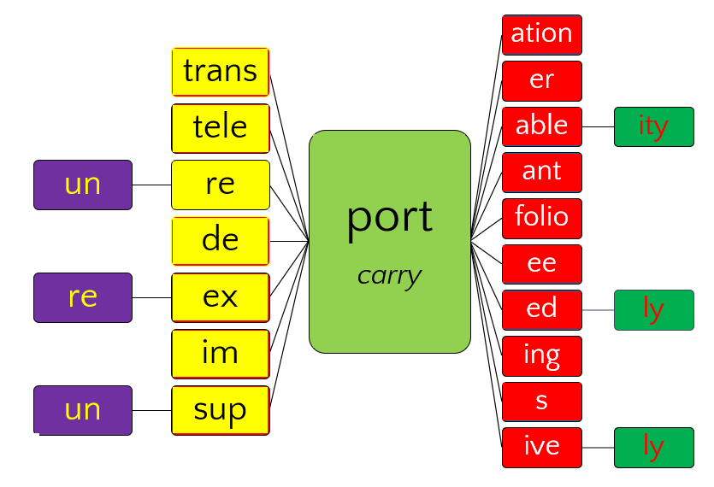 | Maths  Create 5 decimal numbers between 0 and 10.  Your challenge:  - Put them in order from smallest to largest.  - Make your numbers tricky — use tenths, hundredths and thousandths.  - Choose two decimals that are very close together.  - Prove your order is correct using place value, a number line or another representation. | Art Challenge  Select a colour and draw 3 objects. Explore tone by showing light and dark variations of that colour. | Mindfulness  Lay in a quiet room of the house or  somewhere comfortable outside  e.g. on the grass for a few minutes.  Take a moment to just stop and  listen to all the sounds around you.
Writing  Writing Sprint.  Set a timer for 15-minutes. Use the picture prompt to generate ideas, asking yourself ‘What if?’  e.g ‘What if the shadow comes to life?’  ‘What if the shoes are magic?’  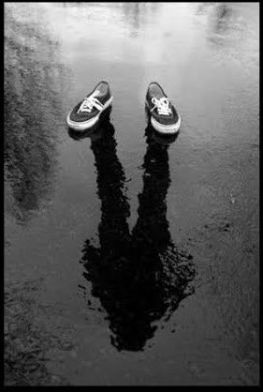  Pick an idea and develop a story. Use your authorial decision making to decide whether you are going to write from first person or third person. | Maths Skills/Fluency  Practice your 7 times tables.  Challenge: See if you can skip count by  7’s go right past 100. | Science Challenge  Recount your adventure on SEPS Air. | Emotional Literacy  Create a feelings collage using  magazines, coloured paper or art  supplies. Find pictures  representing different emotions to  create a collage that visually  portrays your feelings.
Maths  Choose a multiplication problem using 2-digit numbers (eg. 24 × 6)  1. Solve it in two different ways using the distributive property.  Eg. 24 × 6 = (20 × 6) + (4 × 6)  2. Solve it in two different ways using equivalence.  Eg. 3 x 6 = 9 x 2  Prove that both strategies give the same answer.⭐ Challenge: Create another multiplication problem and find 3 different ways to solve it. | Online Platforms  - Read a book on Wushka  - Complete tasks on Mathletics  - Play a game on Maths frame  - Listen to a story on Storybox | Mandarin Challenge    Scan and play blooket | Empathy  Think about 3 ways in which you  can brighten someone’s day this  week or ways in which you can  cheer someone up if you notice  they’re sad.

