Student Representative Council Rationale
Why have an SRC?
'The role of the SRC is to be the voice of the students, find out what students think, help make the school a better place for everyone, have an impact on decision-making in the school, including on teaching and learning and student behaviour.' (SRC)
SRC Model
There is a single Student Representative Council (SRC), made up of the College Captains, College Ministry Captains and students drawn from the six House Forums. The SRC then meets regularly as one team, makes decisions, and organises activities. The House Forum can meet alternately in whole sessions and in working groups.
House Forum Structure
A forum is a place, situation, or group in which people exchange ideas and discuss issues, especially important public issues. ... In ancient Roman towns, the forum was a square where people met to discuss business and political matters.
Possible discussion points would be:
- Student Safety
- House activities such as Sports Days, MAD Day initiatives, House Assemblies
- Problems or concerns that students have and which need to be discussed by the Student Representative Council. (An example of this is the discussion and proposal regarding winter uniform and shorts for girls doing PE).
- Letters and requests from various organisations.
- Any fundraising that is seen as important to the school to be completed at a House level.
- Organising and running end of term activities such as discos and videos
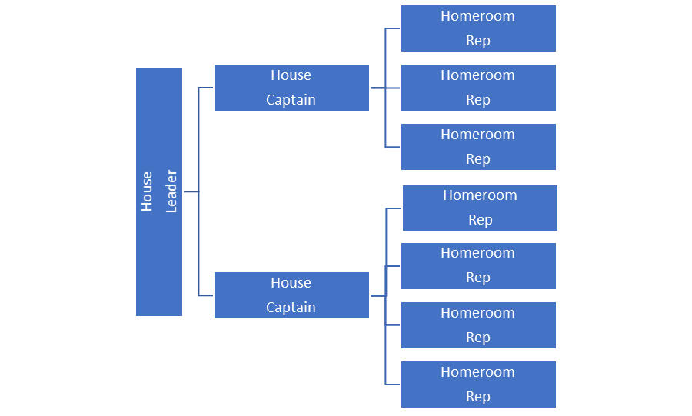
Student representative Council
SRC each meeting would be made up of 2 X College Captains, 2 X College Ministry Captains, 2 X House Captains & 1 X Homeroom Representative (rotation basis) from each House.
College Captains, College Ministry Captains would be elected from year 12, House Captains will be elected from year 12 (& 11?) and Homeroom Reps from years 7-10 (11?) (at least one person from each year level across the 7 Homerooms).
Possible discussion points would be:
- Recommendations to College Leadership team
- Student Feedback to College Board
- Consensus is required on a whole school student initiative
- Uniform Recommendations to College Leadership Team / Board / Parents
- Use of Whole school student surveys to capture student voice
- Student Safety

