Local Support Services

headspace Geelong
Supports young people from 12-25 who are going through a tough time.
To book an appointment, call 5222 6690. www.headspace.org.au/headspace-centres/geelong/

Hope Bereavement Care
Offers free information, support and counselling when grieving the death of a child, the sudden and unexpected death of an adult and those experiencing loss after suicide
Call: 03 4215 3358 EMAIL: hope@bereavement.org.au

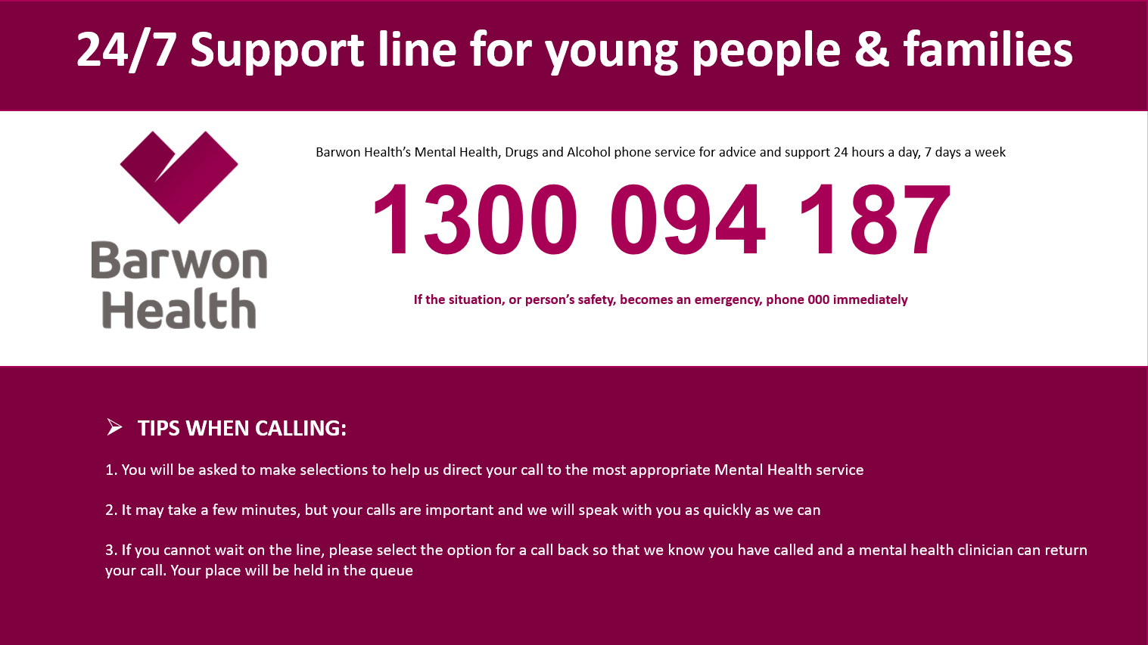
Barwon Health Jigsaw & Barwon Child and Youth Triage
This is the initial point of contact within Barwon Health Mental Health Drug and Alcohol Service for infants, children and young people aged 0-25 years and their families.

HeadtoHelp
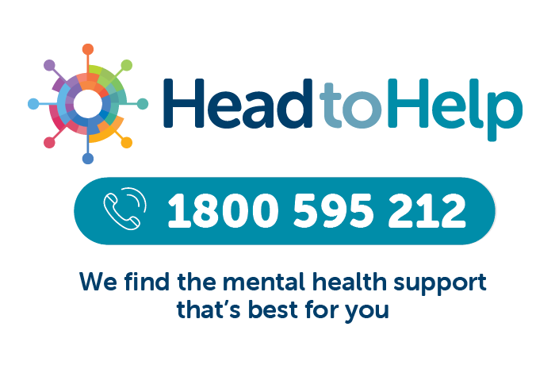
HeadtoHelp is a mental health support service for people of any age who live in Victoria.
Support can be provided within the HeadtoHelp team or you can be referred to other service providers.

This is a free service.

www.headtohelp.org.au

National Support Services

