The big things in Queensland

The big pineapple

The big pineapple is located in Woombye sunshine coast and designed by Peddle thorp, Paul luff and Gary smallcombe

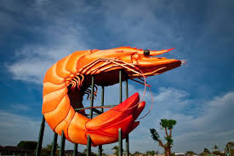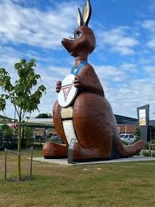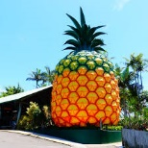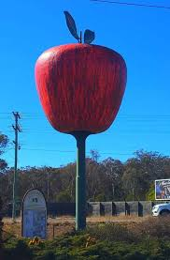

The big captin hook

It is eight metres and has stood beside sheriden st for 50 years

The big prawn

It stands 9 metres high weighs 35 tonne and is in Ballina Queensland

The big kangaroo

It is 13 metres tall and is located in the gold coast. Fun fact it was based on the commen wealth games