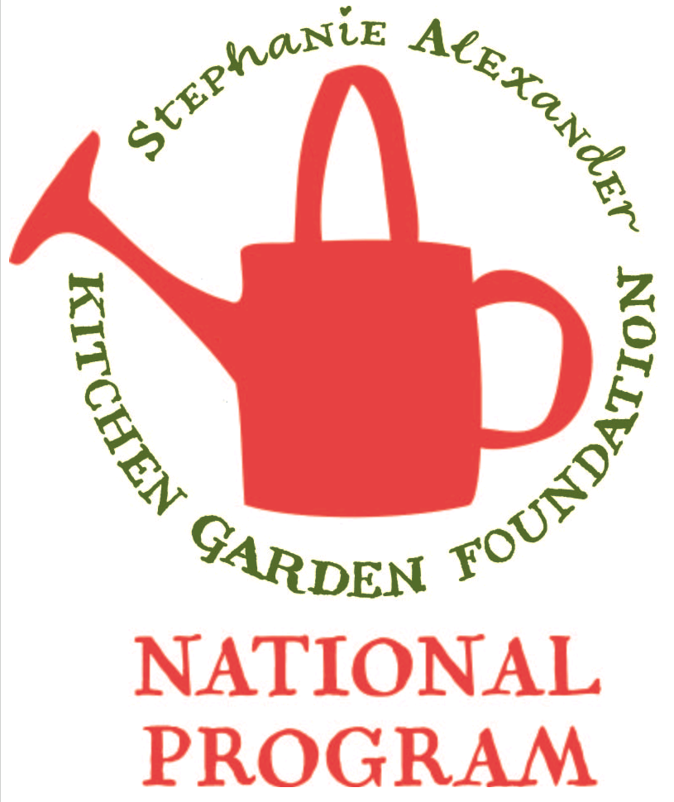
Fried Rice

Season: Summer / Autumn

Type: Vegetable Dish

Difficulty: Medium

Serves: 30 tastes in the classroom or 6 at home

Fresh from the garden: Carrots, celery

Recipe source: Sunbeam Professional Wok recipe book

Equipment:  * knives  * bowl  * wok  *grater  * wooden spoon  * measuring spoons  *measuring cups  * chopping boards  * serving dishes | Ingredients:  - 2 tablespoon oil  - 3 eggs, lightly beaten  - 1 onion, finely chopped  - 3 spring onions, chopped  - ½ cup frozen peas  - 2 carrots, peeled, finely diced  - 2 sticks of celery, sliced  - 3 cups of cooked rice, cold  - 1 tsp grated ginger  - 2 tsp soy sauce

What to do:
- Steam 1 cup of uncooked rice and allow to cool. This will make 3 cups of cooked rice.
- Chop up onion, and slice carrot and celery.
- Heat ½ of the oil in wok.
- Pour in eggs, turn to cook other side. Remove from wok and chop finely.
- Add remaining oil, onion, carrot and celery and saute until onion is tender.
- Add peas, spring onion, rice and egg, stir to combine.
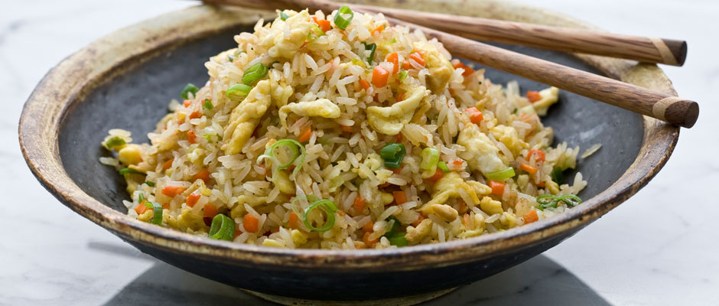
- Stir ginger and soy sauce through the rice.
- Cook until heated through.

