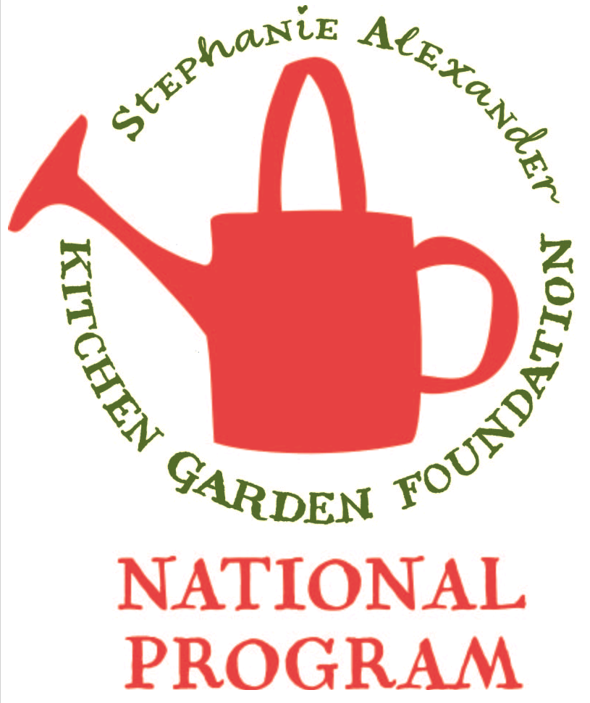
Lentil Dhal

Season: Winter

Type: Vegetable Dish

Difficulty: Easy

Serves: 20 tastes in the classroom or 4 at home

Fresh from the garden:

Recipe source: Taste.com

Volunteer information: Please double quantity!

Equipment:  * knives  * bowl  * wooden spoon  * measuring cups  * chopping boards  * serving dishes | Ingredients:  - 1 cup (210g) red lentils, rinsed well  - 3cm fresh ginger, sliced  - 2 Bay Leaves  - 1 cinnamon stick  - 2 tablespoons (40g) butter  - 1 large onion, finely chopped  - 2 cloves garlic, crushed  - 2 teaspoons turmeric  - 1 teaspoon cumin  - 1/2 teaspoon garam marsala  - 1/2 teaspoon chilli flakes  - 2 tablespoons lemon juice  - 1/2-1 teaspoon salt  - 1 tablespoon chopped coriander leaves

What to do:
Place lentils, ginger, bay leaves and cinnamon in a large saucepan with 3 cups of cold water.
Bring to the boil, reduce the heat to medium and simmer, stirring to prevent sticking for 10-12 minutes. Discard spices and set aside.
Heat the butter in a large frying pan over a medium high heat.
Add the onion and cook for 3 minutes.
Stir in the garlic, turmeric, cumin, garam marsala and chilli flakes and cook for a further minute or until fragrant.
Stir in the lemon juice and season to taste with salt.
Add the lentils to the pan and mix well.
Cook for a further 3 minutes, stirring constantly.
Remove from the heat.
Stir in coriander and serve hot with naan/ roti bread or pappadums.

