Dear Parents/Caregivers,
Please find below the instructions for accessing Semester 2, 2021 Learning Tasks for the areas of English and Mathematics and Semester 2 2021 reports. Reports will be modified according to the requirements from the Department of Education and Training as outlined below:
To meet the Foundation to Year 10 (F-10) student reporting requirements for Semester 2, schools must:
- provide a written report (print or digital) in an accessible format that is easy for parents or carers to understand

For English and Mathematics, schools must:
- provide a short description of what was taught
- report achievement by making a teacher judgement against the Victorian Curriculum F-10 achievement standards (including Towards Foundation Levels A-D)
- Provide a 1-2 sentence - general comment/ eg. remote learning.
- report progress since the last time the curriculum area was reported on (this should be automatically generated by the reporting software)
- include an age-related five-point scale.

For all other curriculum areas delivered, including English as an Additional Language, schools must provide a short description of what was taught and a short comment on progress and achievement in their learning across the semester.
Learning tasks are also available on Compass. Learning Tasks provide ongoing reporting that builds throughout the year and provides students and parents with ongoing assessment of how a student is progressing.
- Greater accountability of students’ work habits
- Timely feedback – the progress report is issued when the task is completed and assessed, enabling the teacher and the parent to identify, intervene and improve
- No “surprise” negative results coming home at the end of a semester. If there is a problem, parents are notified when it arises
- Access online anywhere, anytime via a secure web-based program.
Students across all year levels have completed Learning Tasks which provide a snapshot of achievement in the key areas of Mathematics, Reading and Writing. These learning tasks have been released regularly throughout the year and are accompanied by comments, goals and/or a RUBRIC showing student achievement.
If you have any questions about the Learning Tasks or Semester Reports please contact your classroom teacher or myself via email. Email addresses can be found on the school website.
Yours sincerely,
KAREN HALKET
Assistant Principal

How To View your child’s Learning Tasks

The CSPS Learning Tasks provide assessment and feedback on work being completed in class.
To view your child’s tasks, click the ‘Profile’ option for that child on your dashboard. This will take you to their profile page.
Click to their ‘Learning Tasks’ tab. Here you will see their tasks listed.
Note: The school may have archived some past tasks, you can click ‘Show Hidden Tasks’ to have archived tasks displayed in the list.

Click the title of a task to view the details and any results/feedback provided by the teacher.

If you have more than one student at the school and wish to view all their Learning Tasks collectively, you can click the pencil icon and select ‘Learning Tasks’.

Accessing Your Child’s Report on Compass

Web Browser Option Compass App Option

1. In your web browser, open your child’s 1. On the Home page click on your
home page and click ‘View Academic Reports’. child’s photo.
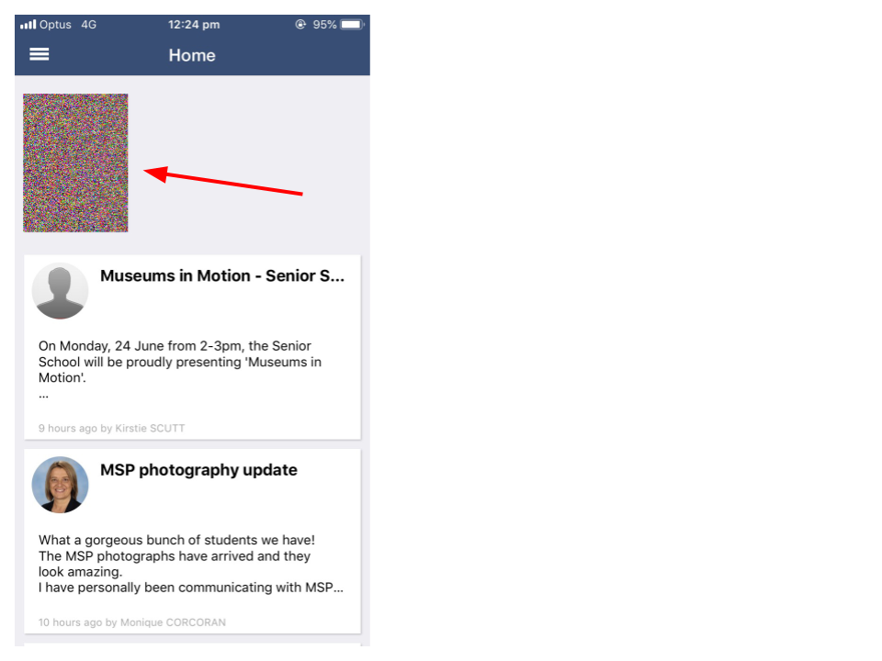
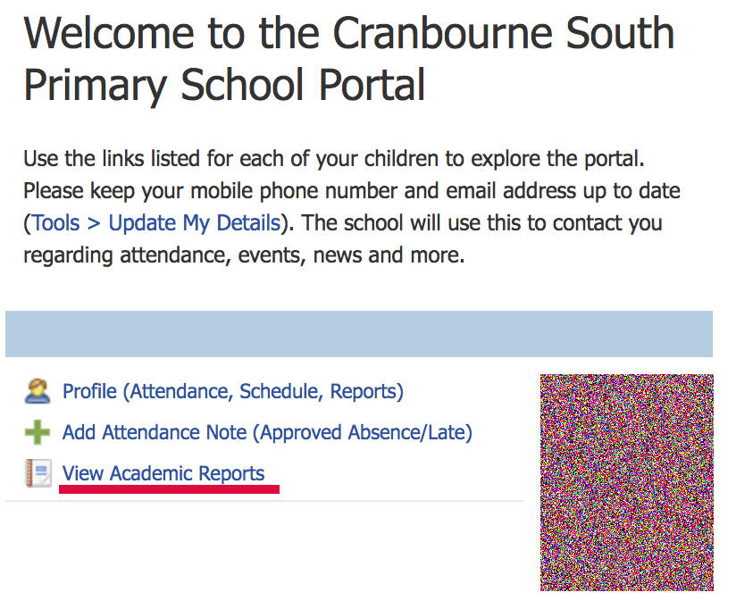

2. Select the correct report to download. 2. On the top right (you may need to
This will say ‘2021 - Semester One Reports’ scroll across) select Reports.
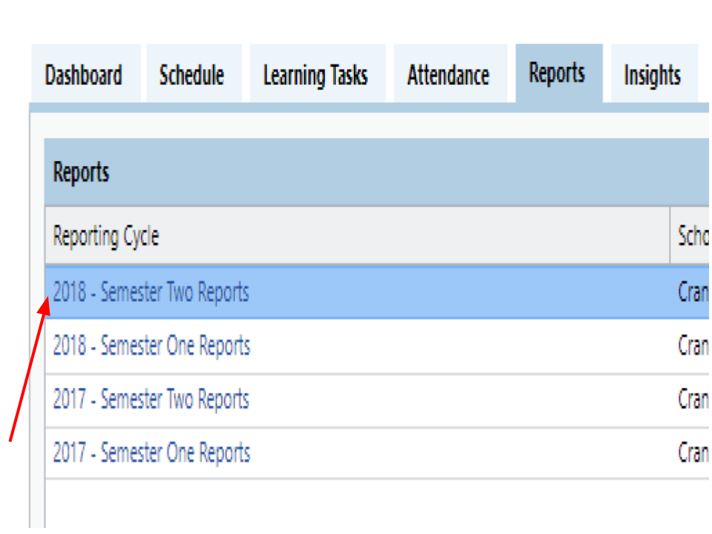
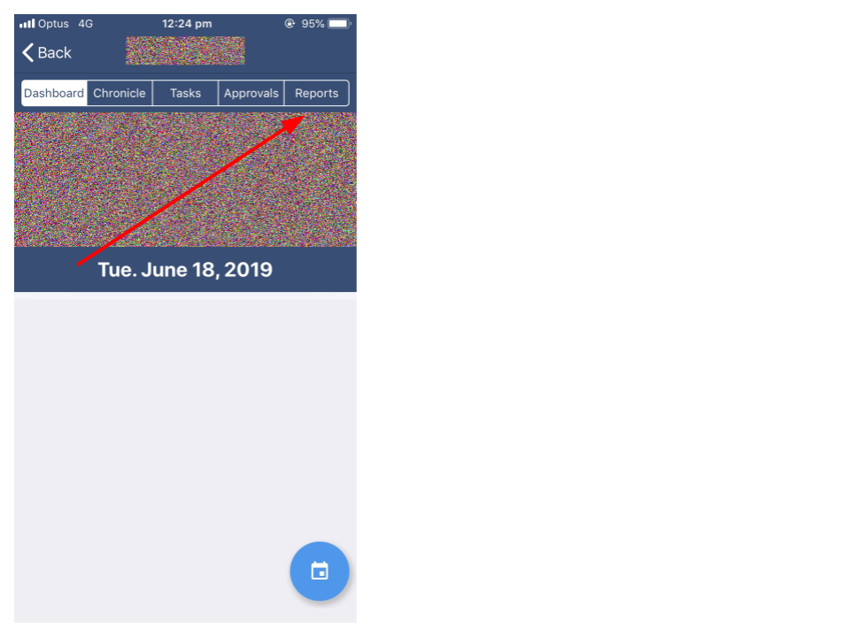

3. Select the report you wish to view and 3. Select the report you wish to view
print if required. and print if required.
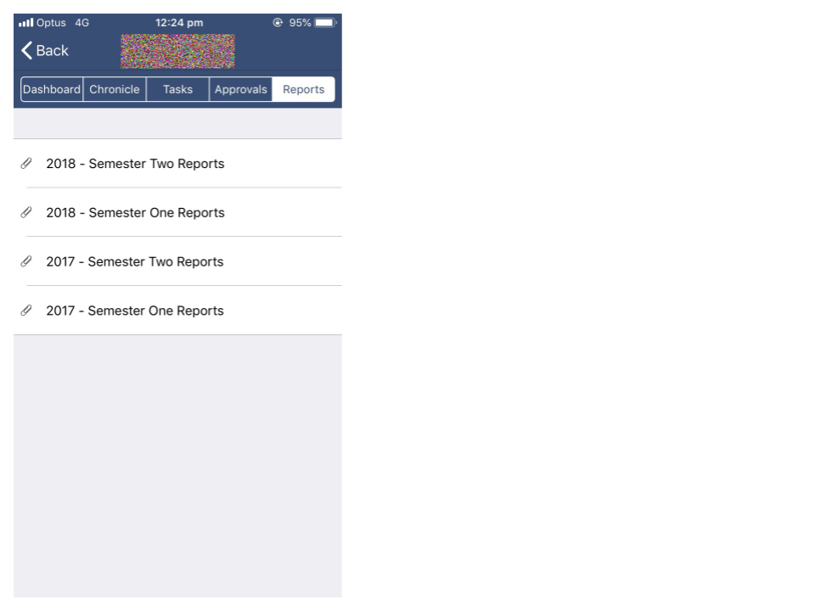

If you have any queries, please do not hesitate to contact your classroom teacher or myself on karenh@cranbournesouth.vic.edu.au

Yours sincerely,

KAREN HALKET
Assistant Principal
Monday 13th December, 2021

