Dear Parents/Caregivers,

At CSPS we believe that clear and timely reporting of your child’s achievements and progress at school is important. Feedback from families during Remote Learning indicated that parents and carers wanted information about what the students were achieving and what the next steps (learning goals) were.

Ongoing Reporting is a report that builds throughout the year and provides students and parents with ongoing assessment of how a student is progressing.

- Greater accountability of students’ work habits
- Timely feedback – the progress report is issued when the task is completed and assessed, enabling the teacher and the parent to identify, intervene and improve
- No “surprise” negative results coming home at the end of a semester. If there is a problem, parents are notified when it arises
- Access online anywhere, anytime via a secure web-based program.

Students across all year levels have completed Learning Tasks which provide a snapshot of achievement in the key areas of Mathematics, Reading and Writing. These learning tasks are released regularly throughout the year and accompanied by comments, goals and/or a RUBRIC showing student achievement.

Semester reports include Specialist, Guided Inquiry and General comments and progression marked against the Victorian Curriculum achievement standards.

Please find below the instructions for accessing Learning Tasks for the areas of English and Mathematics and Semester reports.

If you have any questions about the Learning Tasks or Semester Reports please contact your classroom teacher or myself via email. Email addresses can be found on the school website.

Yours sincerely,

KAREN HALKET
Assistant Principal

How To View your child’s Learning Tasks
The CSPS Learning Tasks provide assessment and feedback on work being completed in class.
To view your child’s tasks, click the ‘Profile’ option for that child on your dashboard. This will take you to their profile page.
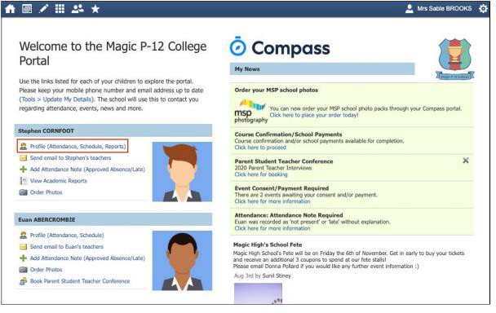
Click to their ‘Learning Tasks’ tab. Here you will see their tasks listed.
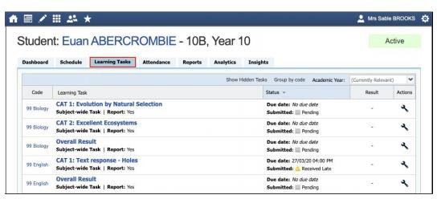
Note: The school may have archived some past tasks, you can click ‘Show Hidden Tasks’ to have archived tasks displayed in the list.

Click the title of a task to view the details and any results/feedback provided by the teacher.
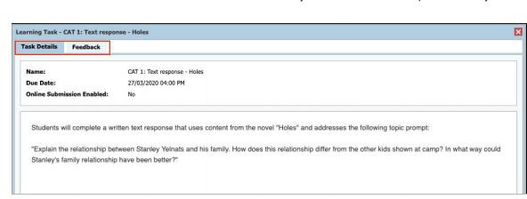

If you have more than one student at the school and wish to view all their Learning Tasks collectively, you can click the pencil icon and select ‘Learning Tasks’.

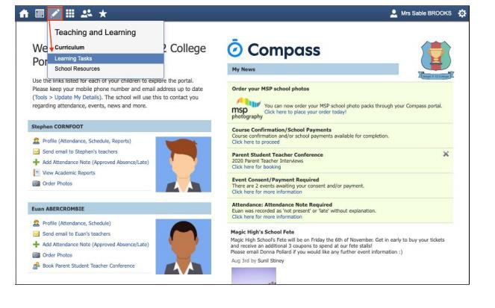

Accessing Your Child’s Report on Compass

Web Browser Option Compass App Option

- In your web browser, open your child’s 1. On the Home page click on your home page and click ‘View Academic Reports’. child’s photo.
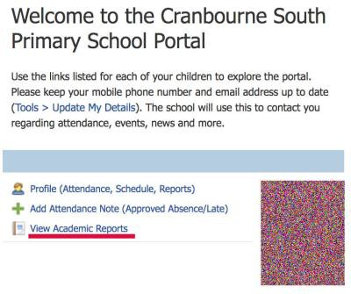
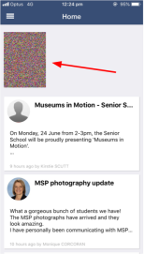

- Select the correct report to download. 2. On the top right (you may need to This will say ‘2021 - Semester One Reports’ scroll across) select Reports.
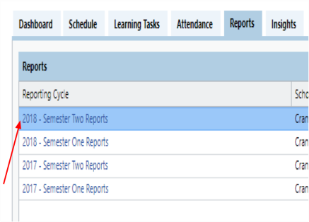
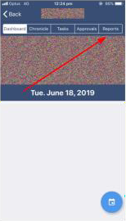

- Select the report you wish to view and 3. Select the report you wish to view print if required. and print if required.
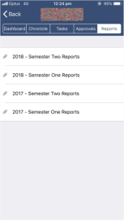

If you have any queries, please do not hesitate to contact your classroom teacher or myself on karenh@cranbournesouth.vic.edu.au

Yours sincerely,

KAREN HALKET
Assistant Principal
Friday 10th May, 2024

