


OSHC NEWSLETTER
Outside School Hours Care at
Introduction

Welcome to St Mel’s Uniting Outside School Hours Care (OSHC)

Welcome families to an amazing start to 2026, My Name is Veronica and I’m the service leader for St Mel’s Uniting OSHC. I feel incredibly proud to be part of this wonderful community and to support your children each day. Our goal is to create a safe and welcoming space where children can relax and explore and express and have fun and build friendships and feel a true sense of belonging.

Meet Deb and Ayon our fantastic members of our team who bring warmth, energy and enthusiasm to the program every day. Together we are committed to ensuring every little hero feels seen, supported and truly valued.

We have an exciting year ahead filled with fun pupil free days, jammed packed vacation care program, fun days at before and after school care, with themed style menus and fun, exciting programs created around the interest of the children.

We look forward to making this year one full of laughter, learning and wonderful memories at Uniting St Mel’s OSHC.




What We Have Been Doing

This month at Uniting St Mel’s we’ve had an exciting and action-packed time at Oshc! Our program has focused on Outcome 4
Before school care: Our before school care and after school care program continues to provide a fun, supportive and engaging environment for our children.
Before school care is a great way for children to start their day calmly and positively. Children enjoy a relaxed atmosphere with games, quiet activities and the opportunity to connect with friends before the day begins, we also provide tasty and healthy breakfast options, helping children feel energized and ready for learning.
After school care, children recently enjoyed some exciting hands-on activities. On highlight was our hairdressing activity, where children practiced creative hair styles and learned to tie their hair up and plait and braid, practicing on each other and the dolls, exploring their creativity and strengthening their fine motor skills. Another favorite was making pizzas for afternoon tea, the children had the chance to create their own mini pizza by choosing their topping and learning basic food preparation skills, the activity was lots of fun and of course delicious.
Pupil Free Day We are running a pupil free day on the 25th March Bookings are Opened we are having a Pizza Party OSHC children chose the theme, come and join the party we look forward to seeing you.

It is through strong partnership with families that we are able to create an inclusive and nurturing program. Thank you for all your support and we can’t wait for another fun-filled term.
Donations are welcomed: e.g.: Toys, Fabrics, Jars, and Card bord boxes



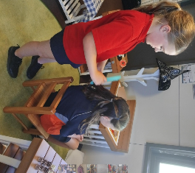

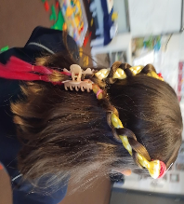

Do you need after school care? You may be eligible for after school care for as little as $7 a day (dependent upon your CCS). You may need to make an appointment or schedule a meeting; we can support you with quality care that is affordable and fun!

IMPORTANT UPCOMING EVENTS AND DATES:
17th February Shove Tuesday
26th February Pancake Day
9th March Labor Day Public holiday
10th March school photos
17th March St Patrick’s Day
25th March Pupil free day

2nd April last day of Term early Finish 2:20pm
3rd April Good Friday
5th April Easter Sunday
7th April Vacation care starts
20th April Pupil Free Day
21st April First day of Term 2

FLYERS:

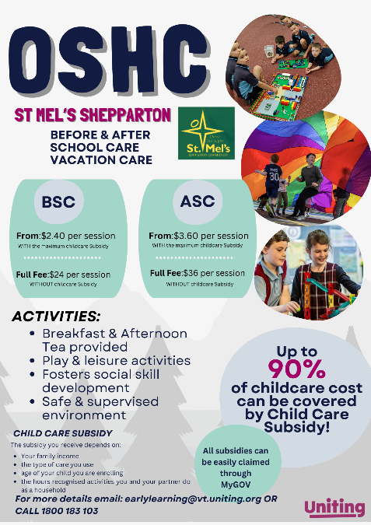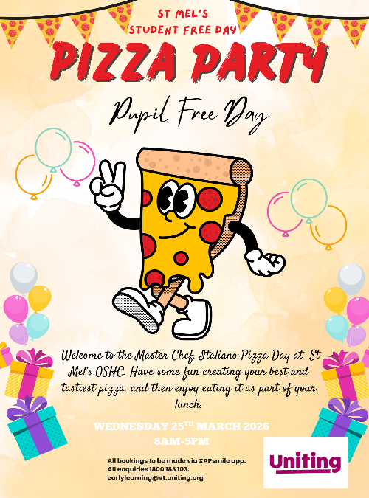
Centre name: St Mel’s Uniting OSHC
Service Leader: Veronica Bowman
Phone: 0436284365
Email: stmels.els@vt.uniting.org
Director of OSHC Victoria: Barb Hall-Duggan
Phone:0437897192
Email: barb.hallduggan@vt.uniting.org
Uniting Head Office Contacts
Address: 130 Lonsdale St, Melbourne VIC 3000
Phone: 1800 183 103
Email: earlylearning@unitingvictas.org.au

