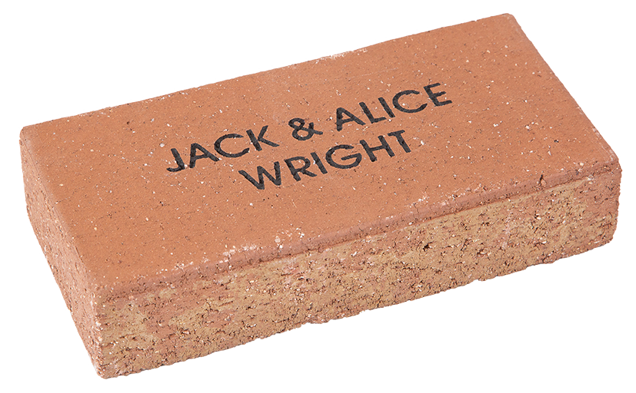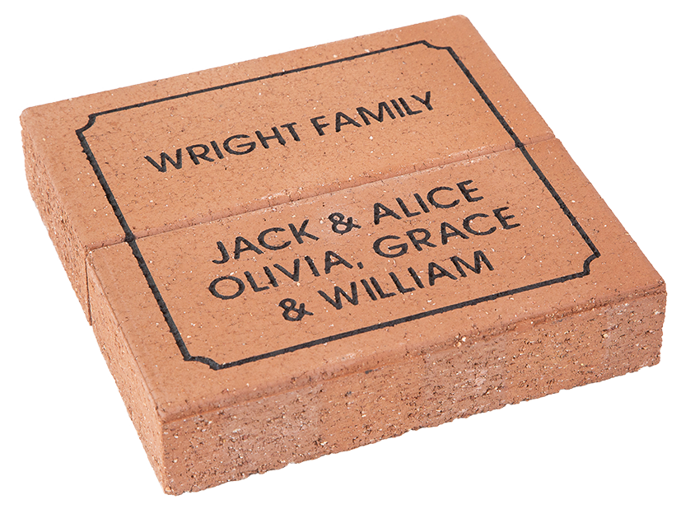

**Miners Rest Primary School**

**2-12 Dundas Street, Miners Rest**

**Victoria, 3352**

Simply fill out this form and return along with full payment by cash, cheque or money order to:

**Alternatively, attend or call the school on 5334 6328 to make a credit card payment.**

For engraving details please complete the form on the reverse.

***Celebrate and commemorate your place in history at the Miners Rest Primary School, School Expansion Project 2022 by purchasing a personalised paver that will form part of a new pathway to our reflection garden and around an historic part of our school for all to see and enjoy into the future.***

INDIVIDUAL PAVERS

Your donation of $40 entitles you to have your name engraved into a paver as a lasting record of your valued support of the Miners Rest Primary School. The paver will be permanently installed in our new refection garden and pathway, marking your place in history and proudly showing your donation.

Commemorative Paver – School Expansion Project 2022



|  |  |  |  |  |  |  |  |
| --- | --- | --- | --- | --- | --- | --- | --- |
| Contact Name/Company | | | | | | Phone | |
|  | | | | | | ( ) | |
| Address | | | | | | | |
|  | | | | | | | |
| Email Address | | | | | |  |  |
|  | | | | | | | |
|  | |  |  |  |  | Total | |
|  |  |  |  |  |  | $ | |

miners rest primary school

OFFER 2: **$80**

80

DOUBLE PAVERS

Your donation of $80 entitles you to have your name engraved into a paver as a lasting record of your valued support of the Miners Rest Primary School. The paver will be permanently installed in our new refection garden and pathway, marking your place in history and proudly showing your donation.

OFFER 1: **$40**

**Offer closes on Friday May 27th 2022**

**Offer 2**

**Offer 1**

SINGLE PAVER – MAX 16 CHARACTERS PER LINE

Please print clearly in block letters (CAPITALS) and always use the ampersand symbol (“&”). Three lines per paver.

Each box represents a character (letter, number, punctuation mark or space). No hand drawings.

The Miners Rest Primary School thanks-you for your contribution to our School Expansion and we look forward to seeing you at the school later in the year to see your paver in our new pathway and reflection garden!

Thank-you!

**PAVER 2**

**PAVER 1**

|  |  |  |  |  |  |  |  |  |  |  |  |  |  |  |  |  |  |  |  |  |  |  |  |  |  |  |  |
| --- | --- | --- | --- | --- | --- | --- | --- | --- | --- | --- | --- | --- | --- | --- | --- | --- | --- | --- | --- | --- | --- | --- | --- | --- | --- | --- | --- |
| **LINE 1** |  |  |  |  |  |  |  |  |  |  |  |  |  |  |  |  |  |  |  |  |  |  |  |  |  |  |  |
|  |  |  |  |  |  |  |  |  |  |  |  |  |  |  |  |  |  |  |  |  |  |  |  |  |  |  |  |
| **LINE 2** |  |  |  |  |  |  |  |  |  |  |  |  |  |  |  |  |  |  |  |  |  |  |  |  |  |  |  |
|  |  |  |  |  |  |  |  |  |  |  |  |  |  |  |  |  |  |  |  |  |  |  |  |  |  |  |  |
| **LINE 3** |  |  |  |  |  |  |  |  |  |  |  |  |  |  |  |  |  |  |  |  |  |  |  |  |  |  |  |

miners rest primary school

**Offer closes on Friday May 27th 2022**

ENGRAVING DETAILS – PLEASE COMPLETE CLEARLY



SINGLE PAVER – MAX 16 CHARACTERS PER LINE

Please print clearly in block letters (CAPITALS) and always use the ampersand symbol (“&”). Three lines per paver.

Each box represents a character (letter, number, punctuation mark or space). No hand drawings.

|  |  |  |  |  |  |  |  |  |  |  |  |  |  |  |  |  |  |  |  |  |  |  |  |  |  |  |  |  |  |  |  |
| --- | --- | --- | --- | --- | --- | --- | --- | --- | --- | --- | --- | --- | --- | --- | --- | --- | --- | --- | --- | --- | --- | --- | --- | --- | --- | --- | --- | --- | --- | --- | --- |
| **LINE 1** |  |  |  |  |  |  |  |  |  |  |  |  |  |  |  |  |  |  |  |  |  |  |  |  |  |  |  |  |  |  |  |
|  |  |  |  |  |  |  |  |  |  |  |  |  |  |  |  |  |  |  |  |  |  |  |  |  |  |  |  |  |  |  |  |
| **LINE 2** |  |  |  |  |  |  |  |  |  |  |  |  |  |  |  |  |  |  |  |  |  |  |  |  |  |  |  |  |  |  |  |
|  |  |  |  |  |  |  |  |  |  |  |  |  |  |  |  |  |  |  |  |  |  |  |  |  |  |  |  |  |  |  |  |
| **LINE 3** |  |  |  |  |  |  |  |  |  |  |  |  |  |  |  |  |  |  |  |  |  |  |  |  |  |  |  |  |  |  |  |

MULTIPLE PAVER – MAX 14 CHARACTERS PER LINE

Please print clearly in block letters (CAPITALS) and always use the ampersand symbol (“&”). Three lines per paver.

Each box represents a character (letter, number, punctuation mark or space). No hand drawings.

|  |  |  |  |  |  |  |  |  |  |  |  |  |  |  |  |  |  |  |  |  |  |  |  |  |  |  |  |
| --- | --- | --- | --- | --- | --- | --- | --- | --- | --- | --- | --- | --- | --- | --- | --- | --- | --- | --- | --- | --- | --- | --- | --- | --- | --- | --- | --- |
| **LINE 1** |  |  |  |  |  |  |  |  |  |  |  |  |  |  |  |  |  |  |  |  |  |  |  |  |  |  |  |
|  |  |  |  |  |  |  |  |  |  |  |  |  |  |  |  |  |  |  |  |  |  |  |  |  |  |  |  |
| **LINE 2** |  |  |  |  |  |  |  |  |  |  |  |  |  |  |  |  |  |  |  |  |  |  |  |  |  |  |  |
|  |  |  |  |  |  |  |  |  |  |  |  |  |  |  |  |  |  |  |  |  |  |  |  |  |  |  |  |
| **LINE 3** |  |  |  |  |  |  |  |  |  |  |  |  |  |  |  |  |  |  |  |  |  |  |  |  |  |  |  |