STUDENT DRESS CODE POLICY
BOROONDARA PARK PRIMARY SCHOOL

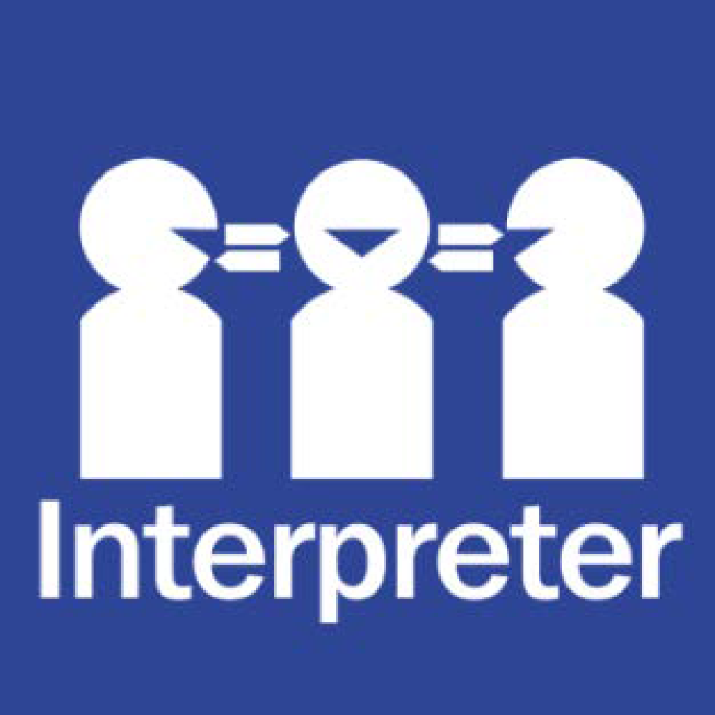
Help for non-English speakers

If you need help to understand the information in this policy please contact the main office on 9857 5157 or email at Boroondara.park.ps@education.vic.gov.au

PURPOSE
The purpose of the Student Dress Code is to outline Boroondara Park Primary School’s requirements for student dress and appearance and to provide information about uniform purchase and support, dress code implementation and exemption processes.
This dress code has been developed by Boroondara Park Primary School’s School Council in close consultation with our school community to ensure that it respects the rights of individual students whilst reflecting the values and interests of our community.

The Student Dress Code aims to:
- foster a sense of community and belonging and encourages students to develop pride in their appearance
- support Boroondara Park Primary School commitment to ensuring that our students feel equal and are dressed safely and appropriately for school activities.
- reduce student competition on the basis of clothing
- enhance the profile and identity of the school and its students within the wider community.

The School Council has developed a dress code that we believe provides a range of choices for students and is cost effective for families.

SCOPE
Students are expected to comply with this Student Dress Code while traveling to and from school, during school hours and when attending school activities.
UNIFORM AND APPEARANCE

The full list of Boroondara Park Primary School’s compulsory school uniform items are available on our school’s website at - https://www.bpark.vic.edu.au/page/169/Uniform

General appearance

While at school, travelling to or from school or participating in school activities, Boroondara Park Primary School students must comply with the following:
- Uniforms must be clean and in good repair
- Uniforms must be clearly marked with the owner’s name
- Additional layers of clothing may be worn underneath the uniform for added warmth, provided these undergarments are completely hidden.

Jewellery and cosmetics
Students are not permitted to wear decorative jewellery to school. Stud earrings and sleepers worn in the ears, and watches, are the only acceptable jewellery.

Cosmetics may not be worn at school. Only clear nail polish is permitted.

Hair and Sun safety
Shoulder length or longer hair is to be tied back to help restrict the spread of nits and lice and for student safety.

School uniform hats must be worn outside in Terms 1 and 4 and on any other day prescribed by the school. School uniform hats may also be worn at any time, by parent or student choice.

Hats are not to be worn inside.

Students are permitted to wear sunglasses during outdoor activities. Sunglasses should be close-fitting, wrap-around that meet the Australian Standards 1067 and cover as much of the eye area as possible.

PURCHASE OF UNIFORMS
Uniform items can be purchased from the uniform shop at school, or parents may order it directly from RH Sports.

Boroondara Park Primary School also operates a second-hand uniform store for parents. In general there are two sales per term.

Support for families experiencing difficulty
Please contact the Principal to discuss support that we may be able to provide to families experiencing difficulty meeting uniform costs, including information about eligibility for uniform support through State Schools’ Relief. Further information about State Schools’ Relief is also available on their website: htps://www.ssr.net.au/
IMPLEMENTATION
Boroondara Park Primary School will ensure that the Student Dress Code is communicated to all families and students through our website and newsletters. We will assist students who may be experiencing difficulties complying with this policy where possible.

If a student is out of school uniform or otherwise breaches the Student Dress Code on a recurring basis, a note will be provided to the student and parents by the classroom teacher. If non-compliance with the dress code becomes a continued occurrence, the Principal will be informed and a phone call home may be required. In this event, the school will continue to work with the student and family to support compliance.

Measures taken by Boroondara Park Primary School to address concerns about student non-compliance with the Student Dress Code will also be addressed in accordance with our Student Wellbeing and Engagement Policy.

EXEMPTIONS TO STUDENT DRESS CODE
We recognise that there may be situations where the application of this dress code may affect students unequally.
Students and their parents or carers may apply either in writing or in person to the Principal for an exemption to this Student Dress Code if:
- an aspect of this code prevents the student from complying with a requirement of their religious, ethnic or cultural beliefs or background
- the student has a particular disability or health condition that requires a departure from the dress code
- the student or their parents/carers can demonstrate particular economic hardship that prevents them from complying with the dress code.
When the Principal receives a request for an exemption, they will:
- consider the grounds for the exemption request
- explain the process to the student and/or their parents/carers
- encourage the student and/or their parents/carers to support their application with evidence.
The Principal or delegate will then try to negotiate a resolution that is acceptable to all parties. If an exemption is not allowed, then written reasons will be provided to the student and/or their parents or carers.
CONCERNS ABOUT THIS STUDENT DRESS CODE
Boroondara Park Primary School welcomes feedback from the school community in relation to this Student Dress Code. If you have a concern or complaint about the Student Dress Code, further information about raising a concern or complaint is available in our school’s Parent Complaint Policy, available on our school’s website.

COMMUNICATION
This policy will be communicated to our school community in the following ways:

- Available publicly on our school’s website
- Reminders in our school newsletter
- Discussed in student forums
- Included in staff handbook/manual
- Discussed at staff briefings/meetings as required
- Included in transition and enrolment packs
- Discussed at parent information nights/sessions
- Hard copy available from school administration upon request

FURTHER INFORMATION AND RESOURCES
- Boroondara Park Primary School Sunsmart Policy
- Boroondara Park Primary School Parent Complaint Policy
- Boroondara Park Primary School Student Wellbeing and Engagement Policy
- Department of Education and Training Student Dress Code
- Department of Education and Training Student Engagement policies and guidelines.
POLICY REVIEW AND APPROVAL
Policy last reviewed | 6 September, 2021
Approved by | School Council
Next scheduled review date | 2025

