Uniting St Joseph’s
Before and After School Care

Hello Parents, Carers and Families of Uniting OSHC at St Joesphs’ Nagambie.

Welcome to the 2nd Newsletter for June.
Over the last two weeks the children at OSHC have been enjoying some fun times indoors due to the cold weather that hit us with a vengeance. As they like to play sporting activities, I set up a tabletop Table Tennis game which was quite a hit. It was great to see children of different ages playing against each other and having so much fun.
We also had two Pupil Free days where the children engaged in some fun activities.

For any further information please contact me on 0482133582 for enrolment information.

I welcome you to come in and see me on any morning or afternoon. Rose.

Rosemarie Farrugia
Service Leader
St Josephs’ Nagambie.


Rosemarie Farrugia
Service Leader
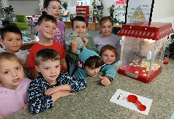
0482133582

Important dates for this term at
Uniting OSHC St Josephs’ Nagambie

7th July Day one of Holiday Program

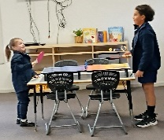
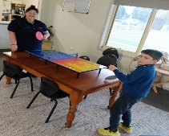
18th July: Last Day of Holiday Program

10th August: Science Week Begins

7th Sept: Father’s Day

22nd October: Term 3 Holidays Begin!
Be sure to book in for the Holiday program 15 Places available, we are offering some great Excursions, Incursions and fun filled activities.


