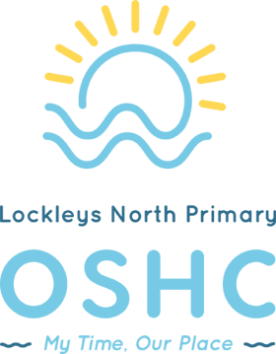
Lockleys North Primary School OSHC Summer Menu
Summer | Monday | Tuesday | Wednesday | Thursday | Friday
Breakfast
Week 2 | Mango magic smoothie | Overnight oats with frozen berries & coconut | Rye bread with cream cheese and strawberries | Cereal with frozen berries and milk | Ricotta hotcakes with yoghurt & seasonal fruit
Afternoon tea
Week 2 | White bean dip, cheese, veggie sticks & crackers | Zucchini slice | Grilled cheese with ham and tomato | Pea, feta and tomato frittata | Pesto and veggie pasta bake

