Dear Parent/Guardian,

I am pleased to provide you with the following details regarding Interm Swimming Lessons for Pre Primary to Year 10 to be held in week 8 and 9 of this term.

Please retain this information letter for your records but return the accompanying consent form and enrolment form to class teachers by Monday 16th November 2020.

Purpose of the Excursion: Provide opportunities for students to further develop their swimming and water safety skills through participation in the activities of the Country Interm Swimming Program.

Conducted by: AustSwim qualified Swimming Instructors. Centre Supervisor will be Bethan Graham.

Dates: Monday 30th November- Friday 11th December 2020

Cost: Nil

Location: Mukinbudin Swimming Pool

Transport Arrangements: Students will be transported by bus

Staff Action in Case of Accident or Illness on the Excursion: First aid as per Mukinbudin DHS Policy. School and parents will be notified.

Special Items Required: Broad-brimmed hat, bathers, rashie, sunscreen, towel, slip on shoes (optional) and goggles (optional). Consider packing extra lunch in your child’s lunch box as they are often hungry after swimming.

Please note that:
Staff accompanying students on excursions will take all reasonable care while the students are in their charge to protect them from injury and to control and supervise their behavior and activities. Parents/guardians should be aware that staff members are not responsible for injuries or damage to property which may occur on an excursion where, in all circumstances, staff have not been negligent.
In the case of an excursion not involving an overnight stay, costs incurred as a result of accident or illness is the responsibility of the parent/guardian.
The school camp/excursions insurance policy applies for approved camps/excursions involving an overnight stay. The policy covers students to a maximum of $50,000 for medical and ancillary expenses where Medicare or private insurance does not cover these costs.
Parents are required to inform the organisers well before the scheduled excursion departure of any change to their child’s health and fitness so that appropriate supervision may be arranged.
Where it is considered necessary, school staff will arrange medical assessment and treatment of students.
Should you have any queries please do not hesitate to contact the office on 90483400, during school hours.

Consent Form for Water Based Excursions

This form is intended to assist the school and supervision teachers in the event of an emergency involving your child. It is required for all children attending water based excursions.
There are two types of water based excursions:
- Closed Water: water in a controlled environment (still or slow moving) such as swimming pool, sheltered coastal areas, dam or inland water body.
- Open Water: water in an uncontrolled environment (fast moving or turbulent) such as a surf beach, flowing river or waterway with tidal waters.

Your child has been invited to attend a CLOSED water excursion.

Student Details

Student Name: ______________________________________Date of Birth:________________

Parent or guardian’s full name: __________________________________________________________________________________

Address: _________________________________________________________________________________

Main Ph No: ________________________ Other Ph No/s: _____________________________
Family Dr: ______________________________________ Dr Phone No.____________________
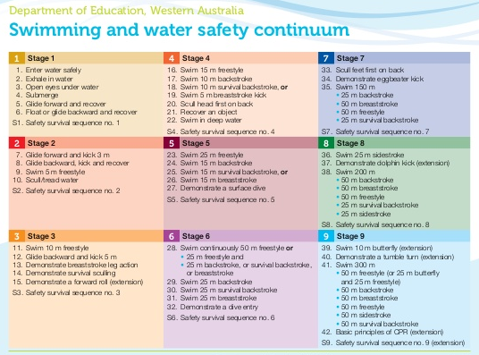
Swimming Ability:

Department of Swimming and Water Safety levels

My child has achieved stage:

Date achieved: _________________

I am unsure. Please assess my child:

