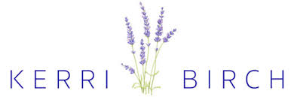
ARTISAN ART THERAPY
ABN 56157625493

Bookings now open for Groups
and Individual Appointments

Is your child having a difficult time at school, personally or socially?
Are you struggling with a problem and unable to see a solution?
Art Therapy is a creative and unique method for intervention in resolving difficulties, providing understanding and overcoming challenges in a fully supported and non-judgmental environment.
This may include:
- Coping and Problem Solving
- Identifying and Utilising Personal Strengths
- Self-Esteem, Anxiety and Self-belief
- Changing Behavioural Patterns
- Expression of Feelings
- Social Skills
- Identifying Emotions
- Grounding, Engagement and Attachment
- Decision Making
- Finding Purpose
- Letting Go
- Trauma, Grief and Loss
Art Therapy is an approved NDIS therapy, please check with your plan coordinator.
Individual and group therapy dependant on places available.
For further information or to book a no-obligation information session, please call
Kerri Birch on 0447445495
or email artisanarttherapy@gmail.com

