CAREER NEWS Friday 13 March

 Dates to Diarise in Term 1
- Victorian Careers and Employment Expo – 19 to 21 March 2026

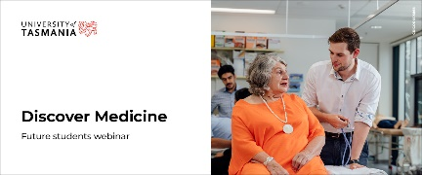 Discover Medicine Webinar – University of Tasmania
Are you considering studying medicine in 2027?

Join the University of Tasmania’s Discover Medicine webinar to hear directly from Dr. Anthea Dallas, Director of Medicine, and learn what studying the Bachelor of Medical Science and Doctor of Medicine at the University of Tasmania is really like.

The webinar will cover:
· Course structure and curriculum
· Student experience and support
· Clinical placements and practical learning opportunities
· Campus locations
· Entry requirements
· Key pathways and processes

Date: Thursday 12 March 2026
Time: 6.00pm – 7.00pm (AEDT)

Register at Discover Medicine Webinar.

 Victorian Careers & Employment Expo 2026
Victorian Careers & Employment Expo will showcase over 130 organisations and employers with career opportunities for all ages.
This free event is for school students, parents, teachers, graduates, job seekers, people looking for courses and workers seeking new training and career options.
The Expo is packed with Free advice, and attendees can -
- Talk with over 130 Training Organisations & Employers
- Gain Free Career Advice
- Discover Jobs of the Future
- Talk with Leading Organisations about Training & Apprenticeships
- Experience the Free Career Seminars
- Enjoy the Try’a Skill Zones

Dates: Thursday 19 March, 9am to 3pm
Friday 20 March, 9am – 3pm
Saturday 21 March, 9am to 4pm
Venue: Melbourne Showgrounds in Ascot Vale

 Discover ACU – April Holidays
Students from Years 10 – 12 can explore our campuses, engage in hands-on workshops, and meet other students who have similar course and career aspirations. They can also chat with current ACU students and staff to get a sense of university life.
Discover ACU Ballarat: Occupational Therapy and Physiotherapy
Monday 13 April 10.00am – 12.30pm
Register now
Discover ACU Ballarat: Teaching and Education
Monday 13 April 1.30 – 4.00pm
Register now
Discover ACU Ballarat: Nursing and Paramedicine
Friday 17 April 10.00am – 4.00pm
Register now

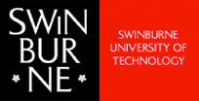 Day in the Life of a Swinburne Student
Keen to experience a regular day on campus? Curious to know exactly what your dream course involves? Not sure which study path is right for you? Come along to our Hawthorn campus for a sneak peek at what comes after high school.
Students in Years 9 – 12 are invited to experience a day at Swinburne. Whether students are interested in fashion design or biomedical science, each day covers different study areas so students can get a firsthand glimpse of what your Uni experience might be like – based on what they are interested in studying.
Health, Sport & Psychology
Allied Health, Biomedical Science, Exercise and Sport Science, Forensic and Clinical Nursing, Nutrition, Psychology, Sports Management
Tuesday 14 April 9.00am – 3.00pm
Register now
Science, Engineering & IT
Artificial Intelligence, Astronomy and Astrophysics, Aviation, Architectural Engineering, Biomedical Engineering, Chemistry, Cyber Security, Product Design Engineering, Software Engineering
Wednesday 15 April 9.00am – 3.00pm
Register now

Design, Media & Social Impact
Arts and Politics, Business, Education, Fashion Design, Games and Animation, Industrial Design, Law, Criminal Justice and Criminology, Social Media, Visual Arts

Thursday 16 April 9.00am – 3.00pm
Register now
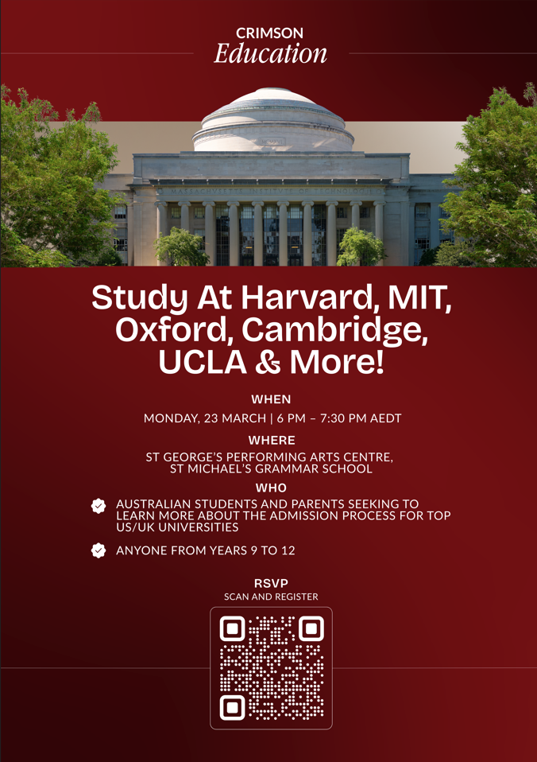
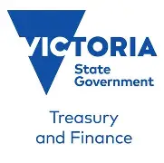 Mentoring Women Program
The Mentoring Women Program provides an opportunity for women and gender diverse university and Year 11 and 12 high-school students interested in or studying economics and policy to connect with passionate mentors at the Department of Treasury and Finance (DTF) over a six-month period. DTF employs economists to design and implement policies that improve the lives of Victorians.
Students will participate in small group sessions with mentors from DTF. In the program, secondary school and university students are paired with mentors from DTF and have one-on-one mentoring sessions throughout the second half of 2026. Students also have an opportunity to network with other program participants at learning and development sessions on topical economic issues.
Previous topics have included using economics in public policy, Truth and Treaty in Victoria, youth housing, as well as advice on job applications.
Mentoring sessions are tailored to suit the needs and goals of individual students. This allows mentees to gain relevant career and educational guidance, and an insight into the diverse pathways to economics and possible careers available to them.

Application for the program are open now and will close on Sunday 22 March 2026.
Students keen on finding out more might like to browse Mentoring Women | DFT and also watch the video provided.

 RMIT Trades Experience
Join us at RMIT's Trades Experience to take the first step towards a career in trades.

RMIT is hosting a Trades Experience for students keen on finding out more about a trade. At the Trades Innovation Centre, students will experience four interactive stations where
they will rotate through four hands-on stations led by RMIT teachers and students.
The stations will cover the following trades:
- Carpentry: Learn how to safely use a nail gun and practice basic construction techniques to make a mini stool.
- Plumbing: Join a pipe connection challenge and pull apart a tap to see how they work from the inside out.
- Electrical and Refrigeration: Practice using wire strippers, learn the basics of circuitry and wiring, and experiment with using thermal cameras.
- Surveying: Use specialised equipment to measure distance and see how the experts use laser scanners to capture accurate measurements.
Date: Thursday 26 March
Time: 4.30pm - 6.30pm
Location: Trades Innovation Centre, building 262, Bundoora campus
Free onsite parking is available.
Registration is essential. Book a spot at RMIT Trades Experience.

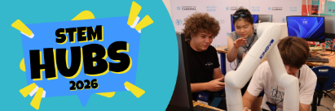 2026 National Youth Science Forum (NYSF)
Are you curious about STEM and what comes next?
The 2026 National Youth Science Forum (NYSF) Melbourne STEM Hub is a 4-day immersive experience, taking place from Tuesday 7 – Friday 10 April 2026, connecting Years 10–12 students with real study options and STEM careers.
It’s also an opportunity for students in Years 10 and 11 to get a first-hand glimpse of what is available in the NYSF flagship Year 12 Program, which consists of two 9-day residential programs run in early January each year. Applications for the Year 12 Program will open to current Year 11 students in April.
The NYSF Melbourne STEM Hub will include visits to leading institutions and organisations including The Australian Synchrotron and a full day at Monash University Clayton Campus, and more!
Registrations are open for the first STEM Hub of the year, and students keen on joining should register soon as places are filling fast!
Find out more and register here!

 Fashion, Textiles, & Visual Merchandising Courses in Victoria in 2026
Entry into many of these courses requires a folio presentation. Some of these courses are listed below, but for a comprehensive list of courses at all institutions including Private Providers - such as Collarts, LCI Melbourne, The Masters Institute of Creative Education, Whitehouse Institute of Design, and Torrens University - and their specific entry requirements, please visit VTAC.
INSTITUTION | COURSE | MAJOR STUDIES IN 2026
Box Hill Institute | Bachelor of Design (Fashion Design) | 3D design and virtual prototyping, advanced digital product design, complex patternmaking, digital CAD principles, digital marketing, exploratory design, fabrics and fibres, fashion product development, fashion range development, fashion supply chains, garment construction, production processes, special event management, sustainable design practice, tailoring, understanding the consumer, visual merchandising.
Box Hill Institute | Bachelor of Design (Fashion Enterprise) | Creative design process, advanced digital product design, branding fundamentals, content creation, digital CAD principles, digital commerce, digital marketing strategy, fashion analytics, fashion buying, fashion product development, fashion range development, fashion styling, production processes, retail finance, special event management, supply chain networks, sustainable design practice, understanding the consumer, visual merchandising, web design.
Holmesglen Institute | Bachelor of Fashion Design | Contemporary Communication Practices, Design Innovation, Industry Techniques, Pattern Engineering, Sustainability and Ethical Practice.
Holmesglen Institute | Certificate IV in Apparel and Fashion | Colour Theory, Computer Aided Design Tools, Design Studio Concepts, Garment Construction, Networking with Industry, Pattern Development, Product Sourcing.
Kangan Institute | Certificate III in Apparel, Fashion and Textiles | Computer-aided design (CAD), Fabric and fibre technology, Fabric technology, Fashion, Fashion (design concepts), Fashion (design), Fashion (illustration), Fashion (pattern grading), Garment construction techniques, Marketing research, Marketing strategy, Networking, Pattern-making, Pattern-making (computer), Quality assurance, Quality control.
Melbourne Polytechnic | Diploma of Live Production & Technical Services Costume | Accessory Construction, Theatrical Millinery, Costume construction, Costume design, Costume making and co-ordination for stage and screen, Costume research, Making Character and Period costumes, Pattern Making and Draping, Underwear and Corsetry.
RMIT University | Bachelor of Fashion (Design) | Design, Fashion, Sustainability, Textiles.
RMIT University | Bachelor of Fashion (Enterprise) | Fashion, Marketing, Merchandising, Product Management, Retail Management, Sustainability.
RMIT University | Bachelor of Fashion Sustainability | Circular design, Digital communication, Digital fashion, Fashion, Innovation, Materials, Sustainability, Technology, Textiles.
RMIT University | Associate Degree in Fashion | Business and Retail Options, Design and Technology Options, Fashion Business, Fashion IT and Design, Fashion Pattern and Production, Fashion Specifications, Fashion Textiles, Global Impacts of Fashion Industry, Production Planning and Supply Chain.
RMIT University | Diploma of Fashion Styling | Business practices for fashion stylists, Catalogue styling, Editorial styling, Event management and styling, Fashion trend analysis, Personal styling, Project Management, Styling for still and moving images.
RMIT University | Diploma of Apparel, Fashion and Textiles | Developing and constructing products, Dyes for textiles, Experimental textiles, Fibres and fabrics, Knitting, Screen printing, Social media, Studio class, Sustainability, Textile design concepts, Textile design process, Weaving
Swinburne University | Bachelor of Design (Fashion) | Emerging technologies in fashion and textile design, Fashion branding and management, Fashion design capstone, Global fashion cultures, Professional fashion practice, Sustainable fashion design, Wearable technology design studio.
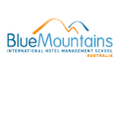 Snapshot - Blue Mountains Hotel Management School in 2026
- Blue Mountains International Hotel Management School (BMIHMS) was founded in 1991 and is a college of Torrens University Australia .
- Ranked #3 in Australia in the QS World University rankings by subject 2025 (Hospitality and Leisure Management).
- There are two campuses in NSW: Leura Campus – situated in the Blue Mountains, and the Sydney Campus, which is in the heart of the CBD. There is also the Melbourne Campus in Victoria for students hoping to study the Master of International Hotel Management.
- The BMIHMS offers three courses, including the popular Bachelor of Business (International Hotel Management).
- The Master of International Hotel Management is offered to students in Sydney and Melbourne.

Find out more at Blue Mountains International Hotel Management School.

