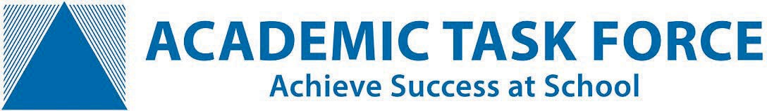
Term 3 School Holiday
ATAR Revision & Skills Development Courses

Enrolments are now open for Academic Task Force - ATAR Revision Courses and Skills Development Courses running in Week 1 and 2 of the October School Holidays.

ATAR Revision Courses for Years 11 & 12

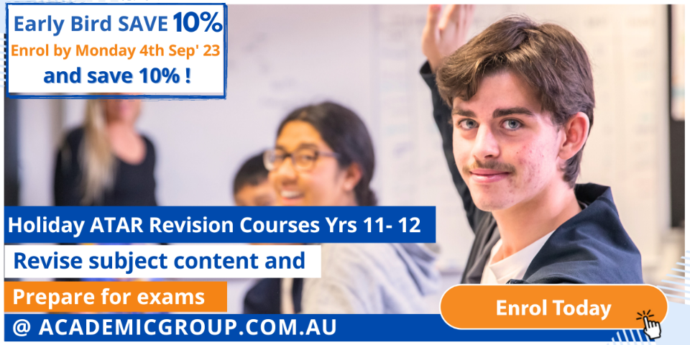
ATAR Revision Courses will help your child revise and prepare for exams, maximizing their exam performance and grades. We offer 10-hour ATAR Revision courses (2 hrs a day, over 5 days) in most ATAR subjects including Essay Writing and Study Skills courses.

- WA’s top ATAR teachers
- Receive interactive teaching from subject specialists
- In-depth revision of the syllabus
- Practise various exam-style questions
- Receive study tips and strategies
- Increase your confidence and understanding
- Maximise your exam performance

Venues: Churchlands SHS, Leeming SHS
and Online.

To enrol: https://academicgroup.com.au/course/holiday-programs/
______________________________________________________________________________________________

Skills Development Courses for Years 7 - 10

Skills Development Courses will improve your child’s confidence and help develop their academic skills. We offer 6-hour (3 hrs a day for 2 days) Skills Development courses in Maths, English, Essay Writing and Learning Skills.

- Learn from WA’s top teachers
- Small group classes for individual attention
- Targeted help to ensure you develop your child’s skills
- Learn time management and homework strategies
- Learn how to structure and write essays
- Build your child’s confidence

Venues: Perth Modern School.

To enrol: https://academicgroup.com.au/course/holiday-programs-2/
Enrol online:
www.academicgroup.com.au
Call: 9314 9500
learn@academicgroup.com.au
Term 3 & 4 – Exam Boost Workshops

Exam Boost Workshops for Years 11 - 12

Exam Boost Workshops delivers subject-specific, targeted, exam preparation in the weeks leading up to exams. In one day, each workshop packs in 6 hours of exam focused teaching from a WACE exam marker, with the sole purpose of boosting student’s exam technique and performance.
- Targeted exam preparation
- Learn new exam techniques
- Strategies and problem solving methods to boost your exam performance
- Insights into the exam marking guide
- Practise answering exam-style questions
- Receive feedback from an experienced exam marker
Venues: Churchlands SHS, Rossmoyne SHS,
Perth Modern School, and Online.
To enrol: https://academicgroup.com.au/course/exam-boost-seminars/

________________________________________________________________________________

Enrol online:
www.academicgroup.com.au
Call: 9314 9500
learn@academicgroup.com.au

