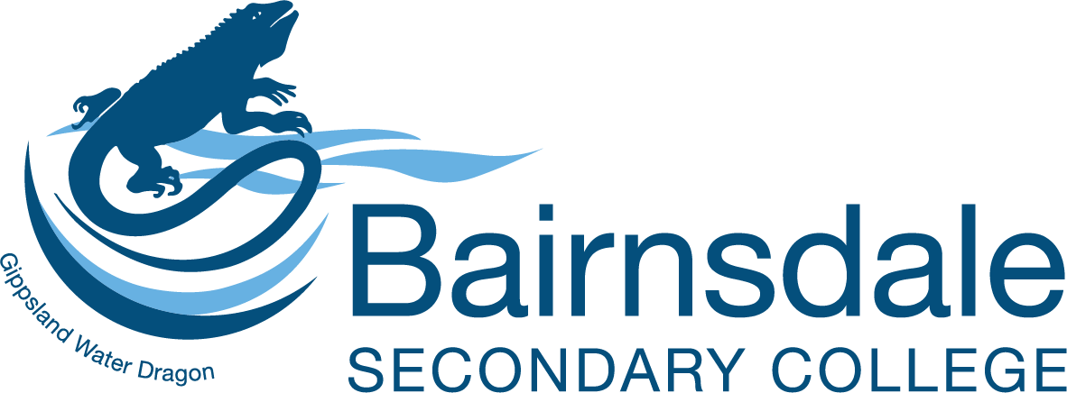
PO BOX 325, Bairnsdale, 3875
90 McKean Street, Bairnsdale, 3875
Tel: 03 5150 4800 Fax: 03 5150 4801
bairnsdale.sc@education.vic.gov.au
www.bairnsdalesc.vic.edu.au
27th August 2024

Dear Parents/Carers

This letter provides a comprehensive overview of the key dates and activities for Year 12 students at Bairnsdale Secondary College for the remainder of 2024. The school has organised an extensive VCE exam revision program during the September holidays and into Term 4. Most students will undertake VCAA external exams starting on 29th October and are expected to attend regular classes until 24th October. Students who have completed all VCE requirements, including Vocational Major students or those not sitting end-of-year exams, may conclude formal schooling at the end of Term 3.

IMPORTANT DATES – TERM 3
Friday -  13/09 | - English Revision Lecture: for Year 12 VCE students – Session 3 & 4 in W1/W2
Tuesday -17/09 | - Dress-Up Day: Theme - "What I want to be when I grow up."
Friday  20/09 | - Student Free Day  - Exam Skills Day: Year 12 VCE students to attend – times TBC
Friday  20/09 – 04/10 | - Holiday Revision Program: Online subject-specific exam revision available.

IMPORTANT DATES – TERM 4

Monday  07/10 | - Student Free Day  - Year 12 English Practice Exam: 8:45 am – 12:15 pm at Wallace Street Exam Centre.
Tuesday  03/10 – 18/10 | - Exam Revision Program: Year 12 classes will run as scheduled for students sitting exams.
Thursday 24/10 | - Hat & Tie Day: Students wear full school uniform with a hat and tie of choice.  A whole school assembly will be held session 4 in Boucher Hall, followed by the Hat and Tie photo and shirt signing over the lunch break.  - Last Day of Year 12 Scheduled Classes
Friday  25/10 | - Celebration Day: No classes for Year 12 students.  - Details: To be provided via compass.
29/10 – 20/11 | - End of Year External Examinations: Full school uniform required for all exams.  - 29th October: English Exam from 9:00 am – 12:15 pm.  - Study Days: Students can study at home or school. Teachers available during scheduled class times until the end of the exam period.
Monday  4/11 | - Student Free Day: Staff professional development.  - Exams: Year 12 students to attend scheduled exams in full school uniform.
Tuesday  5/11 | - Public Holiday: Melbourne Cup Day.
Thursday  21/11 | - Year 12 Graduation Ceremony: [Details Provided in Attached Document]
Monday  12/12 | - VCAA Results Available to Students

PO BOX 325, Bairnsdale, 3875
90 McKean Street, Bairnsdale, 3875
Tel: 03 5150 4800 Fax: 03 5150 4801
bairnsdale.sc@education.vic.gov.au
www.bairnsdalesc.vic.edu.au

GRADUATION 2024
The Year 12 Graduation Evening for Bairnsdale Secondary College is scheduled for Thursday, 21st November 2024, at the Riviera Christian Centre. This event celebrates the accomplishments of the graduating Year 12 students and marks the beginning of a new chapter in their lives.

Event Details:
- Date: Thursday, 21st November 2024
- Location: Riviera Christian Centre
- Time: Doors open at 6:00pm, for a 6:45pm start.
- Break: There will be a light supper served during the evening 30-minute break.

Key Tasks for Year 12 Students (Due by 29th September 2023):
- Upload ‘Now and Then’ Photos: Submit photos via Compass or directly to Yvonne.
Original photos will be returned.
- Complete Graduation Information Sheet: Accessible through the Compass link.
- Notify Attendance Status: Inform the Year 12 Coordinator if not attending the event.
Ticket Information:
- Guest Tickets: Available for purchase on TryBooking from Wednesday, 16th October.
- Cost: $40 per guest; graduates attend for free.
- Reservation: Each student can reserve up to three guest tickets until Friday, 3rd November. Additional tickets will be available for purchase after this date.

For any enquiries, contact Yvonne Rooney. The evening promises to be a memorable celebration of the year’s achievements, we look forward to seeing you there.

Kind regards
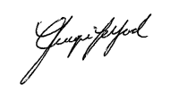

Jacqui Telford
Assistant Principal
Bairnsdale Secondary College

