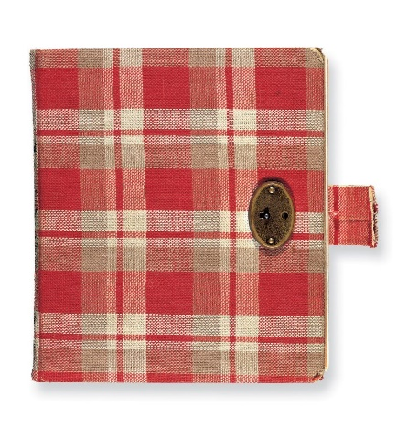Anne Frank

**Anne’s first years**

Anne Frank was born in the German city of Frankfurt on 1929. Anne’s sister Margot was three years older than her

Unemployment was high and poverty was even higher in Germany, and it was the period in which Adolf Hitler and his party were gaining more supporters and land. Hitler hated the Jews and pointed his finger at them for the problems in the country.

The hatred of Jews and the poor economic situation made Anne's parents, Otto and Edith Frank, decide to move to Amsterdam. There, Otto was making a good living becoming quite rich.

Education

On 9 April 1934, Anne Frank went to kindergarten at the 6 the Montessori School in Amsterdam. The school was only a few streets away from her home. She attended primary school until 1941.

One day Hitler tried to get rid of all the Jews. Anne and her parents met two nice people who helped them and hid them in what they called ‘the secret annex’ it was hid by a book case on hinges it would be long days where all Anne frank could do was write in her diary

Diary

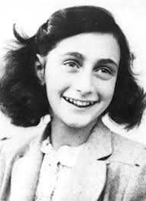Anne frank kept a diary that she documented the war in, that she received for her birthday just before the war started

Anne’s personal life

She always said that she had strings of boyfriends she was considered as a pretty girl but fancied one boy and he was Peter Van Daan one night they found themselves in the attic on a magical night they Slowey came to each other and kissed

Found!

On the 3rd of May 1957 when the secret annexe failed to protect Anne and her family, they had been found

How did Anne Frank's life end?

Though her writings survived, Anne died of typhus fever at the age of 15. For decades, historians listed the date of her death as occurring on March 31, 1945 a mere two days before the Bergen-Belsen camp was liberated by the American forces.