

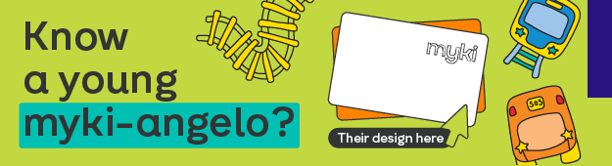

You might have heard that under 18s now travel free on all public transport with a Youth myki! Last year, 11-year-old Charlie’s winning design was chosen for the new Youth myki card — and you can now see his artwork on Youth myki cards across Victoria.

Now, the Youth myki Design Competition is back for 2026!
All Victorians aged 5 to 17 are invited to design the next Youth myki card for a chance to win a $1,000* Visa gift card. The new Youth myki design will be available for purchase online in 2027.
Whether it’s hand-drawn or digital, we’re looking for original, creative designs that capture the spirit of young Victorians.
Entries are now open and close 11.59pm, 2 August 2026.
Click to enter.
All competition details can be found on the Engage Victoria website.
Department of Transport and Planning

