

**Adolescent Parenting**

*For parents/carers of children aged between 12-18 years*

**This 2-hour information session aims to provide information on**

***Adolescence is unique time of growth and change, where alongside all of the physical changes, teenagers are getting ready to move into adulthood.***

* Adolescent development and its impacts
* Challenges facing adolescent s & parents/carers
* Understanding our child’s emotions & help to regulate
* Building resilience
* Connecting with your teenager
* Problem solving
* Family Values





**Emotion Coaching – Connecting with our kids**

(Based in the Tuning in Kids Program)

*For parents/carers of children aged between 2-10 years*

**This 2-hour information session aims to provide information on**

* Emotional intelligence and why it’s important
* Looking at children’s brain development
* Tuning into your children’s emotions to help manage behavior
* Learn about ‘emotion coaching’ – helping children to understand and regulate their emotions
* Looking at the different styles of parenting





**Raising Resilient Children**

(From the Triple P International)

*For parents/carers of children aged between 2-12 years*

**This 2-hour information session aims to provide information on**

* Recognising and accepting feelings
* Expression of feelings
* Building a positive outlook
* Developing coping skills
* Dealing with negative feelings
* Stressful life events



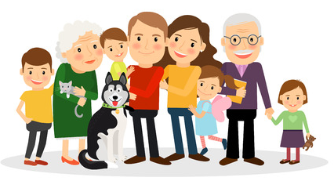

**The Power of Positive Parenting**

(From the Triple P International)

*For parents/carers of children aged between 2-12 years*

**This 2-hour information session aims to provide information on**

* Building strong relationships with children
* Good communication
* Teaching children new skills
* Predictable routines
* Focusing on the positive’s
* Positive environment
* Expectations of children
* Balancing family life





**Raising Confident, Competent Children**

(From the Triple P International)

*For parents/carers of children aged between 2-12 years*

**This 2-hour information session aims to provide information on**

* The importance of showing respect
* Being considerate
* Commutation & Social skills
* A health self esteem
* Supporting problem solving
* Encouraging independence

