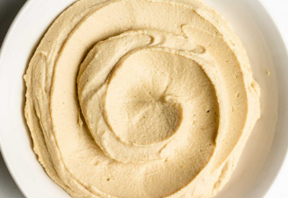
Skye Primary School

Hummus

Fresh from the garden: lemons



Equipment:  - Sharp knife  - Food processor  - Measuring cups and spoons  - Juicer  - Microplane | Ingredients:  - 3 cans of chickpeas, drained and rinsed  - 6 to 8 tbsp. water  - 6 tbsp. extra virgin olive oil  - 3 tbsp. lemon juice  - 3 garlic cloves grated using a microplane  - 2 tsp. ground cumin  - 1/2 tsp. salt

What to do:

- Add the chickpeas, 6 tablespoons of water, olive oil, lemon juice, garlic, cumin, and 1/2 teaspoon of salt to a food processor.
- Process until smooth and creamy. If needed, add additional water to thin out the hummus. Taste the hummus and add more seasoning if needed.
- Serve in small bowls with a serving spoon in each.

