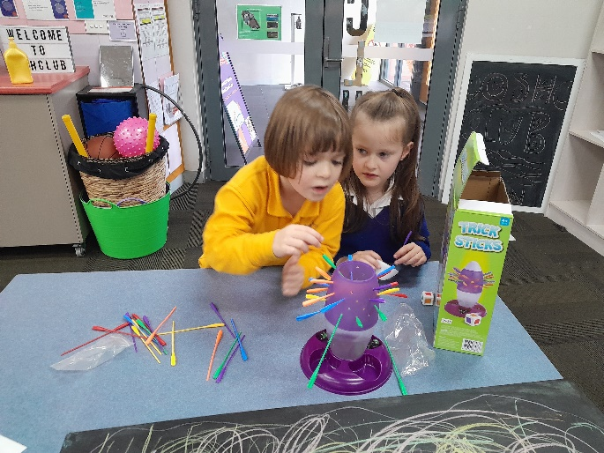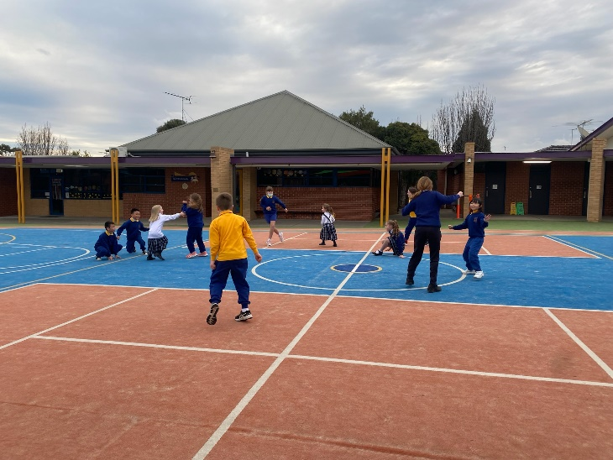

Over the last couple of weeks, we have been getting the children’s input on what they would like to do to at OSHClub.

We have been having group meetings with the children to discuss their ideas and suggestions so we can incorporate them into our program. They have been wanting to do more hands-on activities like Kinetic Sand and Playdough, which we will add on our planner in the next few weeks.

Our Coordinator Ash went to the snow

last week! She built a snowman, had a

snowball fight and did some

tobogganing.

We had some great feedback from the

staff filling in that all the children were

so kind, well mannered and all helped

one another. Well done everyone!

# What’s been happening…

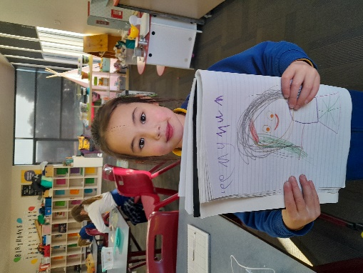

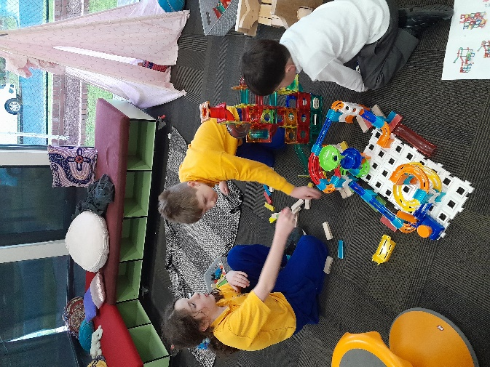

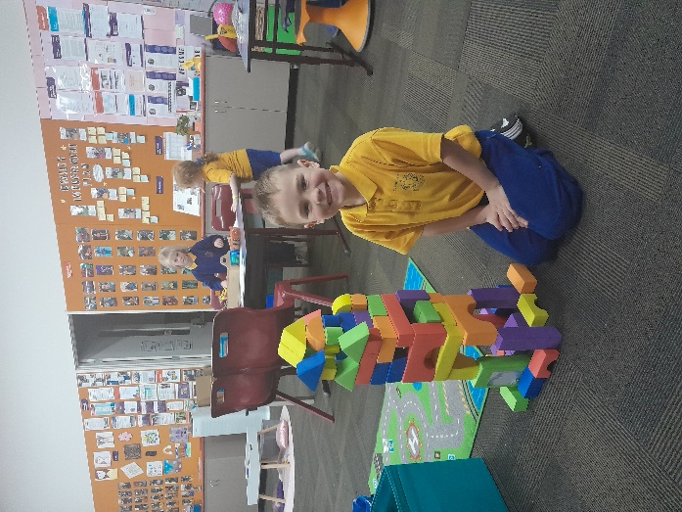

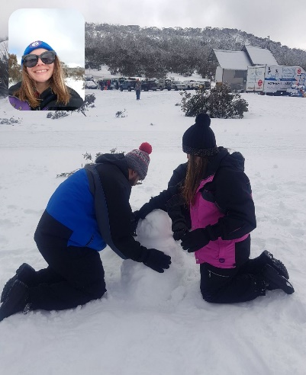

**Quality Area 6: Collaborative partnerships with families and communities**

Over the rest of the term, we will be focusing on families being supported to be involved in the service and contribute to service decisions.

We will be working on this by slowly implementing class dojo, which is an online platform to see photos of what the children have been up too.

If you have any queries or require further assistance, please contact us on 0401 501 661. Our contactable hours are between 7am and 9am and 3pm and 6pm; however, if you leave us a text message or voicemail outside of these hours, we will get back to you as soon as possible.

Furthermore, you can also call our Customer Service & Billing team on 1300 395 735

# Contact Us

School finishes at 1pm

Wear your footy colours day

School closure day

Service closed

# Quality Area Reflection

With our cardboard rolls and boxes, we give the children and opportunity to use them to create their own ideas on the art table. Jacob and Fenix worked together to create a robot outfit.

They incorporated paper, sticky tape and textas to create arms and a robot head. They were so patient in creating their robots and helped each other when they were finding it difficult.

They found an awesome way to use our recycled boxes and their robots turned out great!

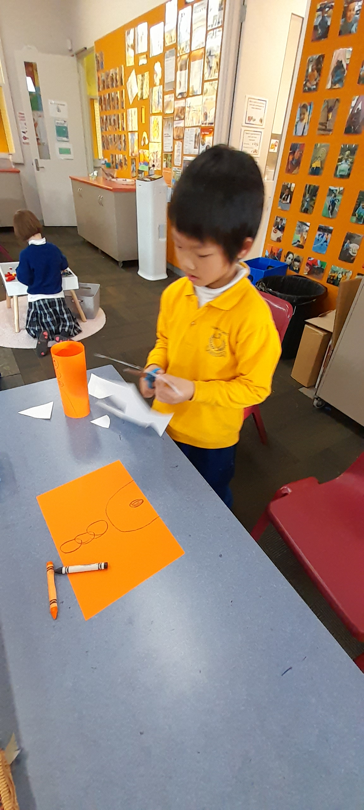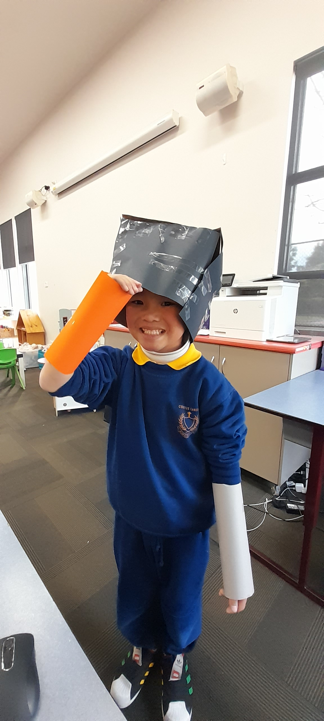

# Paper and recycled materials art and craft

# Important Dates

# Let’s Reflect

Well done Izzy for continuously growing her confidence in her climbing skills. She has been loving playing tiggy and other group games on the playground

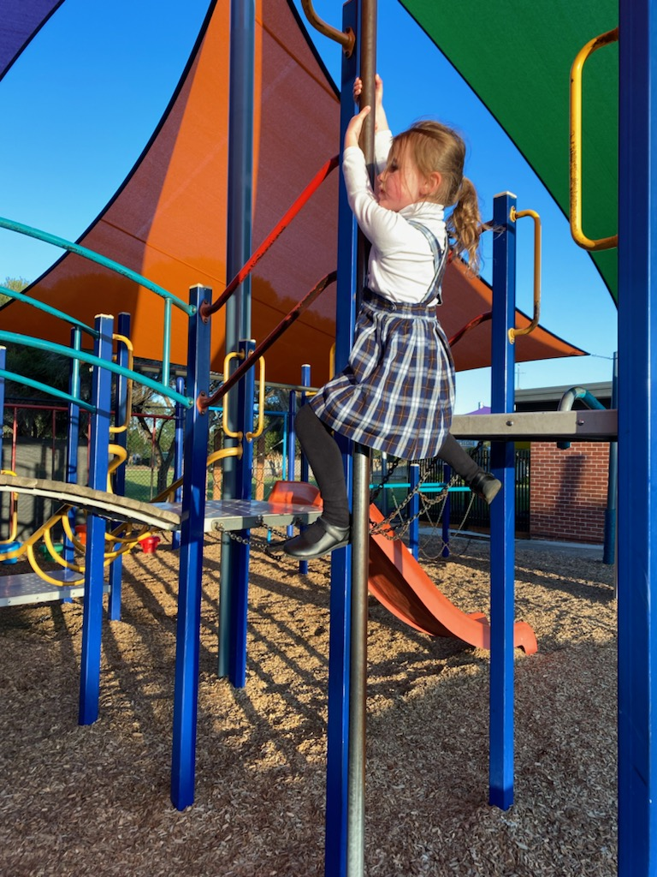

It has been great to see the children make Lego creations together! Well done to Lulu, Tex, Anh and Will for using their sharing and teamwork skills

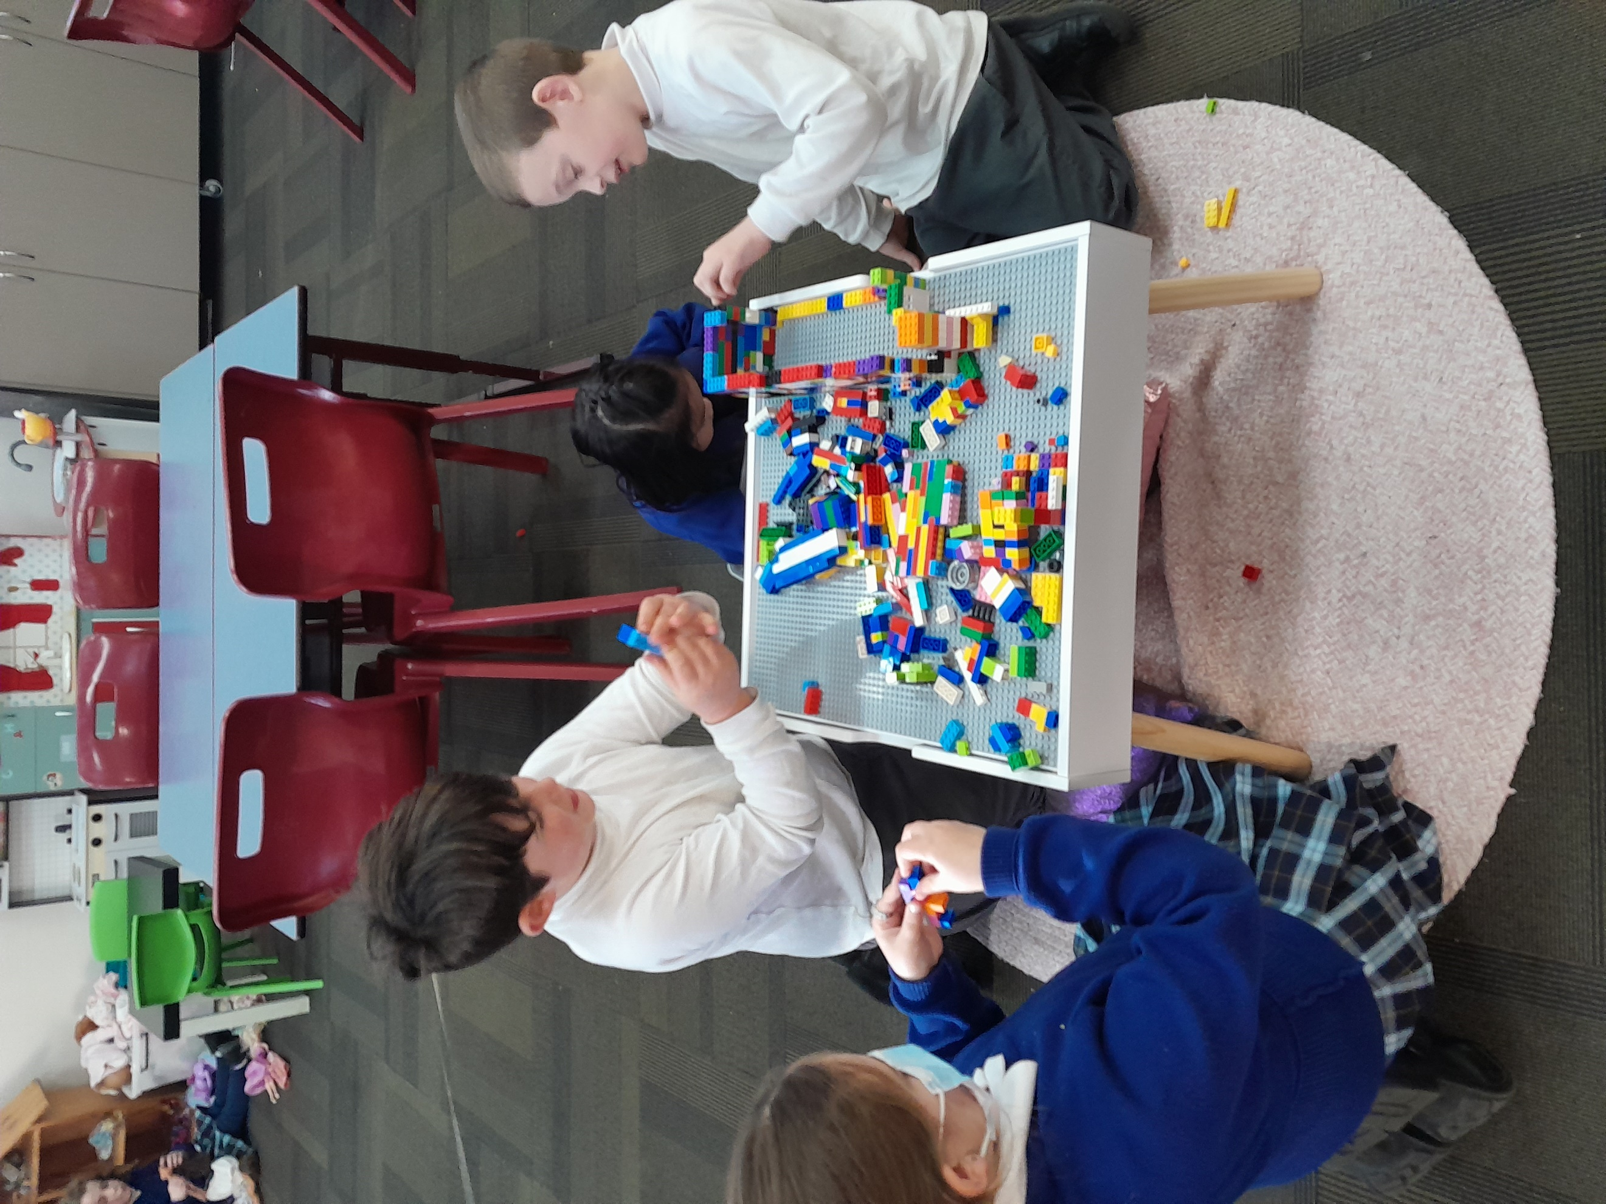

# OSHClub Stars

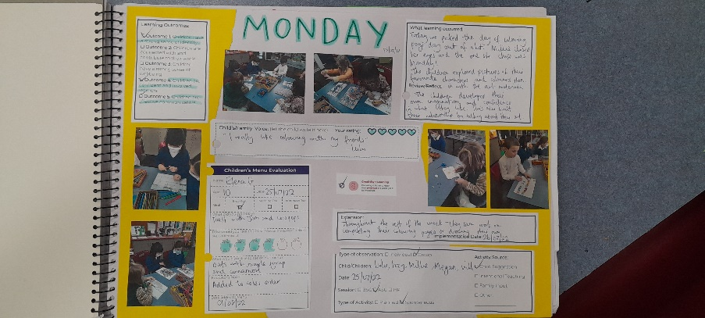

Come in and check our weekly reflection journal!

Inside you’ll find an overview of each day and all the fun activities the children have been enjoying.

Filled with pictures and the kid’s artwork, come in and have a look.

