Table of Contents
Section 1 for Students and Families 1
Career News 1
Career Events 7
Career Statistics 12
University Events. 15
University News 19
Training News 23
Senior School Opportunities 26
Year 12 Opportunities 29
Year 11 Opportunities 33
Middle School Opportunities 34
Regional Opportunities 37
Aboriginal and Torres Strait Islander Opportunities 39
Students with Disability Opportunities 42
International Student Opportunities 43
Blog posts with rich WA Career Information 44
Section 2 For Career Professionals 47
Events for Career Advisors 47
Career Events for Schools 50
Career News 51
University Resources 56
VET Resources 58
RRR Opportunities 59
Year 10 Resources 60
Year 7 – 9 Resources 60
Resources for Career Educators 61
Aboriginal and Torres Strait Islander Opportunities 63
Science Opportunities 64
Brain Food 66
Career Opportunities for Educators 68
Section 3 Career Calendar 2024 69

Section 1 for Students and Families

Career News

Careers Expo 2024
IDEAcademy
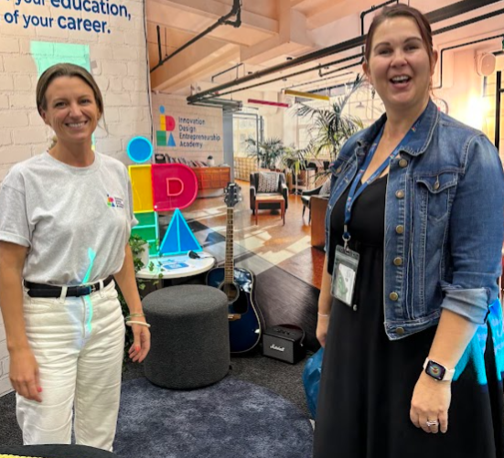
For the past few years the IDEAcademy team has been breaking new ground in the delivery of education to senior school students in WA.
They mix WACE and VET programs with the big focus being on innovative and flexible which help students to think and achieve beyond their horizons. Check them out HERE.

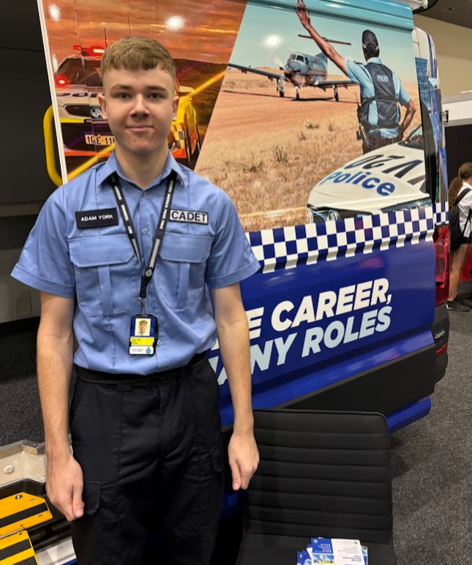
Police Cadets
Adam York dropped out of Year 12 this year when he won a Police Cadetship. He has always wanted to join the police force and was talking to school students about how he managed to get his cadetship without finishing school.
- There are mainstream cadetships which you can find HERE.
- And Aboriginal cadetships which you can find HERE.

ECU moving Teaching to Joondalup as ECU Mt Lawley Closes
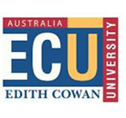
If you want to be a teacher and plan to study a Bachelor of Education at ECU from 2026, you will need to travel to Joondalup.
ECU is planning to close its Mt Lawley campus and Education will move to Joondalup in 2026.
WAAPA is moving to the new campus next to Perth station.. Geoff Gibbs was the father of WAAPA. His theatre in Mt Lawley will close and there is no plan to rename one of the new theatres in his honour. Other courses that are moving are:
- Business and Law
- Emerging Technology
- Kurongkul Katitjin
- WA Screen Academy
- Broadcasting and Digital Journalism
- Arts and Creative Industries.
See details HERE.
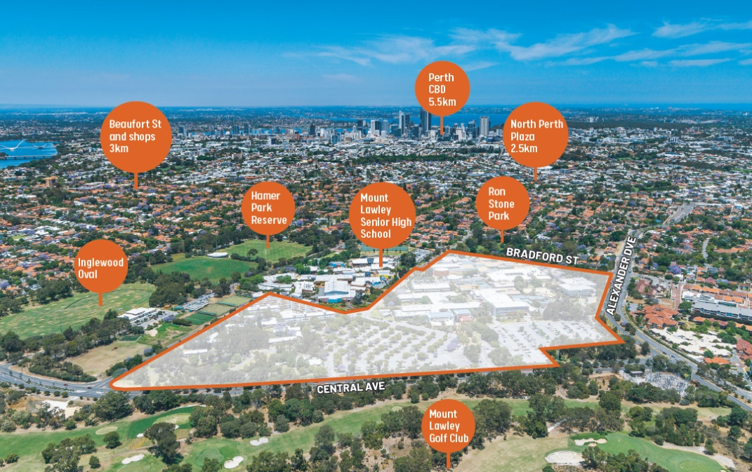
When Mt Lawley campus closes there will no longer be a university based in the eastern suburbs of Perth. According to Development WA the Mt Lawley campus site “presents an incredible redevelopment opportunity” .

Screen Industry Strategy
I was not the only one to get excited when I heard that WA had launched a 10 year Screen Industry Strategy. Friends across the State were excited about sharing the information.
Don’t build up your hopes. There is less than $8m a year from this strategy, across the whole of Western Australia for 4 years.
I have written about what this means for film makers in Are we about to grow a world renowned screen industry in WA?
Read my take on it HERE.

Federal government $90.6m to boost the number of construction and housing projects*
This $90.6m is mainly for $88.8m for 20,000 additional fee-free TAFE training places to increase the pipeline of workers for construction and housing, including:
- $62.4m, working with states and territories, to deliver an additional 15,000 fee-free TAFE and VET places over two years from January 1, 2025.
- $26.4m, working with states and territories, to deliver about 5,000 places in pre-apprenticeship programs over two years from January 1, 2025.
*WA has about 10% of Australia’s population so calculate about 10% of each of these amounts to see how WA is going to do.

State budget good for building apprentices and employers
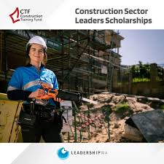
The State Government has put a bucket of money towards attracting apprentices into construction trades.
- There is a $1000 cash bonus for an Apprentice Tool Allowance and a $1000 payment for apprentices who complete their apprenticeship. Employers who employ three or four apprentices will receive $15,000. All the bonuses add up to $52.3M. See all the bonuses HERE.
- 150 places for apprentices through wage subsidies to Group Training Organisations. The wage subsidy is worth up to $135,000for a four-year apprenticeship. More information about the GTO Wage Subsidy Program is available on the Jobs and Skills WA website at jobsandskills.wa.gov.au/gws.

More Houses
There is a $1.1bn package of additional investment to boost housing supply, including $400m towards the Social and Affordable housing fund, $82m in stamp duty relief, $50m towards essential government worker housing and a $35m boost for regional land supply.

HIA Building Women Mentoring Program
If you are female and would like to tap into the booming building and construction industries, the Building Women Mentoring Program is designed to help you to overcome barriers to women joining the industries.
Construction Training Fund is supporting this exciting initiative, showcasing expertise in the industry and sharing knowledge across our networks. The program only goes for six months so get in touch with the CTF soon.

Sky Careers Launches Website Where Girls Aged 11 to 16 Can Explore Aviation Careers
Sky Careers' goal is to raise awareness among 11 to 16 year olds in Western Australia (WA) and the Northern Territory (NT) about the vast array of career opportunities available within the Aviation industry. Their newly launched website presents a vibrant array of resources designed to kindle a fervour for aviation.
Find out more at the new Sky Careers website HERE

LinkedIn Most In-Demand Skills
Human skills like communication, customer service and leadership top LinkedIn’s Most In-Demand Skills for 2024.
"I believe we are in the early days of a world of work that is more human than before,” says LinkedIn CEO Ryan Roslansky, “giving us the chance to do more fulfilling work, and to do that work more easily and effectively with others."
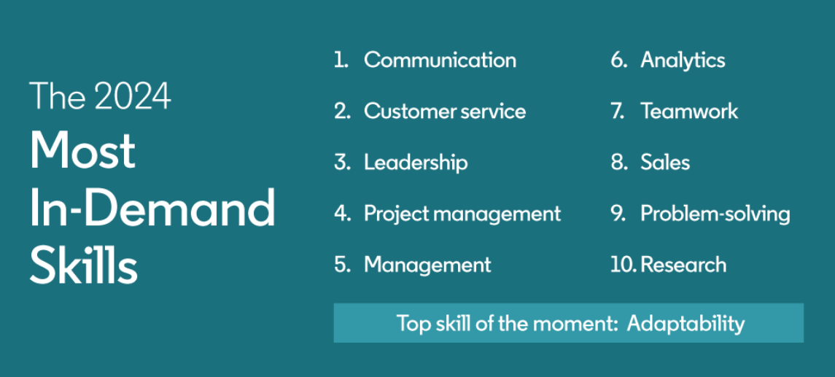
Check out the information HERE.

SEEK - Fastest Growing Salaries
According to research for SEEK, the main reason people look for a new job is because they’re not getting paid enough. These jobs have experienced the biggest salary increases.
You can check your industry on this SEEK site. Teachers won’t be surprised to see that there hasn’t been much salary growth in the Education and Training sector.
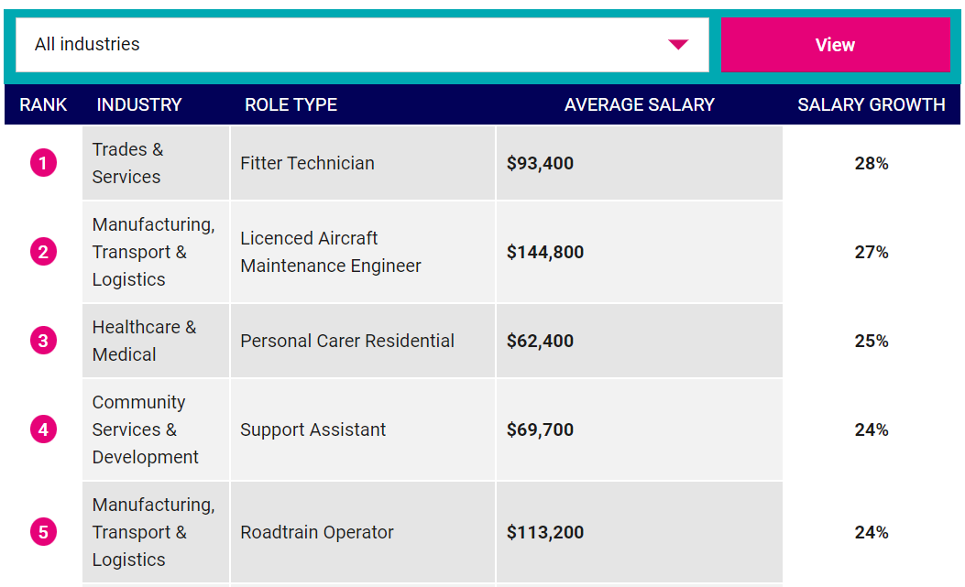

9 June ECU Percussion Pandemonium
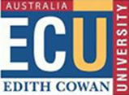
Age: For classical percussionists in high school years 9 - 12
A free afternoon of fun, music, drums and supercharged percussion! Led by Tim White, Genevieve Wilkins and Defying Gravity, WAAPA’s percussionists work with you in fun hands-on workshops exploring ensemble playing, percussion technique, rhythm games, improvisation and world music. The day concludes with a performance for parents at 4.00pm.
Place: WAAPA ECU Mt Lawley
Time: 1.00pm - 5.00pm
Cost: Free
Percussion Pandemonium

12 June Rockingham Jobs Fair
If you live down the coast from Fremantle, get along to the Rockingham Jobs Fair.
Discover local employers looking to recruit new employees and apprentices, government departments, education providers and businesses.
Gary Holland Community Centre 10am – 3 pm
Find details at Rockingham Jobs Fair

13 June Career Conversations Information for Families Morley
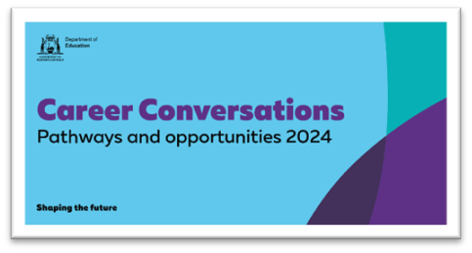
6.30 PM– 8PM
John Forrest Secondary College - Auditorium
180 Drake Street, Morley WA 6062
Places are limited so REGISTER NOW

14 – 16 June Job Ready Expo Ascot
This expo brings together employers looking for staff and people looking for jobs. This expo is for those who are seriously looking for careers.
Some of the companies with the best reputations for employing apprentices will be there. Police Recruiting will be there talking about jobs and cadetships. The exhibitors also include recruiting companies.
Check it out HERE.

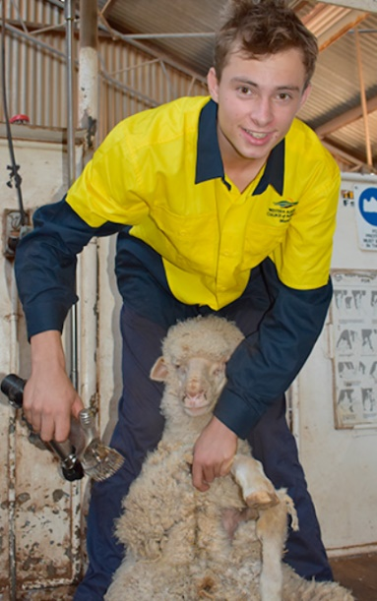
27 June Morowa Ag College Open Day
Prospective parent & student information sessions -11.00 am & 1.00 pm timeslots in the farm classroom.
Find details and highlights from 2023 HERE.

Career Statistics

BCEC Labour Market Update - April
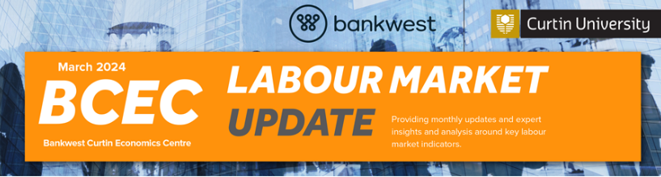
- Unemployment rate edges over 4 per cent despite solid employment growth, albeit only in part-time jobs.
- Vacancies and wages moderate, consistent with a gradual softening in the labour market.
Employment grew by a solid 38,500 jobs in the month (0.3 per cent), but all of that growth was in part-time jobs, while full-time employment fell marginally. The number of job vacancies advertised eased further but remains at levels consistent with strong ongoing demand for workers.
Read the BCEC March Labour Market Update HERE.

Bankwest Curtin Economics Centre Annual Report 2023
The BCEC Annual Report was published on 1 May. It discusses new findings on housing affordability, gender equality, and international trade and investment.
BCEC’s research looked at how best to rebuild crucial economic sectors such as tourism post pandemic, and the critical issue of climate change as state and federal governments prioritised transition to net zero carbon emissions.
You can find it HERE.

ABS April Labour Force Statistics - Steady Employment
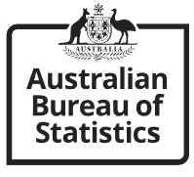
Released 16 May
All of the employment statistics remained steady in April.
Key statistics
In trend terms, in April 2024:
- unemployment rate remained at 4.0%.
- underemployment rate remained at 6.6%.
- Youth unemployment rate remained at 9.6%.
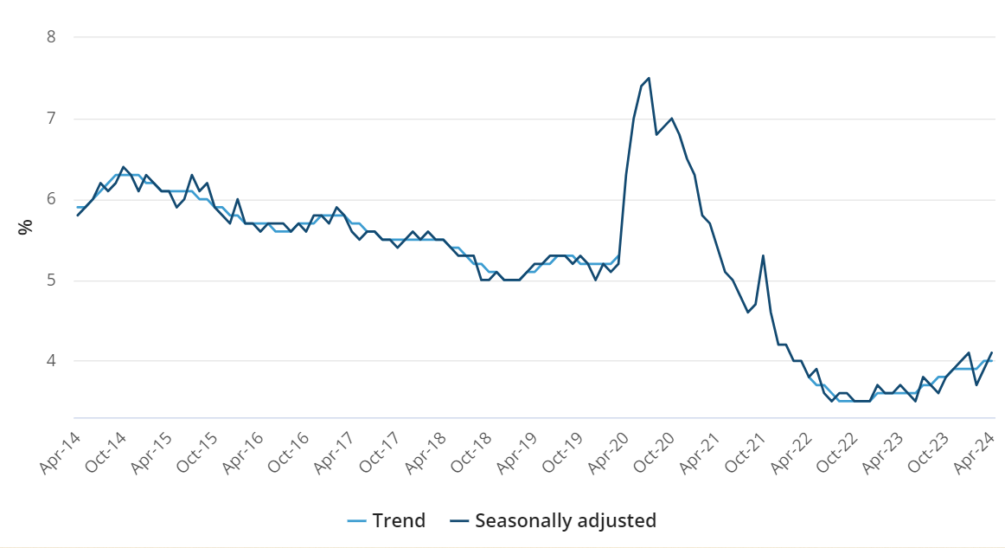
See more details HERE.

Jobs and Skills Recruitment Insights Report
The April 2024 Recruitment Experiences and Outlook Survey (REOS) Recruitment Insights Report found that recruitment eased, and fewer employers were expecting to increase staffing numbers in the next 3 months.
Most of the decreases were in regional areas.
More employers had difficulty recruiting in April than they did in March, a 3 percentage point increase to 53% of recruiting employers. Despite this increase, the long-term movement of the recruitment difficulty rate has been easing since mid-2022.
You can read the report HERE.

Jobs and Skills Australia Internet Vacancies Ads Down
Online job advertisements at the national level decreased in April 2024 (down by 3.2% or 7,800 job advertisements) to stand at 239,400.
- Over the year to April 2024, online job advertisements decreased by 18.1% (or 52,800 job advertisements). Vacancy numbers, though, are at high levels historically.
- This downward trend is present in other demand indicators, with the Australian Bureau of Statistics’ Job Vacancies, Australia series showing a 17.7% decrease in advertisements over the year to February 2024.
See more details HERE.

University Events.

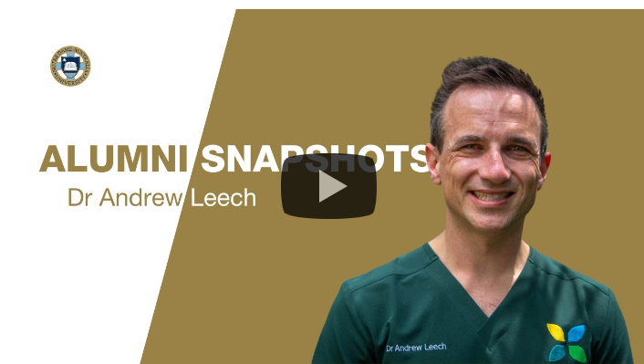
Catch up: Notre Dame Doctor of Medicine Information Session 2024 – Watch on Demand
If you missed the Notre Dame Doctor of Medicine Information Session you can catch up online. You can find it HERE.

25 June ECU Joondalup Campus Tours
Looking to explore the ECU Joondalup Campus? Join us on one of our tours where we will show you our incredible facilities and our beautiful campus, while chatting about your pathway into higher education.
Register your choice of tour HERE.

University News

Early Applications for 2025 are now open

Don’t Rush
If you know what university you want to go to and what course you want to do, you can apply now via TISC.
Only your first preference is considered when you put in an early application. You can change your mind, but it takes a bit of fiddling around. You have until the 2^{nd of} September to apply.
If you want to be more clear about what to do next year you can:
- Speak to your school-based career advisor
- Go to one or more universities and speak to their career advisors.
- There are a range of options that you can check out HERE
- You have probably already done the MyFuture Aptitude Tests. There are lots of different tests for you to play with HERE.
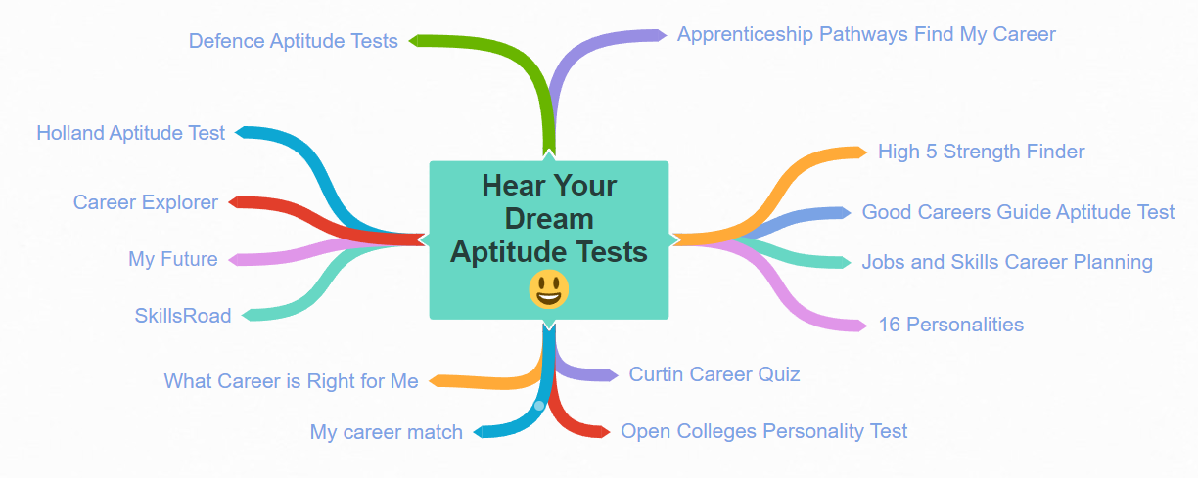

Murdoch Medical, Molecular and Forensic Science in Harry Perkins Research Centre
It was just a matter of time before Murdoch University and the Murdoch Health precinct built strong collaborative bonds. The Medical, Molecular and Forensic Science faculty now has the whole top floor of the Harry Perkins Institute of Medical Research which at Fiona Stanley Hospital, facing Murdoch university.

Murdoch Biomedical Sciences
If you love science the Murdoch Biomedical Science degree will lead you to careers in hospitals and medical research centres.
- Murdoch is the only university in Western Australia to teach veterinary sciences, so Murdoch biomedical science students are well placed to make connections across disciplines and follow a career path involving animals.
- If you decide you want to go on and do medicine, this degree will provide a sound undergraduate degree leading to medicine.

NEW – ECU Bachelor of Education with 1-10 Learning Area
This new course will give you the flexibility to teach children from Year 1 up to Year 10. It also prepares you for working as a dedicated Primary or lower Secondary School teacher, with specialisations in mathematics, science or health and physical education. You can also expect diverse professional practice experiences in a range of schools as part of your degree.
See attached flyer and our website for more information.

ECU Creative Humanities Portfolio Entry
The Creative Humanities Portfolio Entry (CHPE) is a pathway into university for students who are creative and curious people but don't have an ATAR or don’t meet the minimum entry requirements for our courses by another means.
Through CHPE, you can show your unique skills and achievements to demonstrate your motivation and potential for success in your chosen course.
- Bachelor of Design
- Bachelor of Visual Arts
- Bachelor of Communication
- Bachelor of Screen Production
- Bachelor of Journalism and Broadcast Media
- Bachelor of Creative Writing

For more information on how to meet the CHPE requirements visit our website

NEW – Curtin Bachelor of Science (Paramedicine)
Students wishing to become a paramedic can undertake our 3-year bachelor’s degree in paramedicine. They will be taught by experienced paramedics and will gain the fundamental knowledge and skills of out-of-hospital emergency care, including evidence-based clinical best practice, emergency and crisis management, and effective communication. Students will put these skills into practice through a range of clinical placements and simulation exercises preparing them for the diverse workload of a contemporary paramedic.
For more information, visit the Bachelor of Science (Paramedicine) course page.

VET Pathway to University
Many VET courses are currently free, and they deliver practical technical skills that support successful careers.
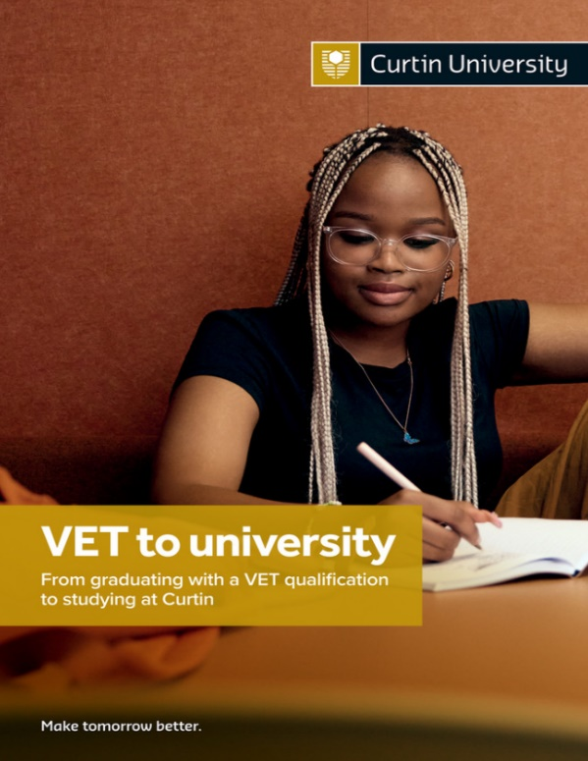
This VET to university pathway provides useful information including credits awarded to graduates of Diploma and Advanced Diploma VET courses who want to do a degree.
For example, Advanced Diploma of Graphic Design graduates can earn up to 2 years credit for a 3 year Bachelor of Design (Graphic Design) degree. They can also continue to work as graphic designers, earning good money, while they study for their degree.
Get your copy HERE.

Curtin Accepted Murdoch Enabling Programs
Curtin is now accepting the Murdoch FlexiTrack High bridging program. If you have any students completing this course, they can now use this to meet Curtin’s minimum entry criteria (70 ATAR and English competency).
For more information on accepted bridging programs, contact the Curtin Future Students team on 1300 222 888.

Training News

$195 million training funding boost.

Fee free TAFE to continue in 2025
The government has announced an $8 million top-up to continue the Fee Free TAFE initiative in 2025.
Funding will also extend the Year 9 Career Taster Program and TAFE College Lecturers Industry Placement Program beyond 2025.
Read more in the media statement HERE.

OUT NOW 2024 Apprenticeship/Traineeship Intake Guide
Find apprenticeships and traineeships that are coming soon.
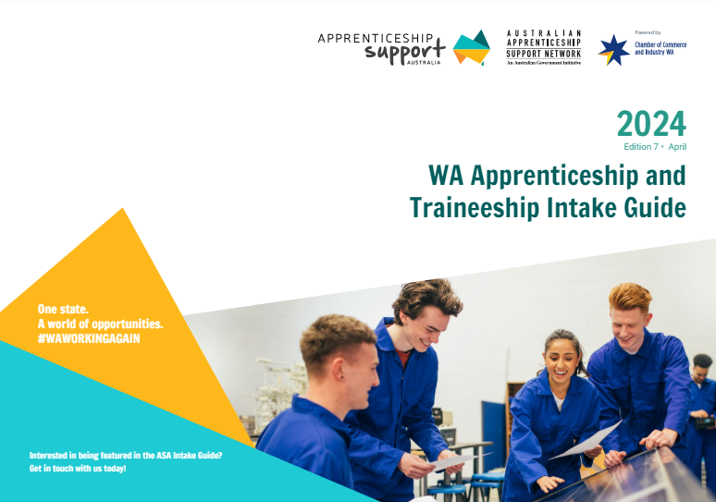
This Apprenticeship and Traineeship Intake Guide shows the vast array of apprenticeships and traineeships that are coming available in WA in the coming year.
You can find the Guide HERE.

Apprentice and Trainee Recruitment Support
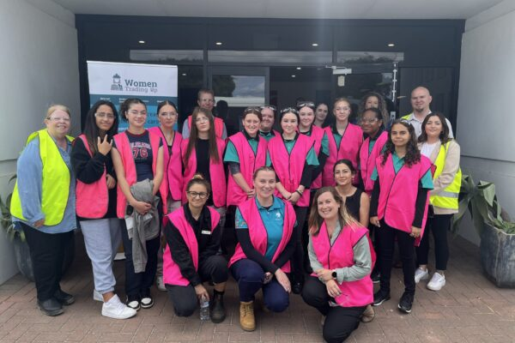
Apprenticeship Support provides recruitment support. It has a:
- Vacancies Board
- You can register on a Job Board.
- Women Trading Up: Step Into series
Check out what they have to offer HERE.

2025 Apprenticeships will be out soon.
Apprenticeships for 2025 will start to be advertised soon. Make sure you are ready.
There is a bit to know. Check out the Apprenticeship Support Blog for information.
You can submit an application for upcoming positions HERE.

Register for Apprenticeship Alerts at Programmed
Woodside and several employers of apprentices in the mining industry advertise and have their training managed through Programmed. You can register for apprenticeship alerts HERE.
You can also register for apprenticeship alerts on SEEK.

Register your interrest in Community Skills traineeships

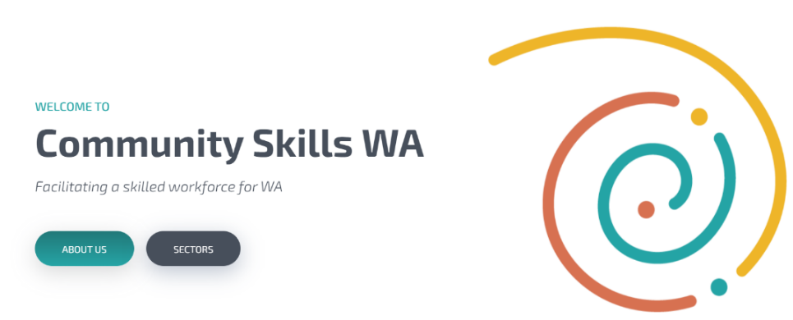
Health and Community Care are booming industries with many entry level jobs and opportunities for further study. The Community Skills Training Council oversees traineeships in health, education and community services industries.
Find out about the industry and register your interest in specific traineeships HERE.

Electric Vehicles Adoption Changes Auto Careers
The demand for skilled workers in the automotive industry encompasses occupations with EV skill sets. According to the 2024 Deloitte Access Economics report, the vacancy fill rate for Electric Vehicle Mechanic / Technicians was only 41% in 2023.
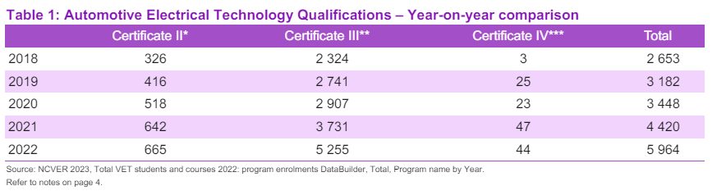
Enrolments in VET programs such as Hybrid Electric Vehicle Inspection and Servicing Skill Set have more than doubled between 2021 and 2022.
The, Australian Government New Energy Apprenticeships Program aims to create 10,000 new energy apprenticeships by providing incentives to apprentices working in the clean energy sector. You can find details HERE.

Senior School Opportunities

Book Now: ECU’s Free ATAR Revision Sessions

23 September – 27 September
ECU’s Free ATAR revision sessions are on during the third term holidays.
They are available online and on campus.
Each ATAR revision session comprises a four-hour seminar covering:
The year 12 syllabus
- Exam techniques and revision tips
- Question and answer session.
- A copy of revision notes
The Year 12 Subjects for 2024 include:
- Biology | - Human Biology
- Chemistry | - English
- Maths: Applications | - Maths: Methods
- Maths: Specialist | - Physics
- Computer Science
Registrations now open!
- On Campus registration
- Online registration
For information go HERE.

Give yourself every chance to success _ ATAR Revision Programs
For a full roundup of all ATAR Revision Programs go to Give yourself every chance to succeed.

June 2025 Nominations Open Black Swan Theatre Youth Ambassador Program
The Black Swan Theatre Ambassador Program is a unique opportunity develop important creative leadership skills, attend special events, workshops and growing friendships with like-minded peers.
This year-long program comprises of attending performances in our annual season, quarterly Ambassador catch-ups, invitations to special events and workshops.
Nominated by a teacher or parent, applications are open to youth in Years 11-12.
Find details HERE.

Financial support for teaching, nursing and social work prac
The Commonwealth budget identified financial support for practical placements for nursing, teaching and social work students. For TAFE this will include Diploma of nursing students. It is expected that these payments will be means tested, so the detail is yet to flow, nonetheless it is an important recognition of the cost to undertake these practical courses. For TAFE nursing students, who are generally slightly more mature and sometimes from underrepresented cohorts, this will be very welcome. (From TAFE Directors News. Subscribe HERE.)

Year 12 Opportunities

Curtin University (Medicine) - Casper Test Requirement
If you will be applying to Curtin University (Medicine) this year, apart from the UCAT, applicants will also need to register and complete the Casper Test, which is conducted by Acuity Insights.
- Applicants will be ranked for the interview offer on the basis of their Casper score, UCAT score and ATAR.
- All applicants (other than Aboriginal & Torres Strait Islanders) must complete the Casper Test.
- School leavers and Curtin Course Switchers must sit the Undergraduate Casper Test. Non-school Leavers (Graduates) will have to sit the Postgraduate Casper Test.
- The Casper Test is held nationally and is sat online from home.
- Applicants are responsible for making their own arrangements to register for the Casper Test. Please refer to the Acuity Insights website to register for the test.
Available Casper Test dates are:
- 26 May 2024
- 23 June 2024
- 8 August 2024
All admission information for domestic and international students including details about the requirement to sit the Casper Test can be found via the Curtin University School of Medicine webpage.

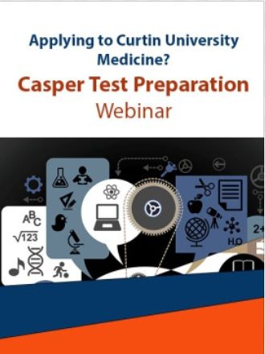
CASPER TEST PREPARATION WEBINAR
9 June or 27 July 2024.
NIE will be conducting a 4-hour interactive and informative webinar designed to provide students with the guidance and support they need to feel well-prepared for the Casper Test.
Presenters: Rebekah Ramsey
ENROL to Secure Your Spot!

2 July Year 12 ATAR Economics Revision Conference
Get ready for Curtin’s annual ATAR economics conference designed to help you to revise and prepare for success! Curtin is bringing together industry leaders to share their expert insights and knowledge with you.
The conference will cover strategies for success, balance of payments, trade issues and foreign investment, tactics for section 2 of the exam, and how to master those tricky multiple-choice questions. Alongside captivating speakers and interactive workshops, your ticket includes morning tea, snacks, merchandise, and car parking.
Find details HERE.
Register now for a day of learning, networking and growth.

Curtin English competency requirements change
English requirements have changed to allow any student who achieves an A grade in general English to meet English competency for Curtin. This is no longer restricted to Portfolio Entry. English requirements for Portfolio Entry have now been adjusted to a B grade in General English. For all information regarding English competency please refer to the English language requirements webpage.

Alternative Pathways – Fee Free
Unis have always had some fee free uni ready places. The budget identified an additional $350.3 million to prepare students for university. This is expected to increase the number of students in these courses by 40% by 2030, doubling by 2040.

Year 12 - Things to do In June

Go to First in Family to Go to Uni site
If you want to go to uni after school, check out the:
- First in Family Online Tools to learn about uni lingo.
- Study hints
- What I wish I’d Known before starting
- Discover your learning style
- Survival hints

Enrol in Holiday ATAR revision programs
Give yourself every chance to succeed _ ATAR Revision Programs for Senior Students. There are lots of ATAR revision programs to choose from. I have captured a lot of them HERE.
Sort what you are doing in 2025
Burnout will be a factor for Year 12 students in Semester 2.
Check Year 12 Burnout Busters. It has strategies to help you to plan Semester 2 so that you make it to the finish line.

Year 11 Opportunities

Applications for the 2025 National Youth Science Forum are open
The National Youth Science Forum (NYSF) Year 12 Program gives students that are about to start Year 12 a broader understanding of study and career options available in science, technology, engineering and mathematics (STEM).
This is a seriously good program that provides insights to STEM careers that you haven’t heard of. You meet leading scientists and make friends with other aspiring scientists who you continue to associate with through the alumni program.
It is held at the Australian National University in January 2025 (and there is a program is Queensland).
It is expensive, $2,990 plus the air fare from WA, but there are scholarships and lots of Rotary Clubs provide partial assistance.
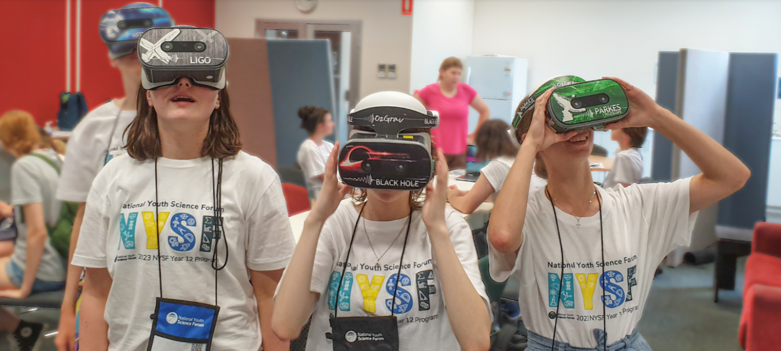
Check it out HERE.

Middle School Opportunities

Curtin’s Year 10 Subject Selection Guide is out for 2027 Uni
This Guide provides career advice, information about going to uni, a link to the Find U quiz and potential pathways to uni.
Each faculty identifies its courses with Prerequisites and Desirable subjects for senior school.
Many courses have no Prerequisites (essential subjects to get into the course) but many have Desirable recommendations which will help students to cope with their university studies.

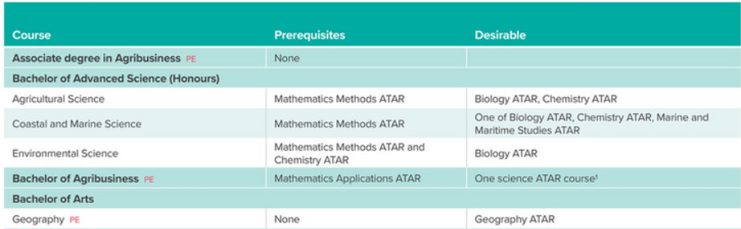
Download your copy HERE.
The TISC University Admissions 2027 should be available before the end of the May.

10 June STEM Career Seminar - Online

Year 7 – 9 Students
Join the Innovators Tea Party on the evening of Monday 10 June for a free series of presentation from WA’s women in STEM to learn about the opportunities a career in STEM can offer.
Scan the QR code to register or go to innovatorsteaperty.org.

15 June RoboCup Junior All Saints
Come along for the day, join workshops, get expert advice and test yourself on the different courses. It’s not too late to start getting your teams together. You're not the only group to still have your robots in parts just waiting to be assembled!
Check details HERE.

Applications Open for School-based Traineeships in the Public Sector for 2025
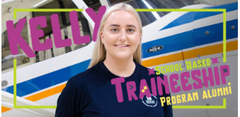
A third of West Australian workers have jobs in government.
This public sector School-based Traineeship runs two days a week and counts towards your WACE.
Check details HERE.

Applications Open for Curtin Year 9 & 10 Girls in STEM Term 4
Applications have opened for GET Forum in Term 4 on the 22nd of November. Get Forum is a one-day program for Year 9 and 10 girls and their teachers to explore the world of engineering, connecting students interested in STEM and introducing them to engineering through hands-on workshops with university and industry mentors and a Q&A session from our panel of inspirational engineers.
Register for GET Forum here

ECU Mid-Year Holiday ECU Experience for Year 9 and 10

2 July Creative Humanities ECU Experience

4 July Business and Law ECU Experience

5 July Medicine and Health Science
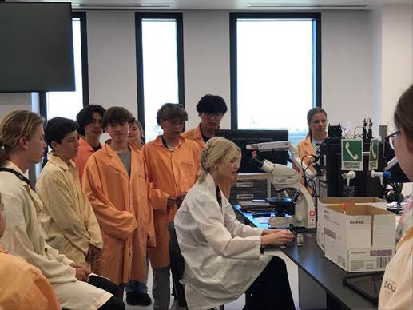
Check out the buildings and laboratories and specialist learning spaces at EUC and find out what studying at ECU would entail.
For information and to book a place during the mid-year holidays contact Ginetta Papaluca g.papaluca@ecu.edu.au
P: 6304 2516

9 – 11 July Curtin DISCOVER | Years 8 – 10
DISCOVER is a 3 day program where students participate in hands on activities, meet Curtin researchers and innovators. It is for students in Year 8 to 10 who have an interest in science or engineering, and would like to find out more about the many rewarding careers in STEM and is running 9 - 11 July 2024.
Visit the STEM Outreach website for more information

Regional Opportunities

4 June Career Conversations Information for Families
This Education Department free event is for parents, students and community in your local area and Registration opens at 6:00 pm for a 6:30 pm start. Refreshments provided.

Goldfields Art Centre 35 Cheetham Street, Kalgoorlie
Places are limited so Register Here

Regional Locations and Dates for Career Conversations
- 25 July in Esperance Register HERE.
- 30 July Karratha Register HERE.
- 31 July Hedland Register HERE.
- 7 August Kununurra Register HERE
- 12 August Katanning Register HERE
- 13 August Narrogin Register HERE.
- 14 August Exmouth Register HERE
- 22 August Newman Register HERE.
- 28 August Tom Price Register HERE

Regional Public Sector Traineeships

Applications open all year.
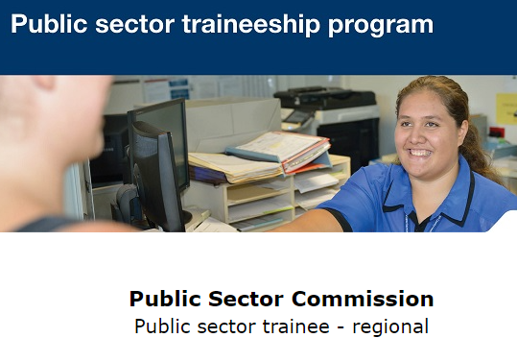
The ‘Public sector traineeships in Government (Public Administration) will give you the opportunity to work in a regional WA public sector agency full time for 12 months or part time for 18 months while earning a trainee wage. On successful completion of the traineeship, you will attain a nationally recognised qualification of a Certificate II, III or IV in Government (Public Administration).
For more information go HERE.

Heavy Vehicle Driving Operations program in south West
A $7.2 million extension of the Government's Heavy Vehicle Driving Operations training program in WA's South West will support people in the region to take up jobs in the transport industry, providing an additional 500 program places a year until the end of 2027.

City Beach Residential College for Gifted Students
If your student is a candidate for a Gifted and Talented Selective Entry program at one of Perth’s best secondary schools, you might like to check out the support and accommodation provided at City Beach Residential College.
Students from regional areas board at the College.
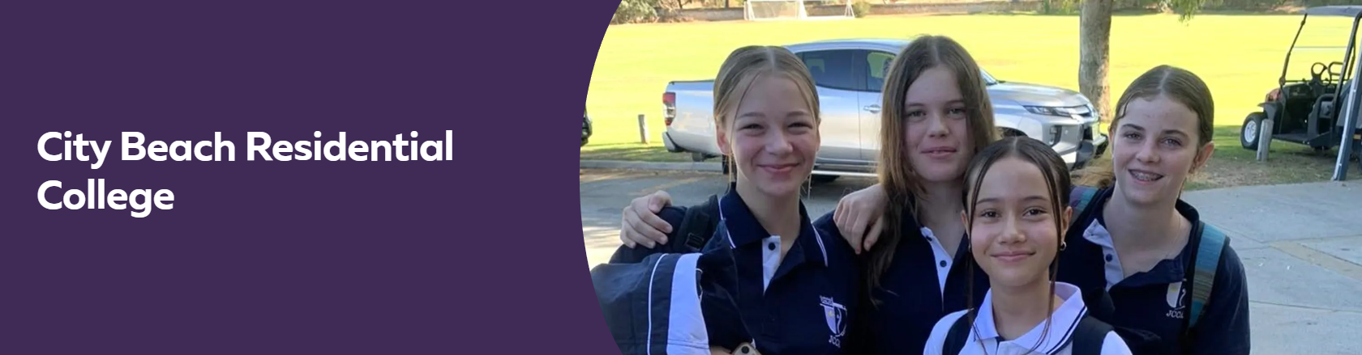

Take a virtual tour of the College and check out the opportunities and support that is provided via this site.

Aboriginal and Torres Strait Islander Opportunities
30 June – 6 July Curtin Indigenous Australian Engineering Residential School
The Indigenous Australian Engineering School (IAES) is a week-long residential camp introducing students to engineering studies and careers. Students will do site visits, meet industry representatives and participate in educational activities. The program targets Indigenous students in Year 9, 10, 11 and 12 with an interest and aptitude towards engineering, science and mathematics
For more information go HERE.

Solid Futures Aboriginal traineeship program
The WA public sector Solid Futures Aboriginal Traineeship program gives young Aboriginal and Torres Strait Islander people formal training, paid employment and support to complete a Certificate III in Government. The program helps agencies to connect with Aboriginal and Torres Strait Islander job seekers and build diverse, talented and inclusive workforces.
Find information HERE. Applications for 2025 are not yet open.

First Nations Health Worker Traineeship Program
The program supports up to 500 Aboriginal and Torres Strait Islander trainees to become Aboriginal Health Workers or Health Practitioners. Trainees will undertake Certificate III or Certificate IV qualifications in the Aboriginal and Torres Strait Islander Primary Health Care training package.
Find details HERE.

Indigenous Pre-Medicine and Health Sciences Enabling Course
Are you interested in pursuing a career in medicine or health sciences? The Indigenous Pre-Medicine and Health Sciences Enabling course will prepare you for entry into most health sciences courses.
Check out the video HERE.
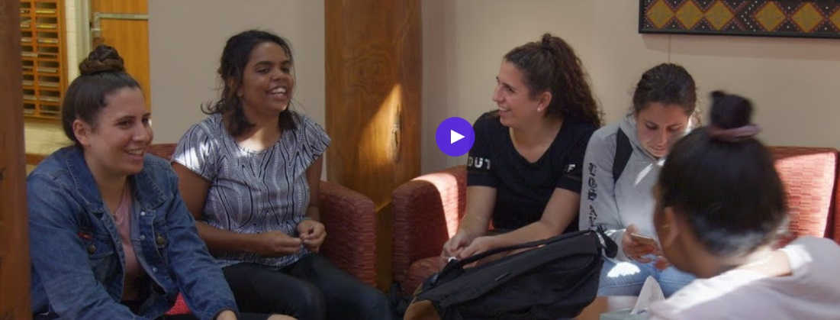
Find more information HERE.

Aboriginal Support extended in Jobs and Skills Centres
Recently enhanced services to improve Aboriginal Western Australians' access to the state-wide network of Jobs and Skills Centres will continue beyond June 2025, thanks to a $4.2 million commitment to involve more First Nations peoples in frontline service delivery.

Students with Disability Opportunities

2025 Curtin Students
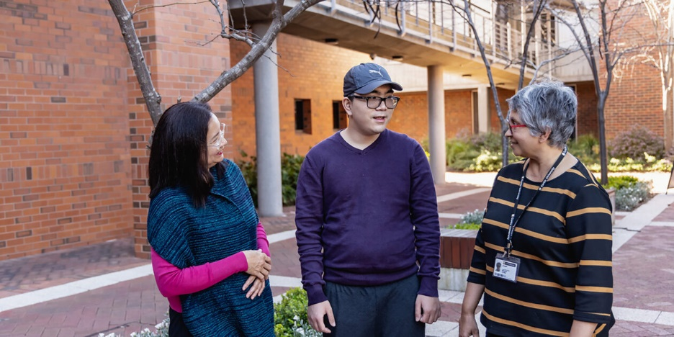
If you have a disability and plan to go to Curtin in 2025, register with Curtin’s Disability and Accessibility Support Unit so that staff are aware that you will be attending and of any specific services they need to provide to ensure your best opportunity to succeed.
You can find details HERE.

Genius Armoury Cyber Security for Autistic Students
Genius Armoury offers a range of courses to help introduce people to cybersecurity, exploring some of the fundamentals of coding, threats and exploits, networking and more. Available to anyone and free to complete, modules in the full course take around 30-90 minutes to complete. Find more HERE.

International Student Opportunities

Labor to cap international student numbers
- The Albanese government will introduce legislation to cap the number of students that can be enrolled by each university or college.
- The education sector is also bracing for budget measures including an increase in the non-refundable student visa fees and another rise in the bank balance required for applicants.
- Labor aims to slash net overseas migration from 528,000 last year to 260,000 next year, and international students are expected to make up 50% of migration numbers.

Help to connect skilled migrants to employers
The Skilled Migrant Job Connect Program will receive $5.6 million over three years to ensure skilled migrants are connected to WA employers in jobs that align with their skills and experience. The program provides subsidies of up to $7,500 to eligible migrants located in WA who are seeking to gain local employment that aligns with their formal overseas qualifications, skills and experience.
A further $4.3 million has been allocated to maintain the Construction Migration Office throughout 2026, to support WA building and construction sector employers looking to hire skilled migrants, and migrants seeking to move to WA to work in the sector.

Blog posts with rich WA Career Information

VET and Uni Pathways to Careers in the WA Resources Industry
There were simply too many pathways into the resources industry in WA to try to fit all of the information into the Newsletter.
You can check out the details, with links to appropriate organisations HERE.

What can you tell your students about jobs in the WA government?
About a third of our workforce is employed by government. This post is about how to get jobs in the WA government.
Traineeships are coming up and there are opportunities for work experience. Check out what you can do to find a job in the public sector HERE.

Are we about to grow a world renowned screen industry in WA?
Screens of all types – the big silver screen, TV and gaming are all covered by governments new West Australian Screen Industry Strategy which is meant to show the way forward for the next 10 years.
It tries to be all things to all people.
See my analysis of the Strategy and mind maps with links to existing opportunities in Western Australia HERE.

Give yourself every chance to succeed – ATAR Revision Programs for Senior Students
Many senior students will spend at least some of their holidays doing ATAR revision programs. I have collated information about them HERE.

A Snapshot of Great New Stuff at the Careers Expo
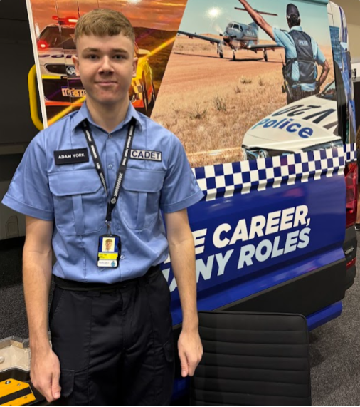
How did you go at the Expo? I notes the change in construction industry offerings. Zero2Hero was popular with students, police cadets gave great information.
This is my take on what was new or interesting at the Expo this year.
You can read it HERE.
Register HERE.

