Camelot Rise Primary School
Baker’s Delight Special Lunch Day – How to order.
Open Compass in Browser. Click on the 2 heads on the top bar then Canteen.
Then click Place order.
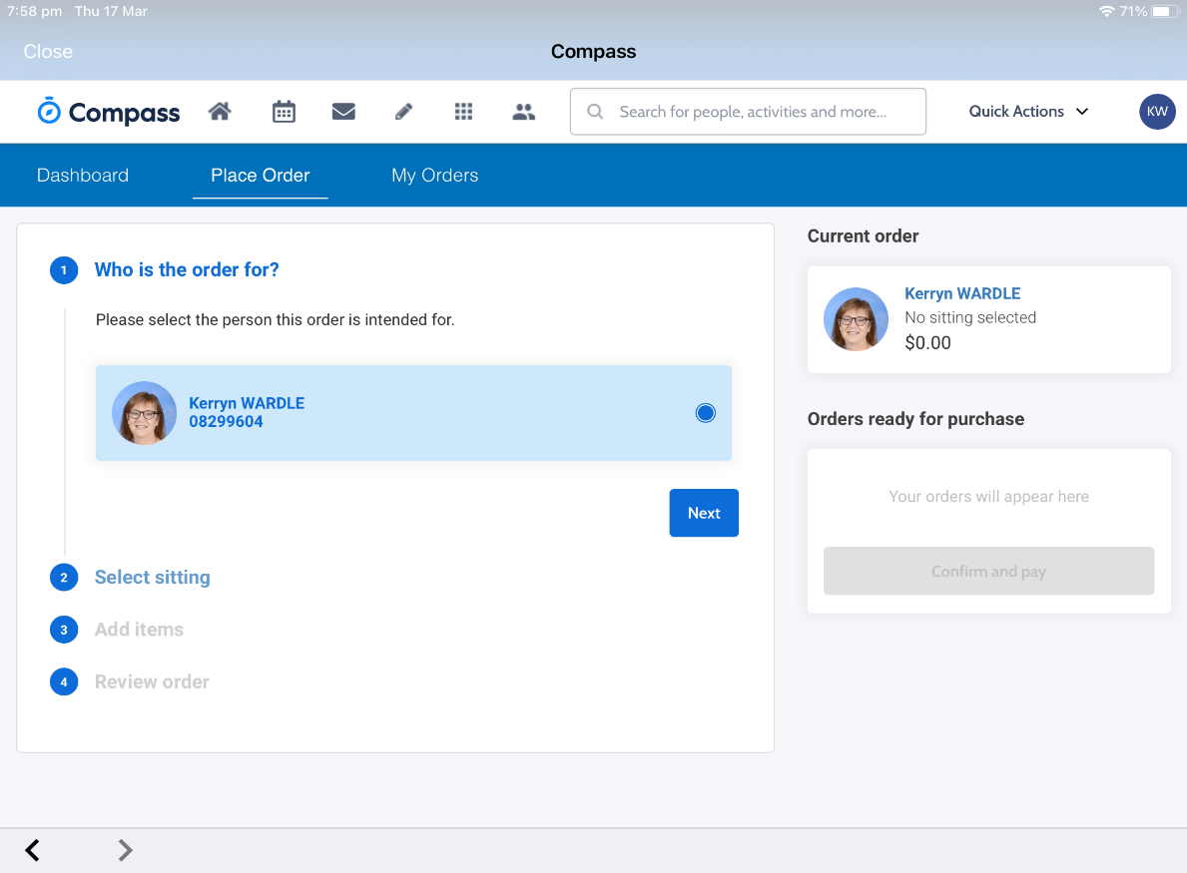
Click on the dot next to your child’s name then click next.

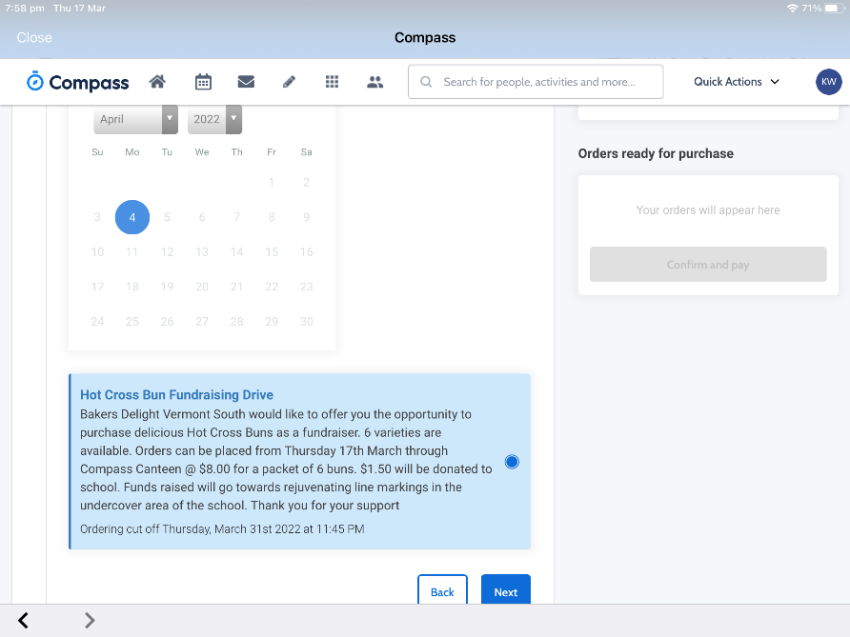
Select sitting – For this Baker’s Delight Special Lunch Day event please click on 8th September and then the dot describing the event.

Then next

Add items you wish to order. Please choose one food item and 1 drink
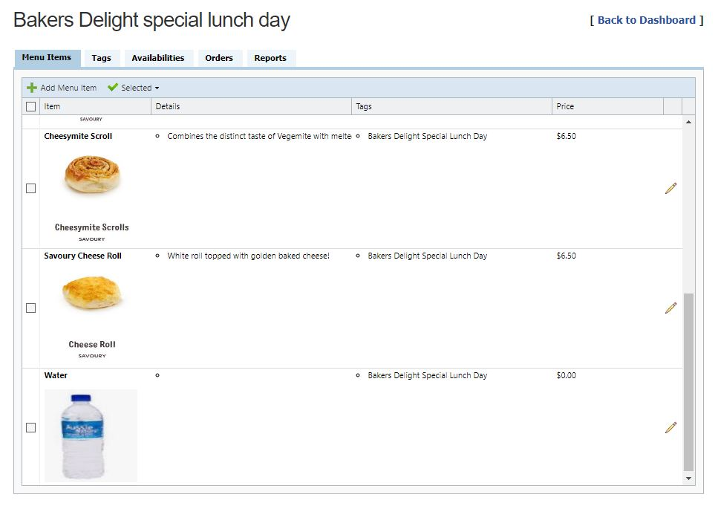
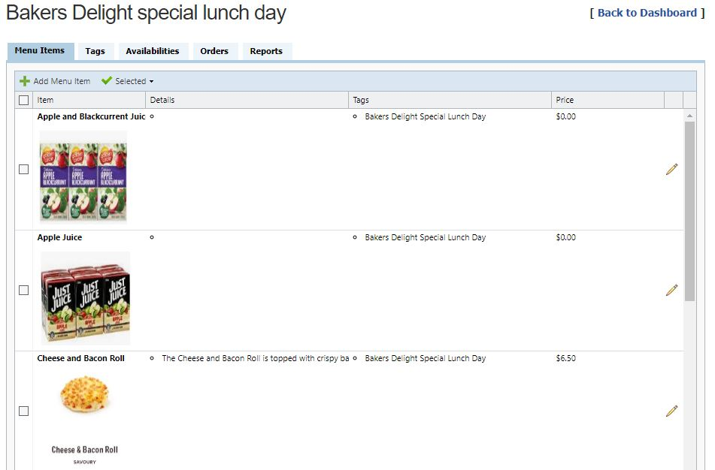
Click Proceed to review order.

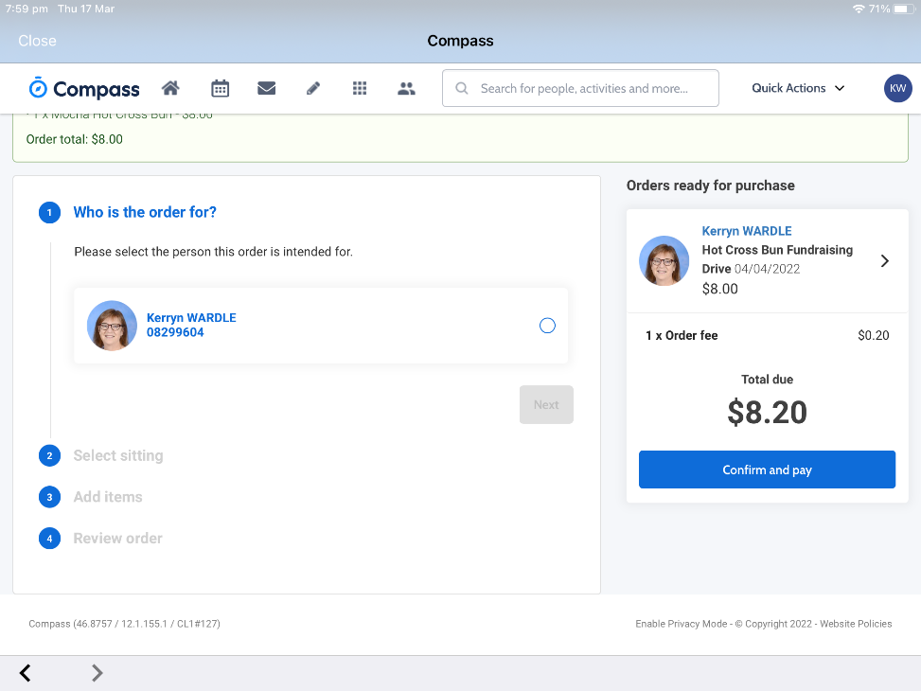
Check then click Add order. Click Confirm and pay

Select New Credit card

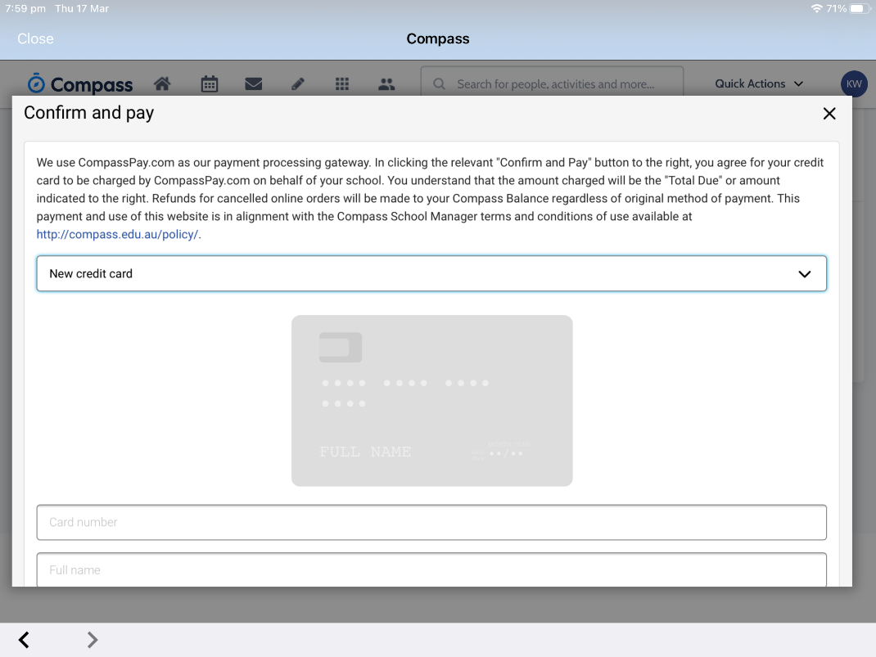
Thank you for your support

