Kilvington Grammar School – Design Engineer Construct Final Report for Kilvington Grammar
Nicholas Giouris, Jerome McClimont, Ayaan Gupta, Zac Cooper, Cassie Yeo, Georgia Thompson, Sofia Karagounis, Ely Buchman, Toby Smith, Milan Bays.

Contents

Digital Contents and Description of Hub...............................................................................................2

Detailed Route Description....................................................................................................................4

Natural Disaster Risk Assessment..........................................................................................................5

Net Zero Features...................................................................................................................................6

Construction Details...............................................................................................................................7

Mood Board............................................................................................................................................8

Appendices..............................................................................................................................................9

Digital Concepts and Description of Hub

Layout and architecture
Originally, the main design of the hub was a curved roof. With this curved roof, the integration of solar panels would have been a challenge. Instead, we switched the curved roof with a more slanted roof that has commonly been used in many buildings. (Appendix B, Figure 7) This works for solar panels that are facing north but it also doubles as extra rooms for gathering spaces, office spaces and break rooms. There is also some space for retail, resting areas and cafes in the roof while people are waiting for the train (Appendix B Figure 8).

The platforms provide access to two, two-way tracks. There is an island in between the two tracks that function as an overflow platform for faster on and offloading for both platforms on the platforms there is plenty of greenery, easy to read station signs and priority seating where the disabled, elderly or pregnant can sit. (Appendix B, Figure 6)

In reality, the roof above these platforms would realistically be higher to cope for tall modern trains like the NGR. Unfortunately, changing these intricate details in Minecraft would be quite difficult because we would have to destroy half the build to fit it in.

Upon entering the station, you can park in the double story carpark, catch a bus to the bus stop that we have created or stop the car at a kiss & go drop off spot. The bus stop will be located on the existing route 250 bus line. There are also some bike racks which are placed to ensure that climbing up onto roofs of structures is impossible whilst also being sheltered (Appendix B, Figure 2). The platform has nearby toilets (male, female, accessible, gender neutral and also parent change rooms) (Appendix B, Figure 5). The walls of these toilets feature switch glass to ensure peace of mind when people aren’t in there and privacy when people are (Appendix B, Figure 1). Located near the café and the platform there is a parent change room for nursing and changing nappies whilst at the train station. On the right of this, there is a two-story carpark (Appendix B, Figure 2) with many carparks including 3 accessible carparks found next to the ticket gates (Appendix B, Figure 4). In the carpark, we have included tinted switch glass windows with adjustable cooling slats. These vents enable warm air to rise and flow out of the roof to keep the indoor carpark well cooled. Switch glass enables the glass to become completely opaque so that the sun does not burn against cars parked inside. (Appendix B, Figure 1). In the carpark there are also three spots for charging an electric car. There are 7 ticket gates which includes 1 accessible ticket gate for access to the station. All these ticket gates have a helpdesk found next to or near them for customers who require assistance with anything (Appendix B, Figure 4). There is also a go card machine where you can top up your card. This has a yellow box on the ground which helps people notice when others step into the area, enhancing natural security. (Appendix B, Figure 3).

Once you have passed through the security gates you are welcomed into an open-air area which is kept cool with all the luscious greenery inside this area sheltering against the sun, wind and rain (Appendix B, Figure 5). Climbing bougainvillea and other plants also help make the station smell nice. The open-air area is crucial in the design of this station to make sure that everyone can be seen at all times and potential threats can be noticed by 1-2 Protection Services Officers (PSO’s) who can and members of the public. People will naturally follow lighter colour or textures in the floor which will be used to help people safely round corners. Some Passenger Information Displays (PIDs) and clocks have been placed around the station in many places so that you can keep an eye on when your train is coming. This station needs to be well sheltered from the elements as it is prone to many environmental disasters such as floods and much more. This drastically affected how we designed the station. We believe that it is important to ensure that there are both indoor and open-air spaces for customers walk through as weather can commonly change in Redland Bay and it is nice to have options if you don’t feel comfortable in one space at any time. All signs have Braille included on them, and we are also incorporating a new technology called Navilens which allows people with visual impairments to scan a colourful code and get information on their phones. We also have hearing loops at customer service stations. There is a library/café through the ticket gates for people to relax and wait for their trains (Appendix B, Figure 5). Near here we have a few toilets (listed earlier) and an office space under the stairs leading up to the platforms.

The station has lots of other features which are useful and practical for everyone. There are many bins (including recycling and landfill) located around the hub to try and prevent littering (Appendix B, Figure 5). Elevators leading up to our extended platforms have glass to ensure that claustrophobia is not an issue when going up the elevator (Appendix B, Figure 5). The platforms have been extended to ensure that the NGR trains are able to fit into the station with some room to spare. NGR trains are 146.17m long and our platforms are approximately 150m long. Multiple security cameras are positioned throughout the station so that vandalism of trains and other illegal acts are recorded. Curved corners will also be included in the build to maintain vision when going around a corner. In addition to this, there are a variety of help points that you can press nearby if you need to call emergency services or other forms of help as well as many exits and fire extinguishers (not included in Minecraft).
You can find the entire Minecraft build through this Minecraft Education import link:

Accessibility
- 3 accessible carparks
- 1 accessible ticket gate
- 3 accessible toilets (also gender-neutral toilet)
- Priority seating throughout the building

The following items are not included in the Minecraft build:
All the following details are impossible to replicate in our Minecraft world due to certain factors:
- Solar panels (would take an exceedingly long time to incorporate these on the slant of the roof)
- Slanted roof (impossible in Minecraft; this is replicated by the blocky slant found on the very top of our build)
- Easy to read station signs (we can include signs, but they are not noticeably clear)
- High roof on the platforms for trains
- Details inside small rooms such as offices or toilets (signs are shown to stand for these spaces)
- Space for cars to freely move around and travel to the top story of the carpark.
- Any switch glass
- Control room and details inside it
- A sandbag room with prepared sandbags in case of a flood
- Charging places for electric cars
- All emergency features
- Security cameras
- Total length of sky rail
- All the pillars for the sky rail section included
- Proper indigenous painting recognising the first peoples on this land
- Elevator for middle platform (too narrow)
- Vending machines for middle platform (too narrow)
- Braille
- Pictures
- Gardens
- Curved corners

Detailed Route Description

Out of our options for building the train line, we were thinking of either Redland Bay or Hamilton North Shore. We decided to choose Redland Bay, as it is still not relatively serviced, compared to Hamilton North Shore, which has Doomben station in walking distance. Redland Bay is a 20 minute drive from the Cleveland station, so instead of creating a new line so close to the already existing Cleveland line, we are going to instead extend the line.

The extension of the Cleveland line will go down to Redland Bay, south of Cleveland. The extension will not impact the lines through running with the Shorncliffe line. Approximately 16 kilometres of double track will be laid between Cleveland Station and the new Redland Bay Station.
The extension will consist of 5 new stations, listed below:
Compass Grounds – Located on the crossover between Bay Street and Cleveland Redland Bay Road
Thornlands – Located next to William Stewart Park
Victoria Point – Located just north of Victoria Point, at the edge of Eprapah Training Centre
Redland Bay North – Located at the tip of Redland Bay, opposite from Redland Bay Golf Club
Redland Bay – Our new hub found in Meissner Park

Due to there already being suburbia and bushland between the stations, the extension will consist of both sky rail and tunnels.
Between Cleveland and South St (Approximately halfway between the new stations “Compass Grounds” and “Thornlands”), we will have 2.8km of double track sky rail.
From there we will have 4.4km of underground, double track tunnels until the new “Victoria Point” station. Sky rail will be used for the remaining 8.8km between Victoria Point and our new station hub, Redland Bay, with double track the full distance.
The only points where significant works will have to be done are at the transition points between sky rail and tunnels, as they must be sufficiently lengthy to allow a safe grade.

Visit Appendix D, Figure 1 for a detailed and annotated map.

To view an interactive map of our line, please visit our Metro Dreamin map, and look for the Redland Bay/Shorncliffe Line. All other Brisbane train lines are also included within the map.

Natural Disaster Risk Assessment

Our hub location is placed in an area where several natural disasters can occur. Landslides, floods, and bushfires are common occurrences. This section will explain each of them and how we have planned for them in our design.
Bushfires:
Several large areas of Redland Bay have been identified as having high and exceedingly high bushfire hazards. This is because the area is mainly bushland, with high amount of vegetation and low amount of access points, which reduces the ability to implement mitigation measures.
The Redland Bay Wastewater Treatment Plant is in a location that is surrounded by high-risk bushfire areas. The treatment plant is primarily our backup, and as such our water recycling project ensures that if this treatment plant was to be made inoperable, our train station can still run.
In terms of our location in proximity to bushfires, our location of Meissner Park is approximately 2 kilometres away from the nearest bushfire risk area, with fire breaks in between. Thus, we are relatively safe from the threat of bushfire.
Floods:
Tidal inundation and flash flooding due to heavy rainfall can cause flooding in various areas of Redland Bay, due to several rivers and creeks running through it. This can cause flooding in several residential areas and roads.
Several nearby low-lying areas to Meissner Park are severely affected by this flooding, which includes Pitt Street Park which is adjacent. This presents a risk to our train station, hence we decided to raise the platforms and main infrastructure above the flood plain and keeping non-essential infrastructure on the ground floor. This non-essential infrastructure includes the library and the cafe. This is to ensure the longevity of the train hub. This also aids in preventing landslides, as explained below.
Landslides:
Depending on the area, Redland Bay has a low to high landslide hazard, particularly in the west and south of the suburbs. To avoid a more general risk of landslides, we chose our location of Meissner Park as it is generally free of landslides.
However, after a major flood or bushfire, stabilizing features of the landscape such as trees and roots are no longer present. This presents a higher risk of landslides.
To prevent this from affecting our train station, we decided to raise the platforms and main infrastructure above the main area of landslides.

Net Zero Features

Our entire hub, subsequently laid track and all construction are designed to reduce our carbon emissions. We have thought of all aspects of this project to make sure it meets the requirements for carbon neutrality and succeed in our mission of serving the community whilst also keeping our planet safe.

In terms of the hub, we are using recycled glass panes throughout, and they will also be double-glazed to provide exceptional sound and heat insulation. We are also using technology to our advantage, using computers to take wind data from meteorological outlets and automatically adjust the window opening angles to provide maximum airflow and passive cooling to cut the need for air conditioning. The platforms will be made of recycled concrete, which also include recycled plastic granules to reduce carbon emissions. Our electricity will be sourced from our roof based solar panels and connected batteries for most daily station operations, and the primary source of train power will be from wind turbines based on the coast. We have water collection systems that use grey water, other wastewater and storm water and treat it to be reused in similar applications. We will also add turbines in the base of downpipes and water pipes to produce lesser amounts of electricity.

Our line extension itself will be made using sustainably sourced steel and concrete. All non-structural/non-critical metal will be recycled, ensuring the lowest carbon footprint. The chosen route (refer to Appendix D and the Detailed Route Description) attempts to avoid having to purchase houses and damage the natural environment, achieved by running the sky rail over roads and tunnelling underneath natural bush and scrubland.

Construction Details
Construction of the hub will be completed by having sections prefabricated and delivered, then put together onsite. The station is 52m long, 33m wide and 25m high. The sections will have concrete bases with four vertical concrete pillars, one in each corner, to provide stability and ensure that it is structurally sound. The width of these pods will be 13m long, 3.125m high and 2.75m wide. This means that we will need a total of 384 pods to construct the whole building. There will also be horizontal beams running from each corner in a rectangular shape (see Appendix A figure 1). The glass will be recycled to reduce the carbon that is released into the atmosphere. On top of the concrete floor sheets Quartz will be laid, to give us a professional, finished look.
We need 16 kilometres of track to be laid which will be sourced from green steel. These will be cut into 20 metres lengths to ensure that the track won’t be under unnecessary strain or tension. This means that we need 500 lengths of track to complete the line extension.
The company selected to build our train station is Laing O’Rourke. They specialize in building train stations and have recently been awarded the job of upgrading and rebuilding Bankstown station. They will hire workers locally and use machinery from local suppliers to aid in lowering transport emissions.
The best solar manufacturers in Australia are Tindo Solar and they are based in Adelaide. We will use them to manufacture solar panels to go on the roof, which will also reduce travel costs and carbon emissions needed to transport them compared to importing from outside the country.
Green Steel WA is pioneering sustainable steel manufacturing in Western Australia. Utilizing renewable energy and green hydrogen, the company aims to minimize carbon emissions and environmental impact. Their Collie Green Steel Mill will recycle scrap steel into rebar, significantly reducing CO2 emissions. Additionally, the Mid West DRI Plant will use green hydrogen to produce directly reduced iron from local iron ore. This innovative approach makes Green Steel WA's products an ideal choice for constructing a train station, aligning with sustainability goals and promoting environmental responsibility.

Train Hub Mood Board

When designing the interior of the train hub, we ensured that all the hubs would be as sustainable and safe as possible, whilst still having aesthetically pleasing aspects such as aboriginal artworks, nature and greenery, and a noticeable colour scheme throughout the hub.

On the areas around the train hub, we have put a garden, and two car parks; one underneath the sky rail to provide shaded areas, and one in front of the entrance. There will be a section in both car parks with provided electric car chargers, which will encourage the use of electric cars instead of petrol cars. As well as this, we have put solar panels on top of the entrance car park to provide shade for the cars, as well as using up the space to gain renewable energy. A garden on the corner of the area can be entered to find seating and communal areas for the public to use as recreational or workplaces. Aboriginal artwork created by an Indigenous artist will also be displayed as murals found around the garden for people to look at. This indigenous artwork will also be displayed on some trains on our route as we believe that it recognises the first peoples of the land that the station has been created on.

The colour scheme can be seen with bolder colours, to match the artworks that are displayed around the hub. However, we have made the artworks to be put on pillars and on specific walls to avoid clashes of the colours, and to make it easier to read directions and text that are on the walls. The floors will be painted with two different lines for disabled people, and for the general public to walk freely on. This will ensure that going to and from the stations flow as smoothly as possible, with minimal complications about travelling through the hub. Braille will be on each sign for people have forms of blindness to help with directory for all people.

The bathrooms inside this hub will be more modern, but still colourful as we want to provide everyone with a clean feeling, so it will be plainer than the outside areas. Mirrors will be provided at each sink, with a few child-friendly sinks. In the parent’s room, there will be many tables, and baby changing tables throughout the room. This room will be more colourful but with simpler colours to provide a bright and friendly feel to this area.

We have built this hub to provide for a diverse community, with a wide range of interior aesthetics to make the travel experience as smooth and easy as possible, whilst also furnishing the spaces with a bold yet simple atmosphere.

train hub mood board

Appendices

Appendix A
Figure 1
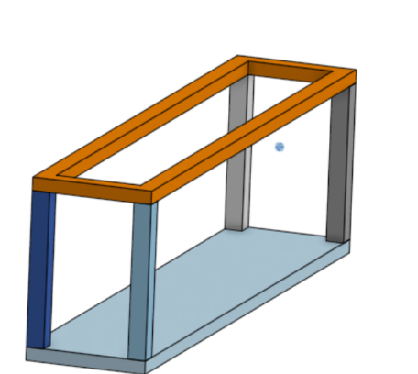

Appendix B
Figure 1
(Opaque)
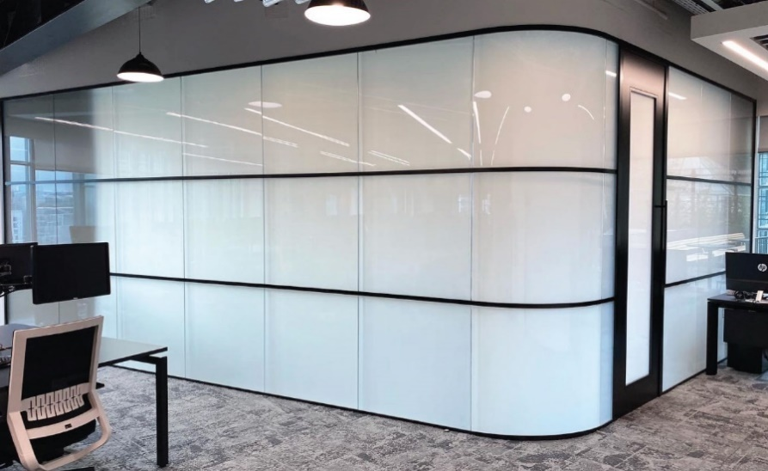
(Transcluent)
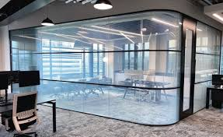

Figure 2
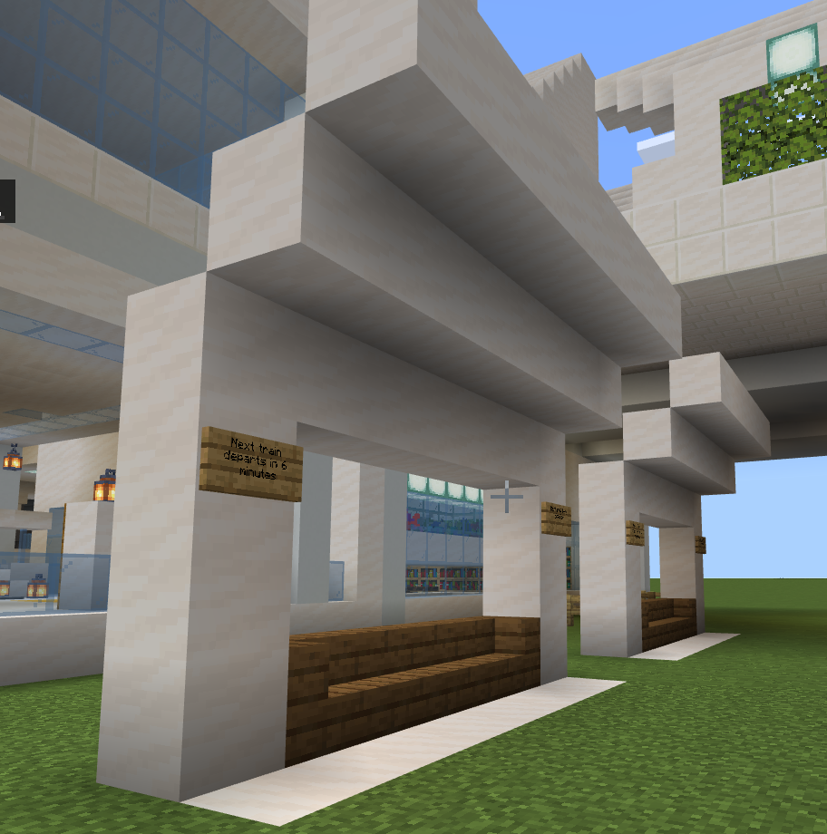
Bus stops
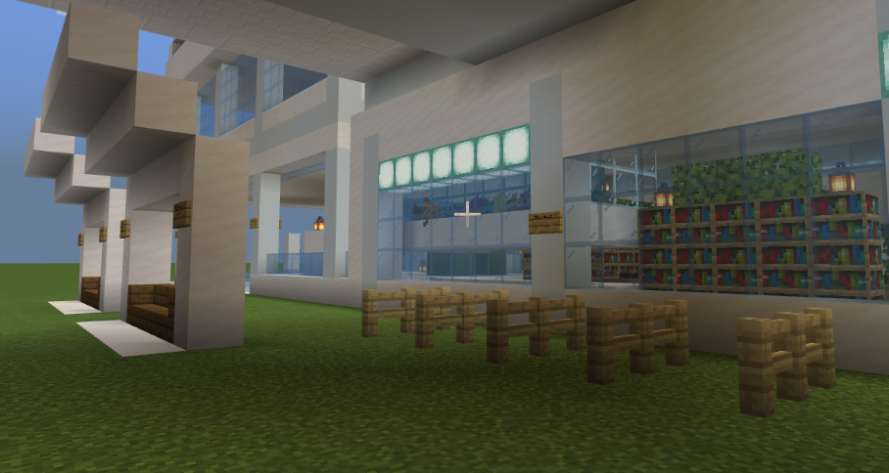
Bike Racks (sheltered) (preventing climbing)

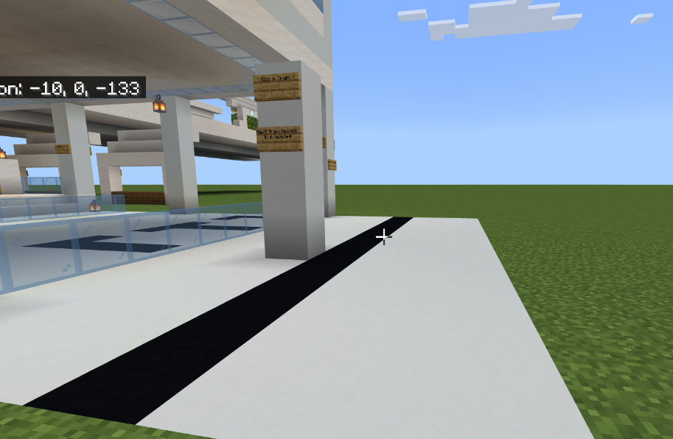
Kiss & Go (A no parking zone where you can stop and drop people off. Max 2 minutes standing)
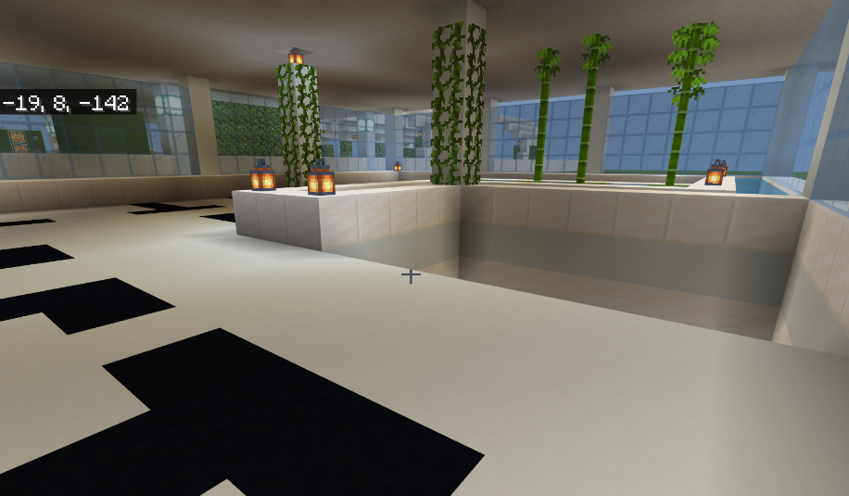
Carpark

Figure 3
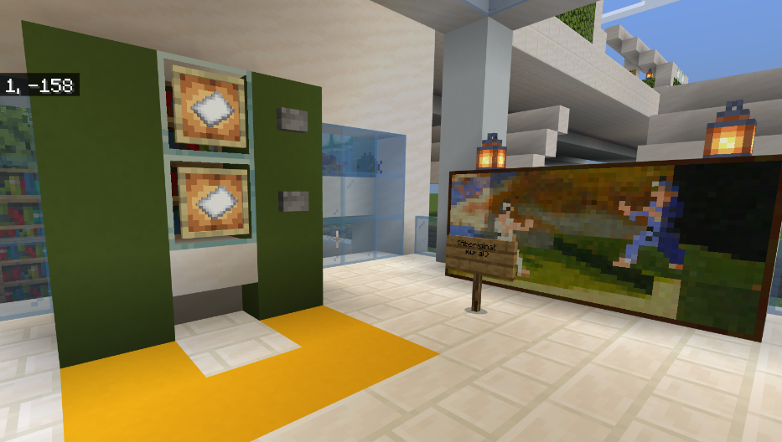
Ticket office w/ indigenous art

Figure 4
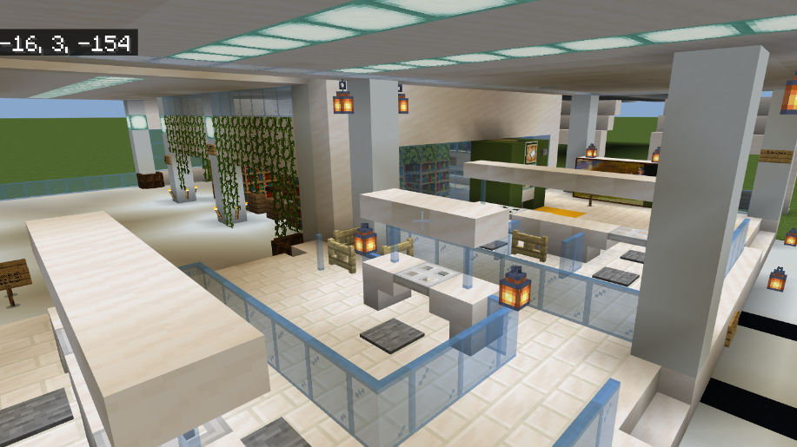
‘
Figure 5

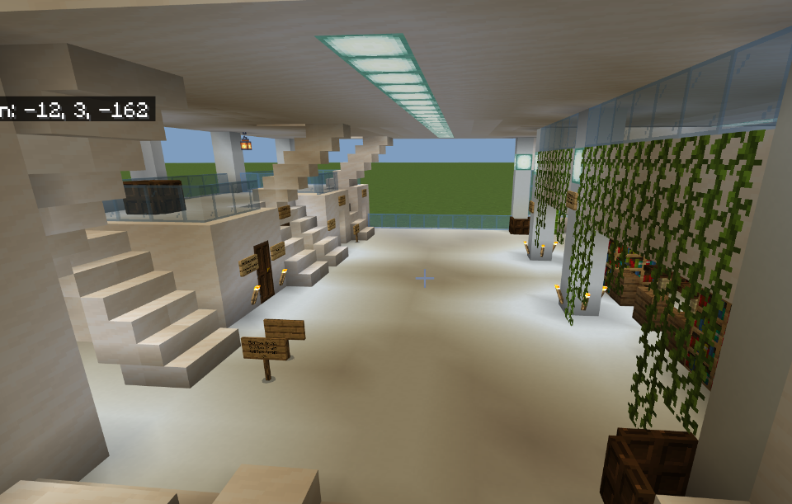
Open space
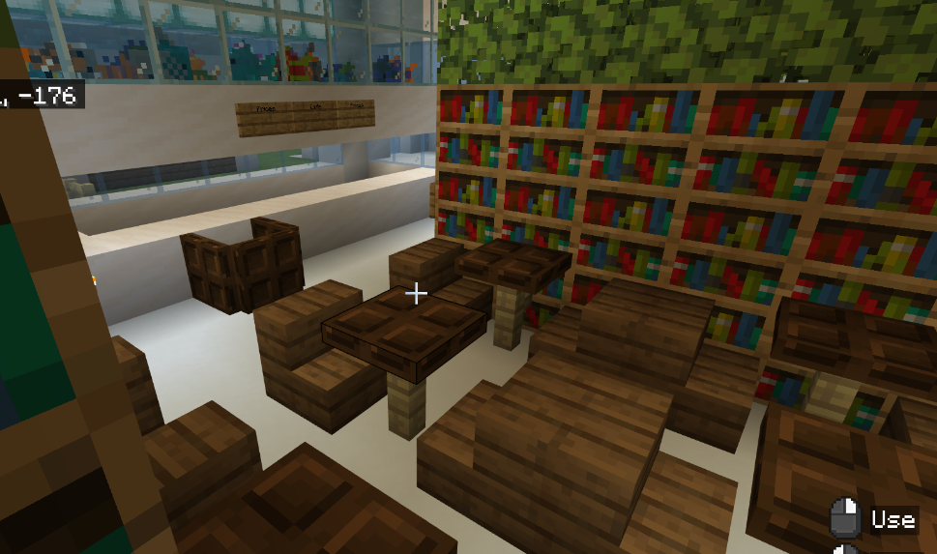
Cafe
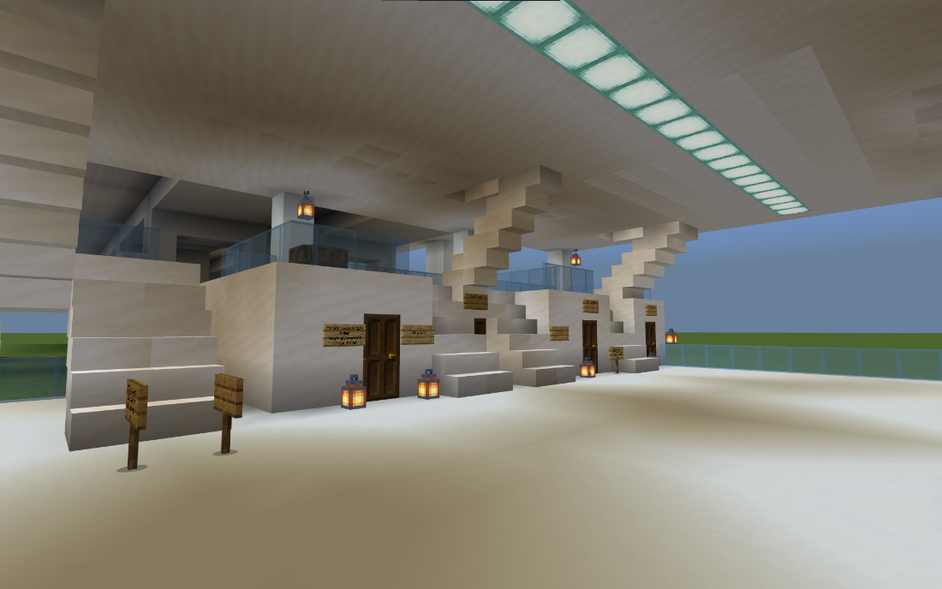
Toilets (all different types)

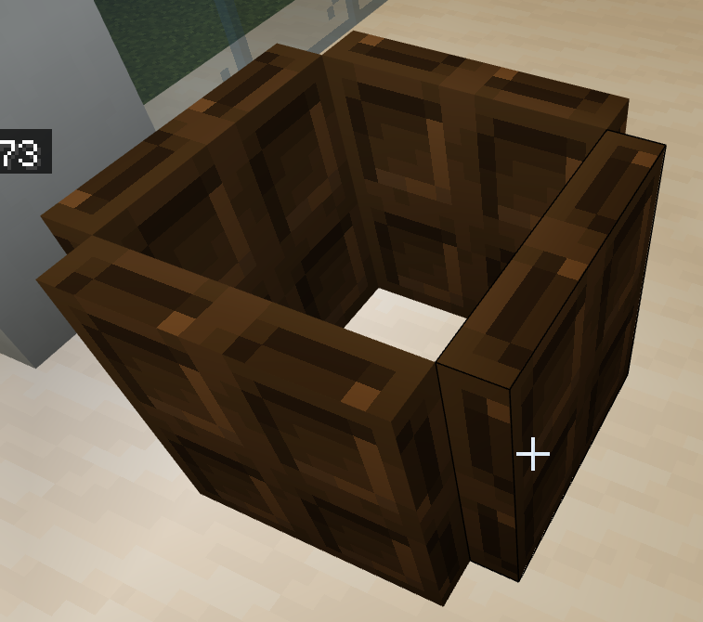
Bins
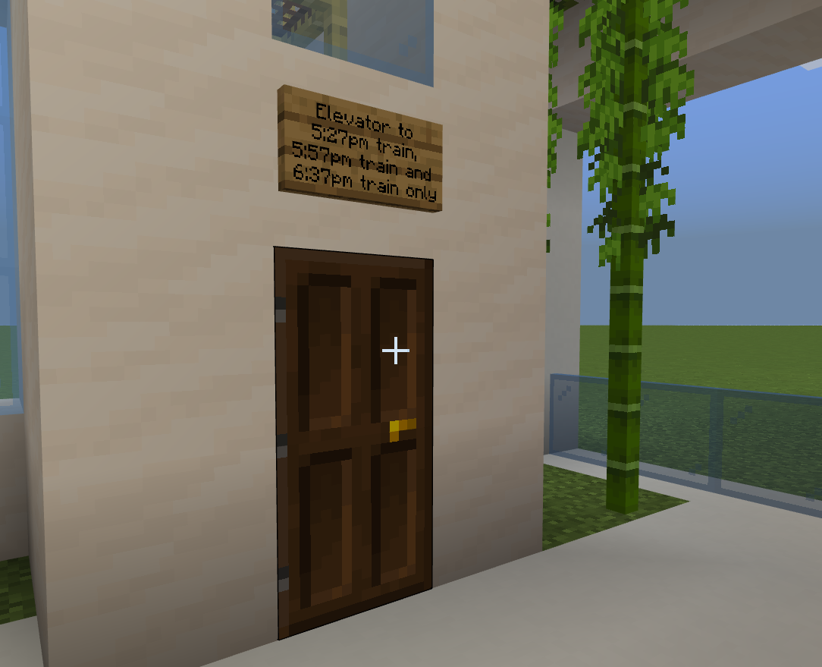
Elevators

Figure 6
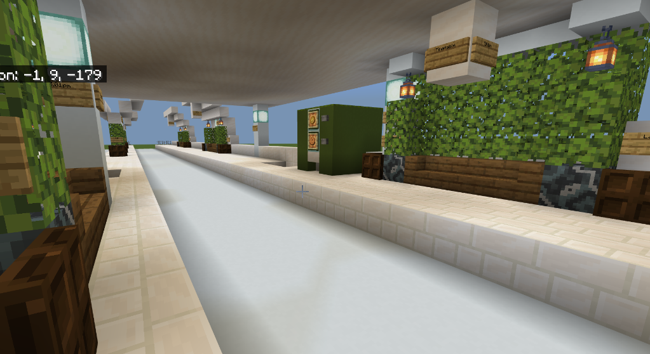
Platform View

Figure 7 – Outside views of the station
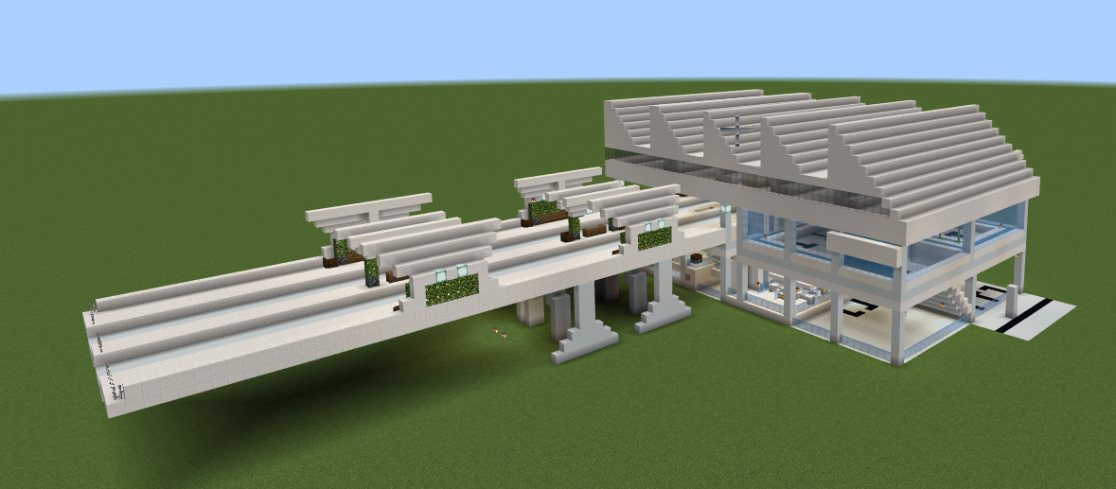
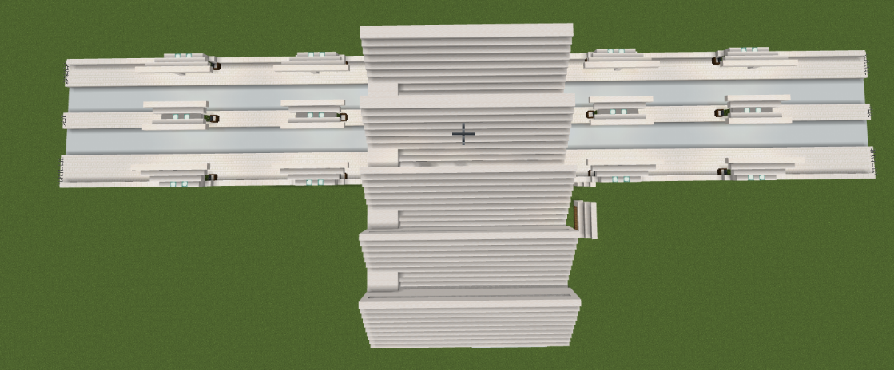
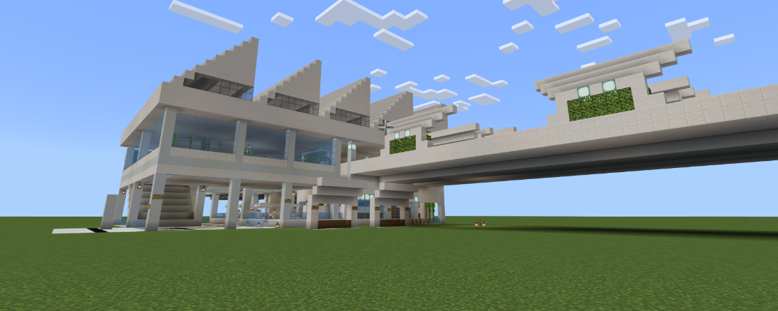

Figure 8
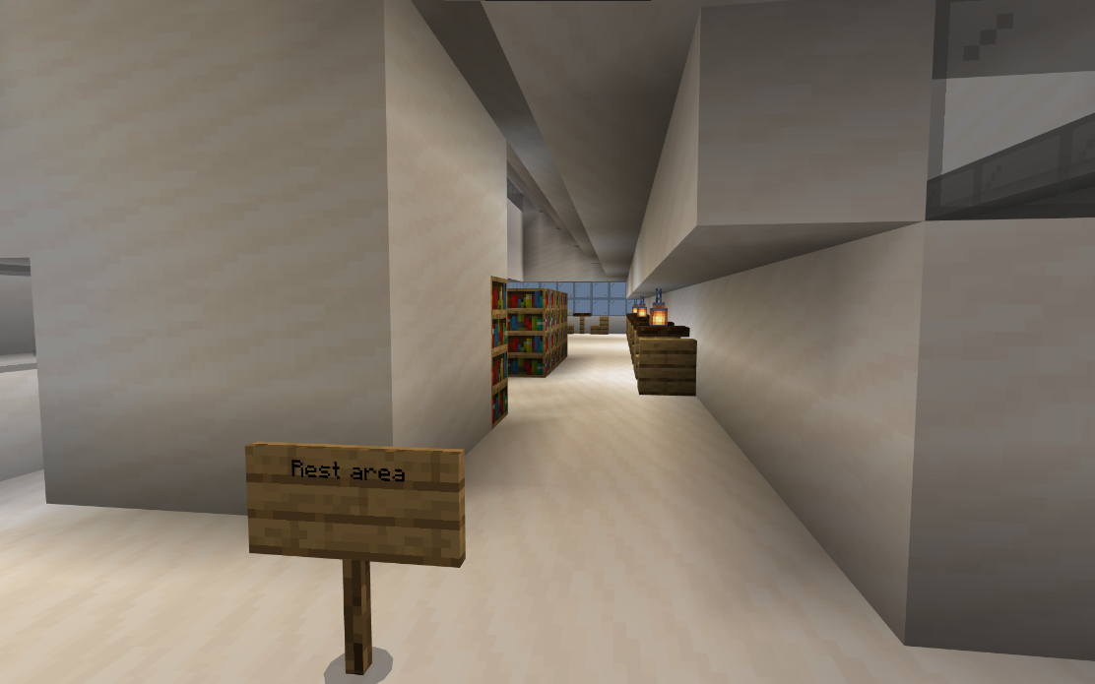
A basic rest area
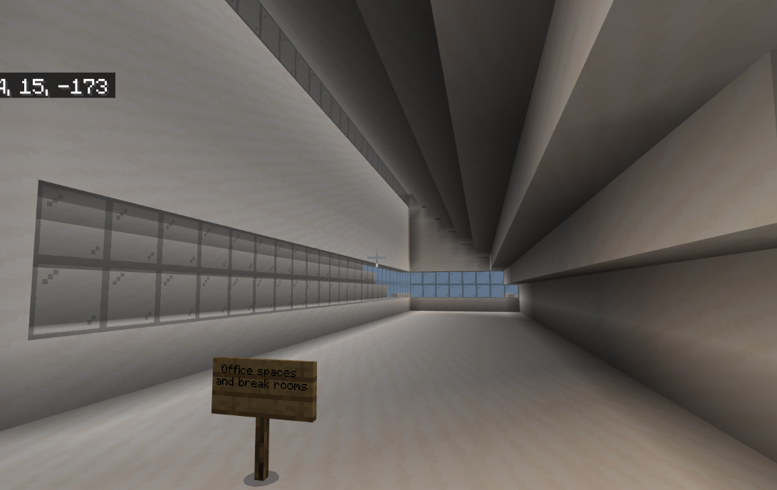
A large space to build office spaces and break rooms

Appendix C: Location of Train Hub
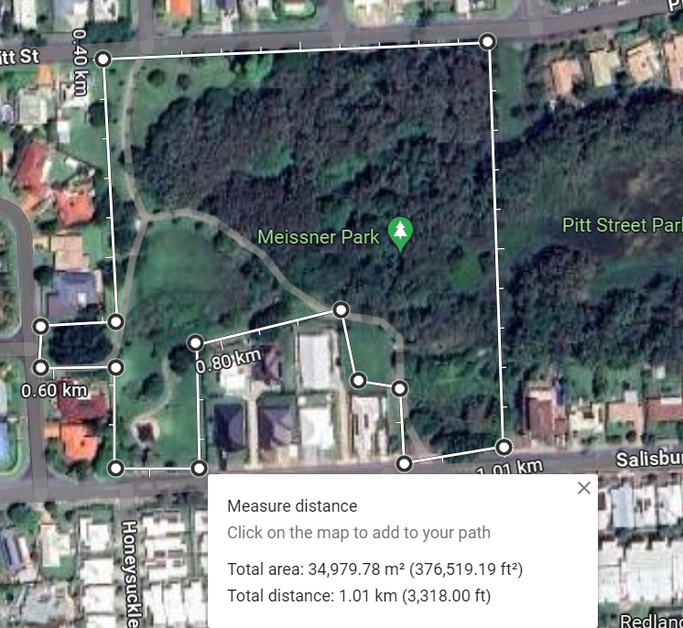

This is where our station will go.

Appendix D
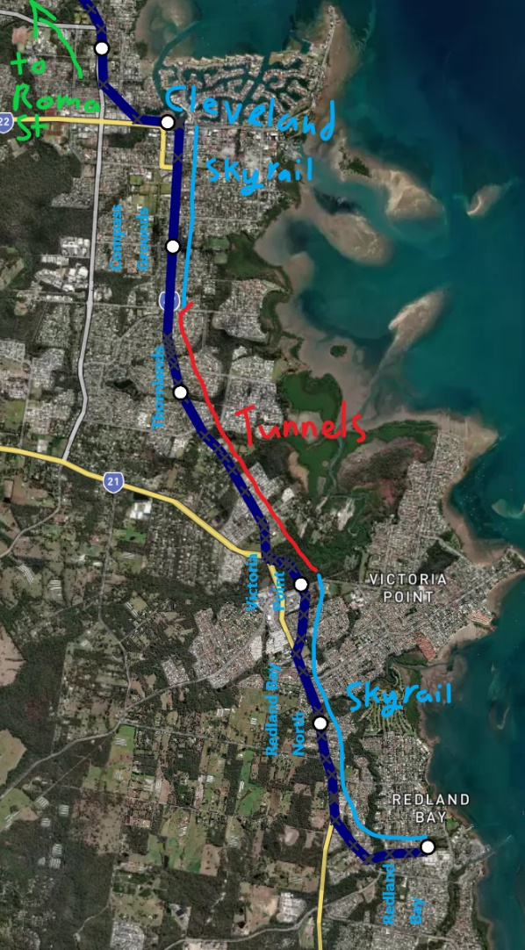
Figure 1
A detailed route map including the areas of sky rail and tunnels, and the locations of the new stations.
Information about the route on page 4

Appendix E - Mood Board
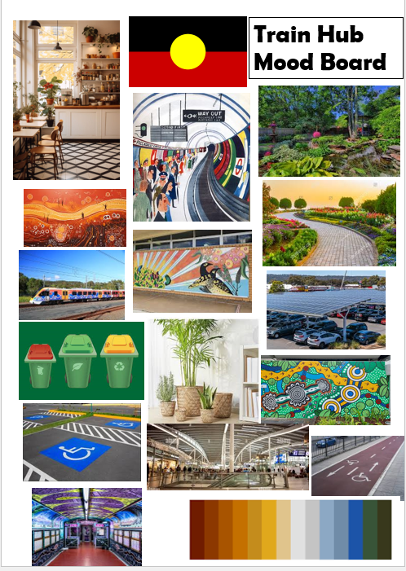

Appendix F - Pictures of the physical model
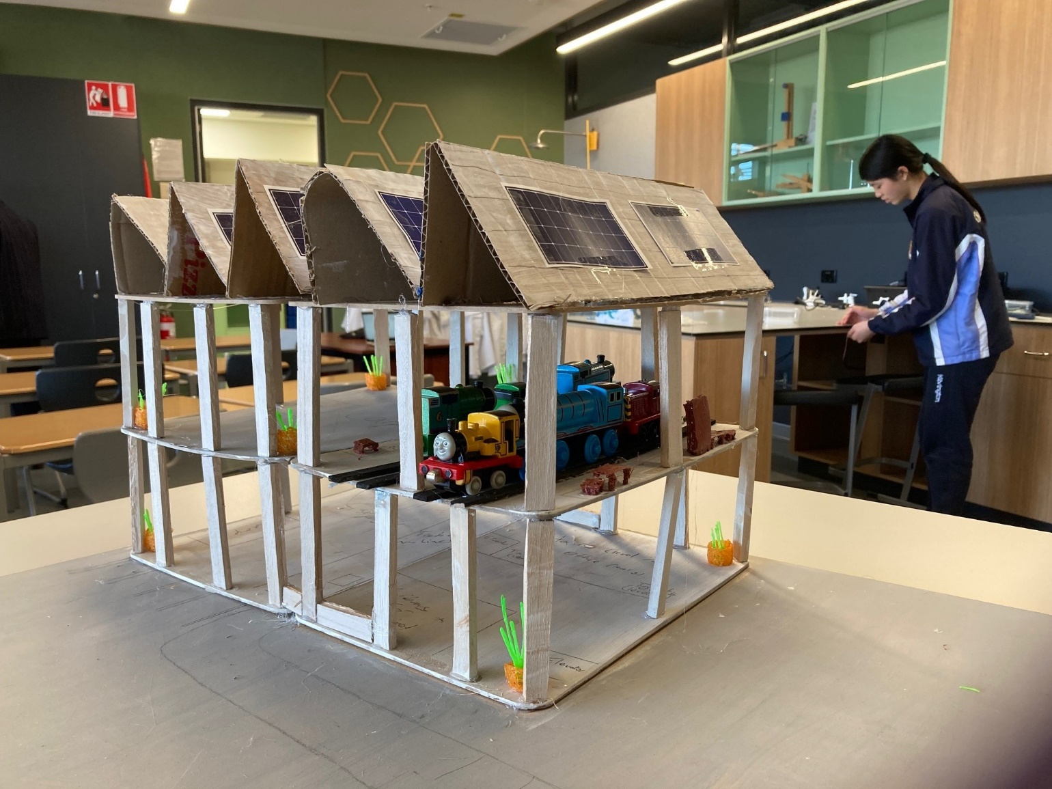
Model from an angle
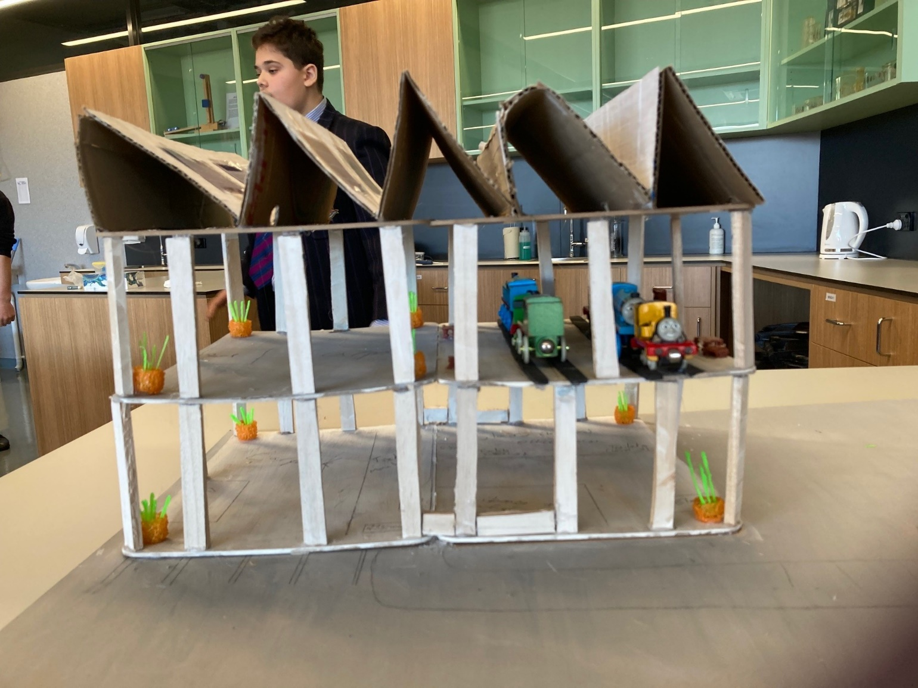
Model from the side

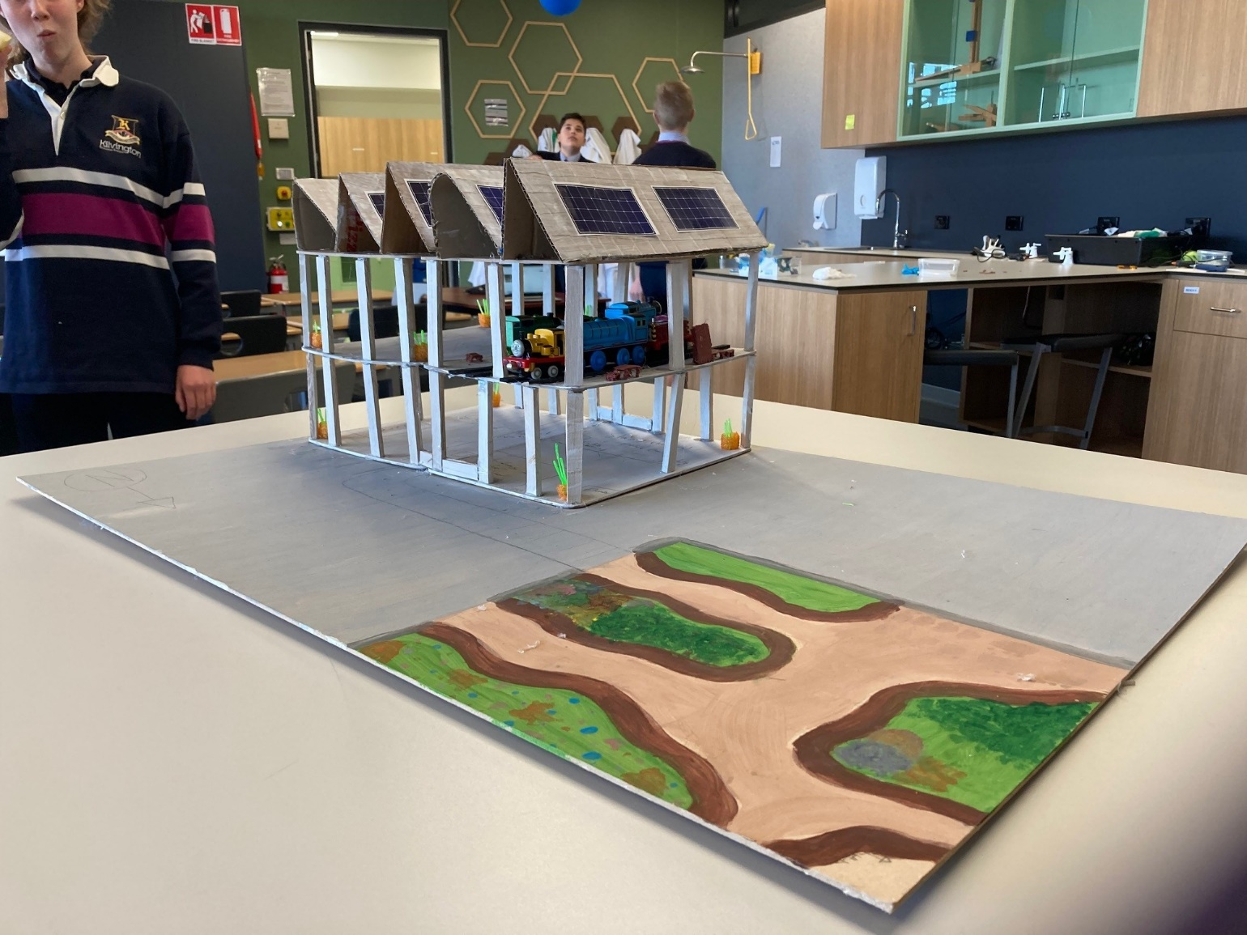
Model from a distance

