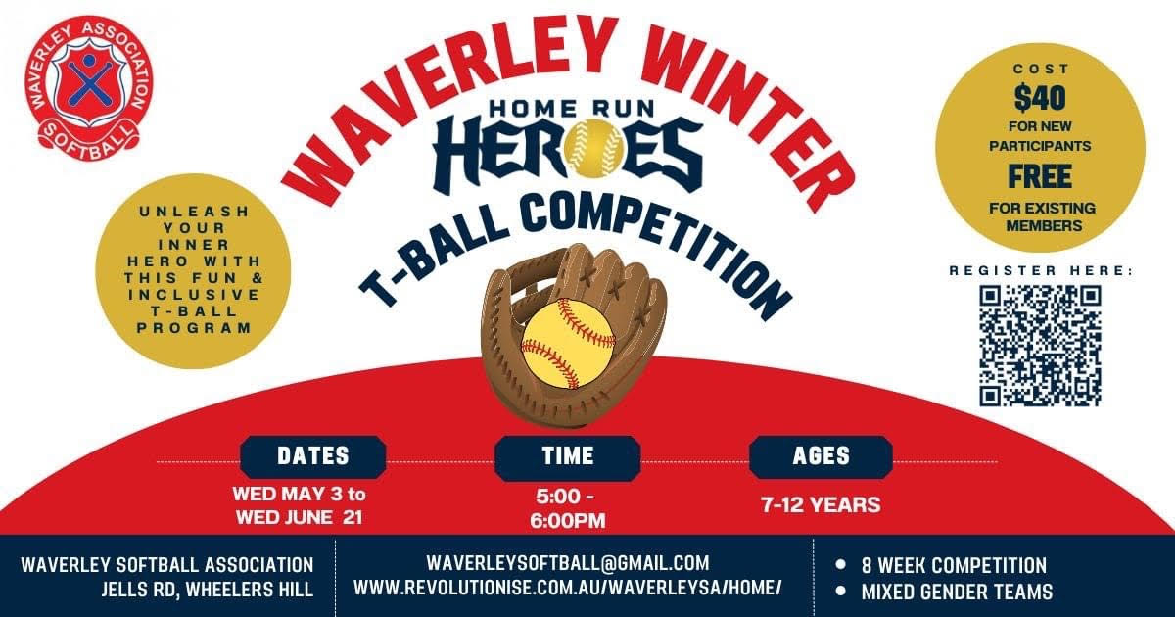

Waverley Winter Softball Competition is starting soon for juniors aged 7-12!!

The perfect competition for juniors to unleash their super skills learnt at home, school or in club training as well as develop and foster new skills in a supportive team-based competition!!

Fun, inclusive, welcoming comp for all
Mixed gender team competition
Wednesday nights from 5-6pm
Once players register they'll be placed in a team

RSVP HERE:
https://www.revolutionise.com.au/waverleysa/events/183328/

AND TELL ALL YOUR FRIENDS TO COME AND BE HOME RUN HEROES TOO!

