Basic Reading Skills
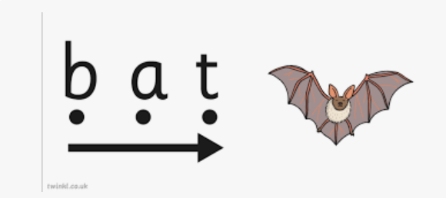
- Always use our sounds to blend. It is best to sing the sounds together.

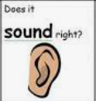
- Listen to what we have read – does it make sense?

- Read the punctuation marks… ! ? .
Breathe at a full stop, get louder at an exclamation and let your voice go up at a question mark.

- Remember NO GUESSING words!
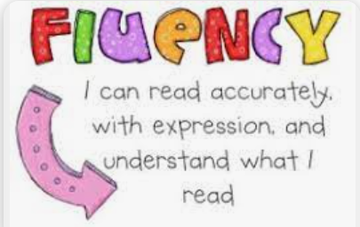
- Re-read our sentence again to show that we are fluent.

