

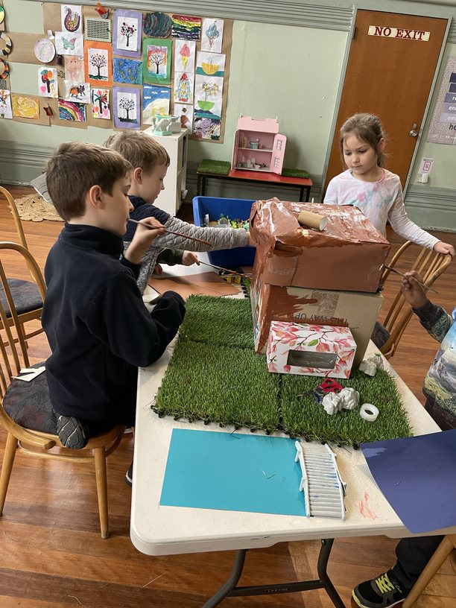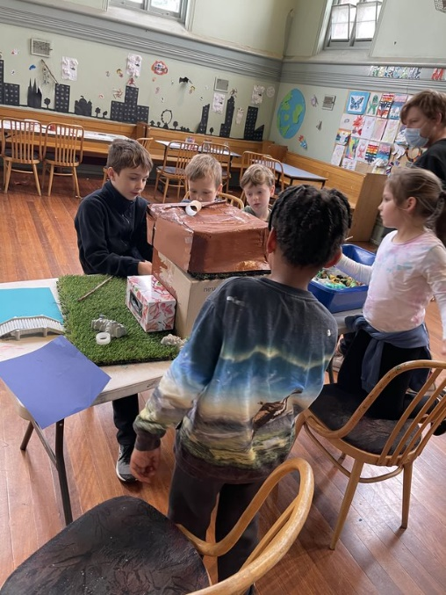

*We acknowledge the Yalukit Willam Clan of the Boonwurrung - as the Traditional Owners of Port Phillip, the land where St Mary's is situated, and we pay our respects to all Aboriginal and Torres Strait Islander people and their Elders, both past, present, and future.*

It is never too late to join in on all the fun at TheirCare :) - Enrol using the website: www.theircare.com.au and click on ‘Book Now’ in the top right hand corner to register your child’s details.

**What’s been happening:**

The last couple of weeks at TheirCare have been fantastic. We have explored different ways to develop our sense of agency, that is taking initiative to design our own interest. The children enjoyed working collaboratively to build their house using the cardboard boxes, creative mind’s theme, and using our fine motor skills to catch and kick balls. The children demonstrated a range of skills with creativity, group work, social and literature skills.

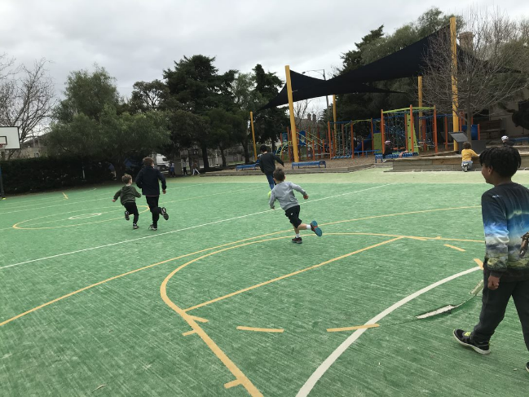

Our weekly menu consists of a variety of vegetables, fruits, and light healthy snacks. It is developed using the Australian Guide to Healthy eating and incorporates voiced suggestions made by the children. Our meals vary, including vegetarian noodles, nachos, sushi, rice paper rolls, and toasties. Children’s health care needs and dietary requirements are taken into consideration when planning our menus.

Educator of the week

Weekly Menu

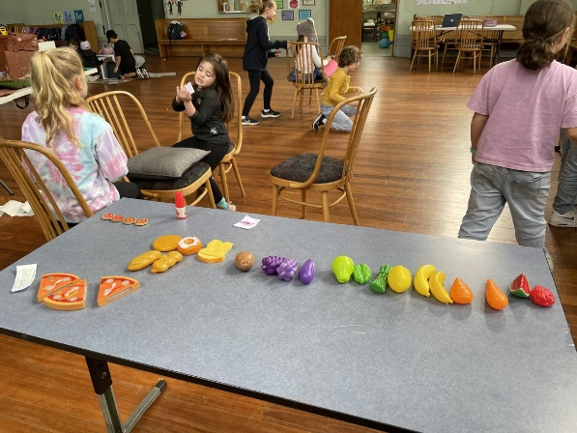

**Feedback**

At St Mary TheirCare, we appreciate when we receive constructive feedback from the community, as we are constantly reflecting on the ways to strive and adapt our current program. All suggestions and ideas collected from families, carers and children, are recognised to ensure we deliver the highest standard program that is tailored to all. Please feel free to speak to one of our staff members or add comments in the parent info book

James