How to book your Parent Student Teacher Conference

Web Browser Option

1. On your child’s home page select ‘Book 2. On the top right select ‘My Bookings’.
Parent Student Teacher Conference’
as shown below.

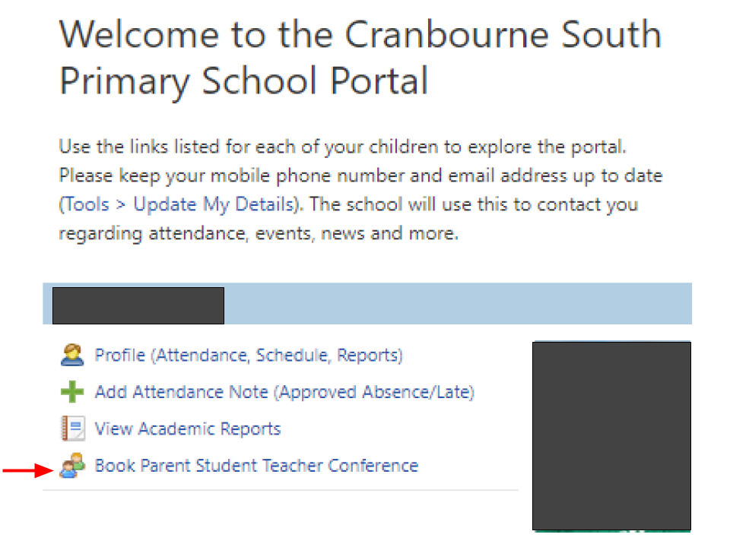
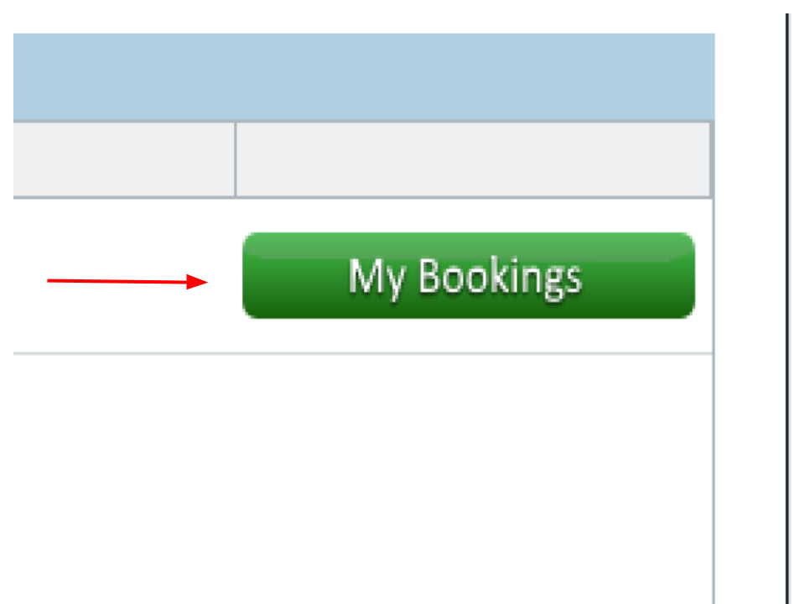

3. At the welcome note select ‘View My 4. On the right select the teacher you wish to
Bookings’. make a booking with.
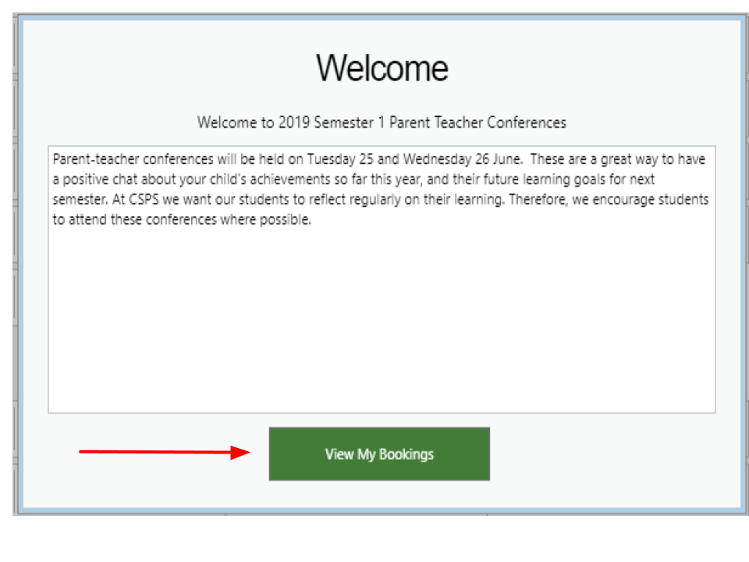
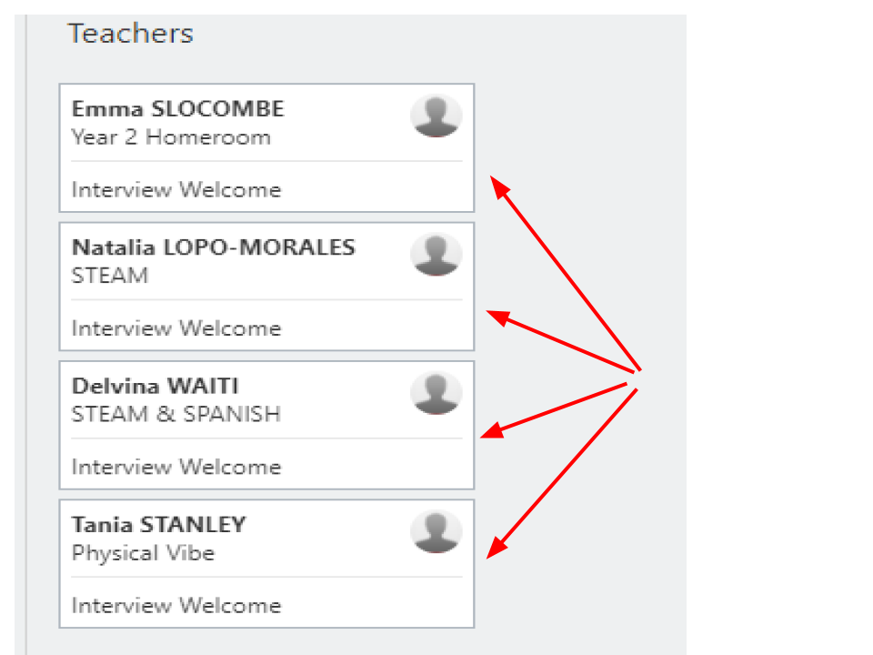

5. Select an available time slot and follow If you are unable to access Compass or have
the prompts to confirm your booking. any other queries relating to reports and
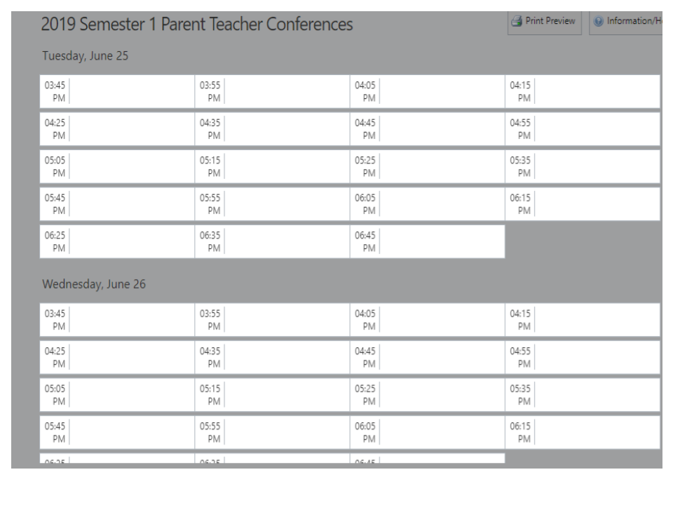
conferences, please contact the school.

How to book your Parent Student Teacher Meetings

Compass App Option

1. On the Home page click the three lines in the top left corner to open the options and select Conferences.
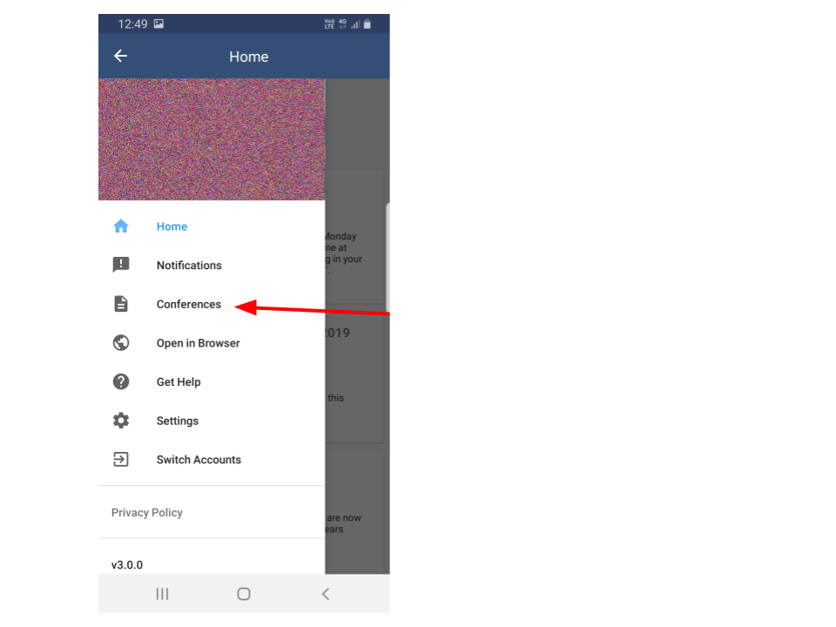

2. On the Conferences page select the teacher you wish to make a booking with.
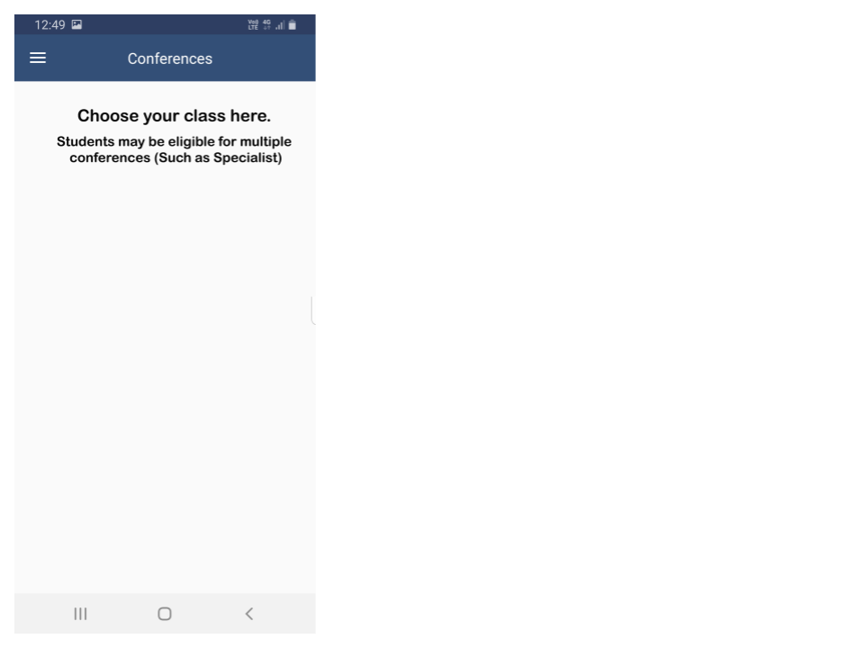

3. Select the time you wish to confirm your booking.
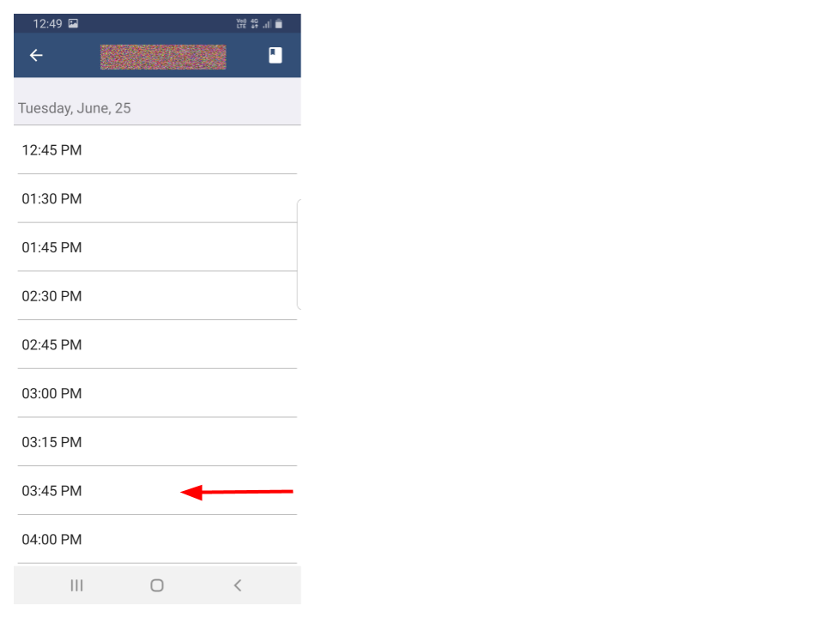

KAREN HALKET
Assessment and Reporting Coordinator
Friday 18th February, 2022

