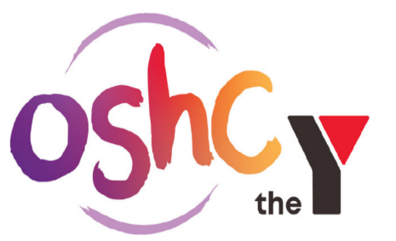

OSHC Educator

About the Role
We are currently recruiting for Educators who believe in building strong lasting relationships with the children and the school community. The position is available on a part time or casual basis.
You will need to be a team player and help build relationships with the school community and support children's learning in line with the National Quality Framework.
You will work alongside the Coordinator and be supported by the OSHC Management team to build community and family engagement, with children at the heart of our service philosophy.
About the Program
The YMCA and the school believe children should have the opportunity in OSHC to:
- Engage in play and leisure activities
- Learn new skills to further their development
- Be safe and supervised at all times
- Build relationships with educators in a community which is connected to but separate from the school community
- Develop as happy, healthy and resilient individuals
- Engage in indoor and outdoor play activities planned with and for the children
- Participate in a range of developmentally appropriate options that cater for the needs and interests of all children including construction, drama, dress-ups, art and craft, cooking, quiet reading and games

If this sounds like the place for you and you have a passion for making a difference in children's lives please get in contact today!
Capabilities and Behaviours
- Demonstrates YMCA values, Honesty, Caring, Respect and Responsibility
- Demonstrates motivation and commitment to perform to their best
- Accepts personal accountability for workplace actions and consequences to better influence
- Works autonomously under general direction
- Ability to recognise and appropriately respond to incidents, accidents and emergencies

Knowledge and Experience
- Demonstrated knowledge, skills and understanding of the National Quality Framework and MTOP.
- Possess excellent verbal and written communication skills as well as well-developed emotional intelligence.
Mandatory Pre-Requisite Qualifications
- Be working towards or hold a child related qualification: Early Childhood, Primary Education, Secondary Education, Outdoor Education, Human Movement, Youth and Community Services etc or hold a Cert III or Diploma in Children's services or Outside School Hours Care.

At the Y, we are committed to empowering all Children and Young People to feel safe and be safe. As such, we ensure that all of our candidates are appropriately screened (including police check, working with children check and reference checks).
In keeping with current health directions, it is a requirement that staff attending our facilities are fully vaccinated. Please be aware that you will be required to provide evidence of your vaccination status as part of the recruitment process.
Benefits
At the YMCA, we value our people. Working for us means you’ll enjoy great work/life balance and a range of benefits which improve your wellbeing and help you develop as an individual, such as:
- Flexible working and rostering arrangements within the Y service in Alice Springs.
- Opportunities for career development and growth
- Free access to YMCA GYM (Alice Springs).

How to Apply
Working for the YMCA is a rewarding and challenging experience for those with a positive attitude, zest for life and who seek to contribute to the bigger picture. If this is you, email jemma.smith@ynt.org.au for further information .

