

***Hi, my name is Hana, and I am the female House Captain for Ibbott 2021. I will be telling you how many points Ibbott got and what place they got for May 2021. Great job to everyone in Ibbott that helped our house get lots of points, keep it up. So, for May 2021 Ibbott collected 2900 points and came 4th place, great job Ibbott.***

*Amazing job Condor for coming second in May! Congratulations for all those people who used the 5 school values to earn points for our house, keep up the good work.  
GO CONDOR!*

!

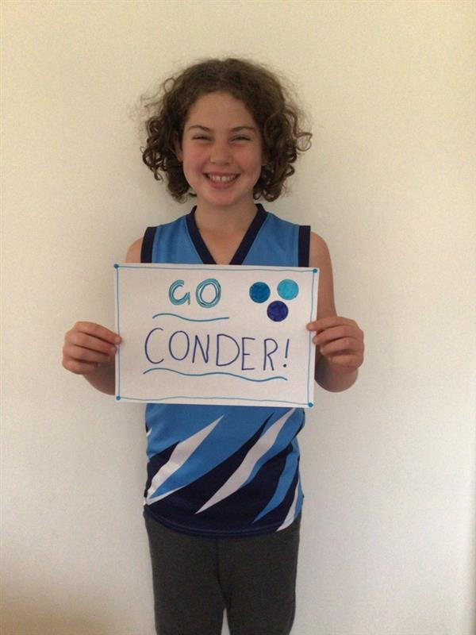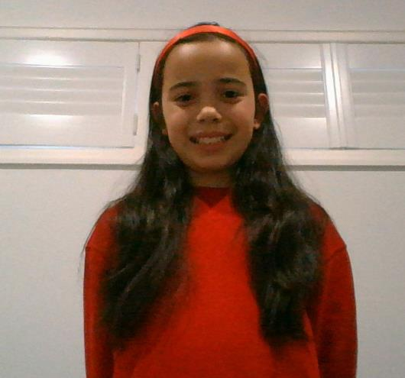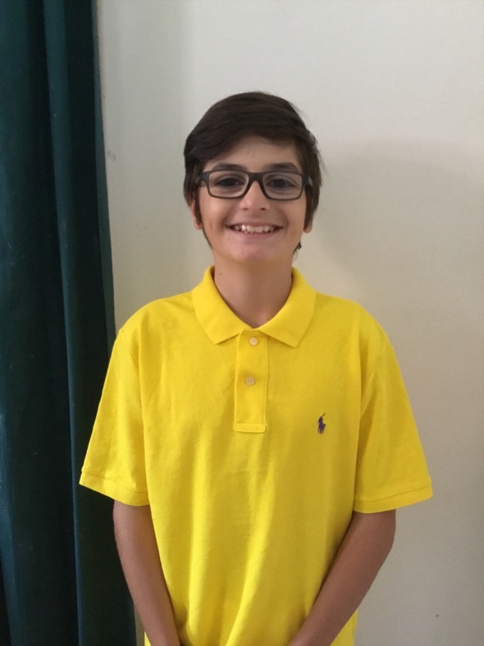

*Hi, my name is Nick, I am your male Sutherland House Captain for 2021 I will be sharing Sutherland’s house points for May. Sutherland got 3,876 house points, you guys made a cracking effort to collect all the house points, well done Sutherland, Go the yellow submarine!!!!*

***Good Morning I.P.S my name is Carys, I am McCubbin's House Captain. Today I will be announcing McCubbin's points and place for May! McCubbin came 1st with an AMAZING total of 4205! Great job to all those people who earnt house points this month! Great job to the other houses too. GO MCCUBBIN!***