Uniting OSHC at St Josephs’ Primary School Nagambie


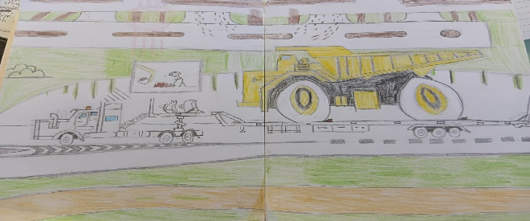
A wonderful drawing from a very talented young boy attending the program! Amazing talent.
Rosemarie Farrugia Uniting OSHC Service Leader at Uniting OSHC St Josephs‘ Primary School Nagambie
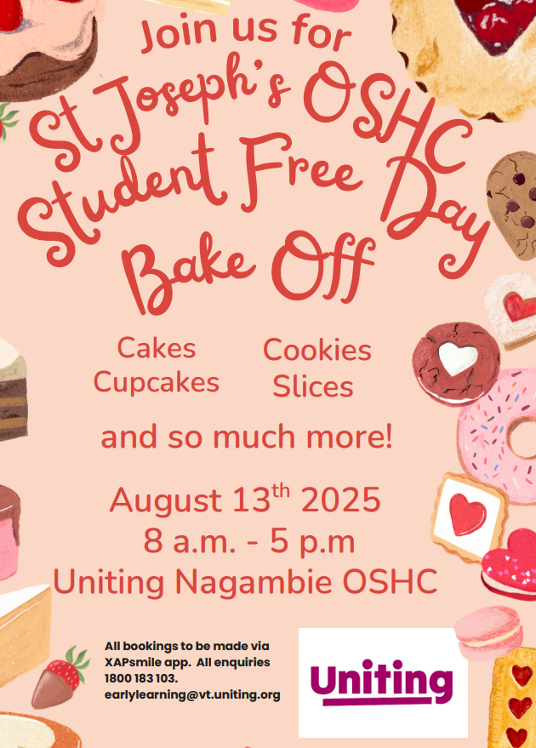
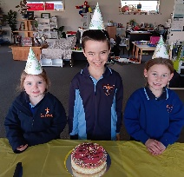
0482133582 or 0447273904
Hello Parents and Carers,

Term 3 has started with a bang; The children have been engaged in some fun activities and play. We celebrated some birthdays and although it was quite cold in the mornings for them to be outside, we made some adjustments to the inside space and played some indoor sporting games, such as Ten Pin Bowling and hot potato with a soft ball.
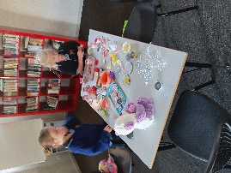
I am impressed with how the children coped with theses adaptions and end up having fun. I have started to re-introduce a story before going to class, as it helps the children to be ready for learning. The children have turns in choosing the book, which gives them a sense of belonging and having a voice. We are all looking forward to our Pupil Free Day on Wednesday the 13th of August.
Uniting welcomes any new families to the service, whether you require a casual booking, or regular on-going booking to allow for your working or appointment commitments. Please feel free to call me on the above number or pop over to see me at the service between 2-6pm

A day full of Baking Fun!



