**WEST COBURG ST ANDREWS CRICKET CLUB**

 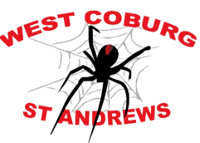 

**JUNIOR BLASTERS PROGRAM 2023/24**

Friday evenings from 6 pm to 7 pm at Shore Reserve from Friday 27 Oct 23 to 23 Feb 24 with a break over the school holidays.

Junior Blasters is for boys and girls new to cricket building their skills through fun, game-based activities designed for small groups to ensure every child gets a go, allowing them to test and learn new skills.

**We actively encourage parents to get involved with the kids and no previous cricket experience is needed.**

Here is the link to register your child to our Junior Blasters Program:

<https://www.playhq.com/cricket-australia/register/0598fb> **OR COME ‘N’ TRY** first before registering.

Contact: Geoff Law, Secretary 0402 473 713 with any queries.

**We look forward to seeing you and the family at shore Reserve for some fun, family friendly activities**.

.