WOORAYL DISTRICT PRIMARY SCHOOL
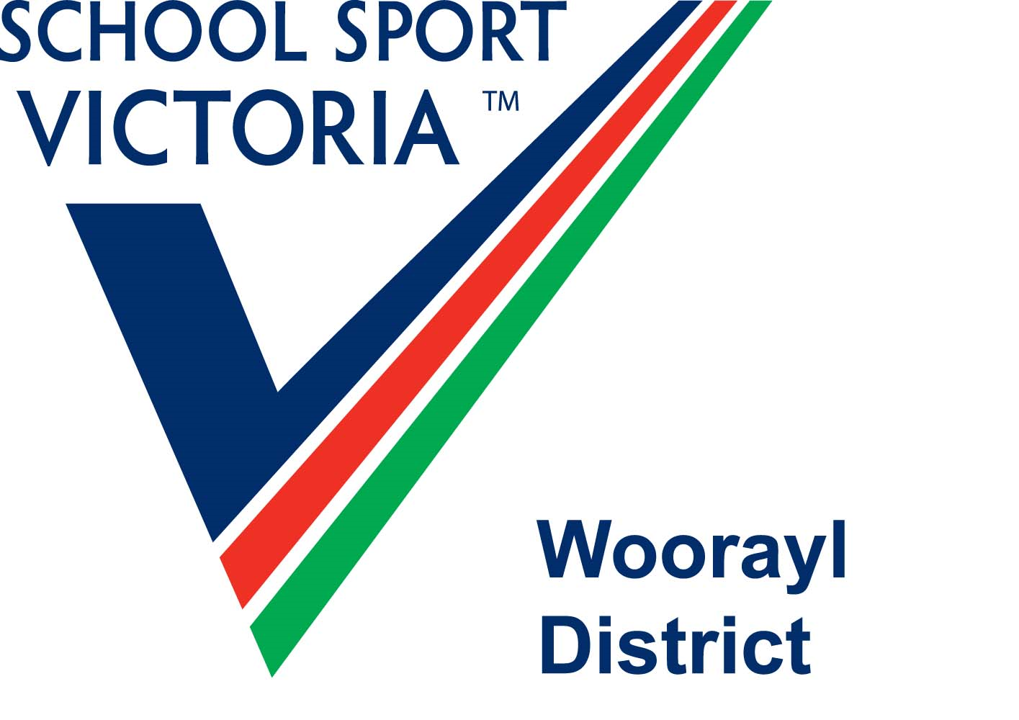
SPORTS ASSOCIATION
C/o Shelley Snooks
Korumburra Primary School
Mine Rd, Korumburra,3950
Ph: 5655 1309
John Wilson
c/o Korumburra Secondary College
Jumbunna Rd, Korumburra, 3950

21 February, 2022

Dear John,
On behalf of the Woorayl District Primary School Sports Association, I would like to extend our thanks to you for enabling us to use your students as helpers at our District Swimming event. The day was extremely successful, with the help from your students.
The manner in which your school accommodates our needs and the welcoming nature of both students and teachers is a credit to your school. I hope we are able to use your students for future events.
The students were great ambassadors of your school, being polite and willing to help in any way they were asked.
Please pass on my thanks and congratulations to those students who helped on the day.
Thanks again.
Yours Sincerely,

Shelley Snooks
WDPSSA Coordinator

