
Baked Beans
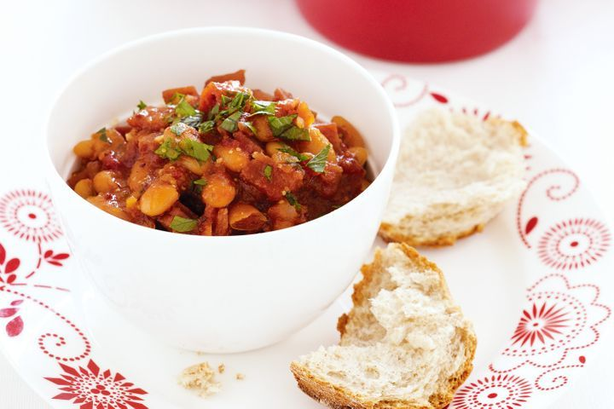
Recipe from taste.com.au
Equipment | Ingredients:  2 tsp olive oil  3 rindless bacon rashers, coarsely chopped  1 small brown onion, finely chopped  250ml (1 cup) passata (tomato pasta sauce)  125ml (1/2 cup) water  1 tbsp golden syrup  1 tsp paprika  400g can cannellini beans, drained, rinsed  2 tbsp chopped fresh continental parsley
  Saucepan.
  Wooden spoon
  Knife
  Chopping board
  Measuring cups
  Measuring spoons
What to do:

- Heat oil in a medium saucepan over medium heat. Add bacon and onion. Cook, stirring occasionally, for 5 minutes or until the bacon is crisp and onion is soft.

- Add passata, water, golden syrup and paprika to the pan and stir until well combined. Simmer, stirring occasionally, for 5 minutes or until the mixture thickens.

- Add cannellini beans (make sure they have been drained and rinsed).

- Cook, stirring, for 3 minutes or until the beans are heated through. Stir in parsley. Season with salt and pepper.

- Serve on top of the baked potatoes (or beside if preferred).

