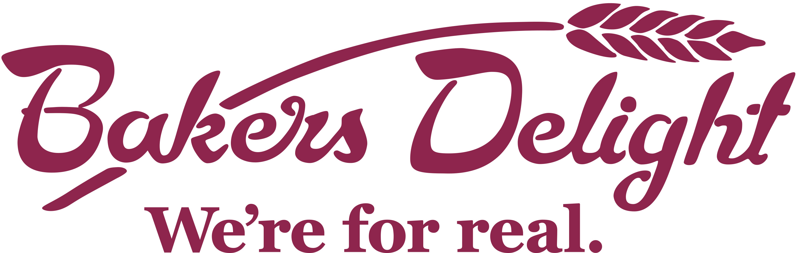
HOT CROSS BUN ORDER FORM
EASTER 2021

Grade 6 Camp Fundraiser

Date of Delivery: Wednesday 30th March
Return Form By: Wednesday 23rd March (Payment in Cash or Card via payment envelope)

Name: _______________________________ Class: ____________ Contact Ph Number: ______________________

Name | Traditional  Hot Cross Buns  Number of packs-  $8.00 per 6 pack | Apple and Cinnamon Hot Cross Buns  Number of packs-  $8.00 per 6 pack | Choc Chip  Hot Cross Buns  Number of packs-  $8.00 per 6 pack | Mocha  Hot Cross Buns  Number of packs- $8.00 per 6 pack | Fruitless  Hot Cross Buns  Number of packs-  $8.00 per 6 pack | Total $ | Paid

