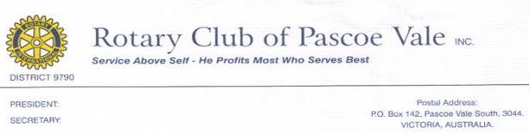
FREE HEARING TESTS

The Rotary Club of Pascoe Vale, in conjunction with The University of Melbourne Audiology Clinic be running hearing testing again.

When: Saturday 26th October 2019

Where: Pascoe Vale South Primary School
411-429 Reynard Street
Pascoe Vale South, Victoria 3044
Melways Ref: Map 29, A1 Off-street parking available

Ages: 3-6 years

Bookings are to be made via Trybooking using the following link:
https://www.trybooking.com/BFMWH

In the many years of running these clinics it has been found that, on average, one third of children tested required further consultation or treatment. Early intervention and education can have a significant positive impact.

We are more than pleased that The Rotary Club of Pascoe Vale has played a significant part in helping with the health and welfare of these children.

Regards Damian Nippard
Mob: 0409 024 086
The chair of the Rotary Club of Pascoe Vale Youth Committee

